**Budget Estimates**

**2019-20**

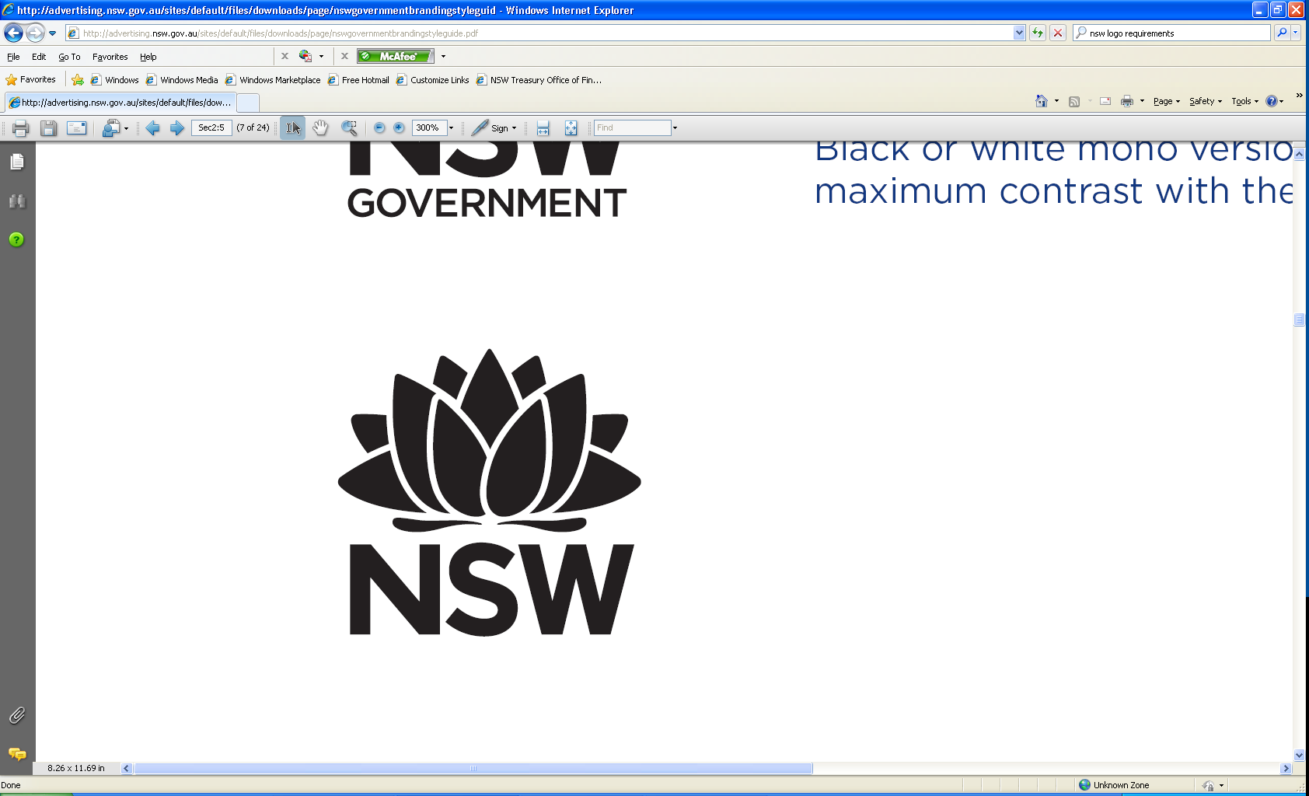

**Budget Paper No. 3**

Circulated by The Hon. Dominic Perrottet MP, Treasurer

# Table of Contents

About this Budget Paper i

**1. Customer Service**  1 -1

Department of Customer Service 1 - 7

Independent Liquor and Gaming Authority 1 - 10

Information and Privacy Commission 1 - 13

Service NSW 1 - 16

Long Service Corporation 1 - 19

New South Wales Government Telecommunications Authority 1 - 22

Rental Bond Board 1 - 25

State Insurance Regulatory Authority 1 - 28

Department of Finance, Services and Innovation 1 - 31

***Independent Offices***

Independent Pricing and Regulatory Tribunal 1 - 34

**2. Education Cluster**  2 - 1

Department of Education 2 - 6

NSW Education Standards Authority 2 - 9

TAFE Commission 2 - 12

**3. Health Cluster**  3 - 1

Ministry of Health 3 - 7

Health Care Complaints Commission 3 - 10

Mental Health Commission of New South Wales 3 - 13

**4. Planning, Industry & Environment Cluster**  4 - 1

Department of Planning, Industry & Environment 4 - 10

Environment Protection Authority 4 - 13

Environmental Trust 4 - 16

Natural Resources Commission 4 - 19

New South Wales Rural Assistance Authority 4 - 22

Royal Botanic Gardens and Domain Trust 4 - 25

Sydney Olympic Park Authority 4 - 28

Aboriginal Housing Office 4 - 31

Biodiversity Conservation Trust of New South Wales 4 - 34

Centennial Park and Moore Park Trust 4 - 37

Hunter and Central Coast Development Corporation 4 - 40

Lands Administration Ministerial Corporation 4 - 43

Local Land Services 4 - 46

Luna Park Reserve Trust 4 - 49

NSW Food Authority 4 - 52

Planning Ministerial Corporation 4 - 55

Property NSW 4 - 58

Water Administration Ministerial Corporation 4 - 61

Western Sydney Parklands Trust 4 - 64

**4. Planning, Industry & Environment Cluster (cont)**

Department of Industry 4 - 67

Department of Planning and Environment 4 - 70

Office of Environment and Heritage 4 - 73

Office of Local Government 4 - 76

**5. Premier and Cabinet Cluster**  5 - 1

Department of Premier and Cabinet 5 - 7

Greater Sydney Commission 5 - 10

Infrastructure NSW 5 - 13

Parliamentary Counsel’s Office 5 - 16

Art Gallery of New South Wales 5 - 19

Australian Museum 5 - 22

Barangaroo Delivery Authority 5 - 25

Historic Houses Trust of New South Wales 5 - 28

Museum of Applied Arts and Sciences 5 - 31

State Archives and Records Authority of New South Wales 5 - 34

State Library of New South Wales 5 - 37

UrbanGrowth NSW Development Corporation 5 - 40

***Independent Offices***

Audit Office of New South Wales 5 - 43

Independent Commission Against Corruption 5 - 46

Law Enforcement Conduct Commission 5 - 49

New South Wales Electoral Commission 5 - 52

Ombudsman's Office 5 - 55

Public Service Commission 5 - 58

**6. Stronger Communities Cluster**  6 - 1

Department of Family and Community Services and Justice 6 - 9

Crown Solicitor’s Office 6 - 12

Fire and Rescue NSW 6 - 15

Legal Aid Commission of New South Wales 6 - 18

New South Wales Crime Commission 6 - 21

NSW Police Force 6 - 24

Office of Sport 6 - 27

Office of the NSW Rural Fire Service 6 - 30

Office of the NSW State Emergency Service 6 - 33

Home Purchase Assistance Fund 6 - 36

Multicultural NSW 6 - 39

NSW Trustee and Guardian 6 - 42

Department of Family and Community Services 6 - 45

Department of Justice 6 - 48

***Independent Offices***

Judicial Commission of New South Wales 6 - 51

Office of the Children's Guardian 6 - 54

Office of the Director of Public Prosecutions 6 - 57

**7. Transport Cluster**  7 - 1

Transport for NSW 7 - 7

Roads and Maritime Services 7 - 13

Sydney Metro 7 - 16

Office of Transport Safety Investigations 7 - 19

**8. Treasury Cluster**  8 - 1

The Treasury 8 - 6

Crown Finance Entity 8 - 9

NSW Self Insurance Corporation 8 - 12

Western City and Aerotropolis Authority 8 - 15

Alpha Distribution Ministerial Holding Corporation 8 - 18

Building Insurers’ Guarantee Corporation 8 - 21

Destination NSW 8 - 24

Electricity Assets Ministerial Holding Corporation 8 - 27

Electricity Retained Interest Corporation – Ausgrid 8 - 30

Electricity Retained Interest Corporation – Endeavour Energy 8 - 33

Electricity Transmission Ministerial Holding Corporation 8 - 36

Epsilon Distribution Ministerial Holding Corporation 8 - 39

Liability Management Ministerial Corporation 8 - 42

Ports Assets Ministerial Holding Corporation 8 - 45

Roads Retained Interest Pty Ltd 8 - 48

Workers' Compensation (Dust Diseases) Authority 8 - 51

Appropriation to the Treasurer for State contingencies 8 - 54

**9. The Legislature**  9 - 1

The Legislature 9 - 4

**Glossary**