2. Building new south wales for today and for the future
The 2022-23 Budget maintains the Government’s commitment to investing in infrastructure. With a record estimated infrastructure program of $112.7 billion, investments made today will ensure New South Wales remains the best place to live, work and raise a family.
Building the right infrastructure is foundational to a strong, productive economy and the liveability of the state. Unprecedented challenges over the past year (including major floods and COVID-19) have highlighted the critical role of productive infrastructure in supporting the well-being of the community.
Highlights of the Government’s current infrastructure pipeline include: $76.7 billion for public transport and infrastructure, $11.9 billion for health infrastructure, $9.2 billion for schools and skills infrastructure and $2.9 billion to meet the Government’s commitment to build stronger communities.

Key infrastructure projects new and underway
Customer Service

$1.5 billion | Capital Expenditure to 2025-26
$625.2 million | Capital  Expenditure  2022-23
The Customer Service cluster is committed to providing trustworthy, effective and easy-to-use services for customers and communities, no matter who they are, where they are or what they need. This includes delivering world-class services in person, online and over the phone, as well as improving the digital availability, reliability and security of NSW Government platforms, information and services.
This Budget upholds the NSW Government’s commitment to investing in whole-of-sector digital information and communication technology to improve services for the people of New South Wales. A key ongoing initiative towards this goal is the Digital Restart Fund, which continues to promote a progressive, whole-of-sector approach to digitalisation, enabling clusters to drive productivity and efficiency.
This Budget includes $1.5 billion in capital spending for Customer Service initiatives and projects over the four years to 2025-26.

Centralised Mission Critical Emergency Services Paging Network
An additional $145.7 million ($60.3 million in capital) will be invested in the NSW Government Telecommunications Authority (the NSW Telco Authority) to consolidate, upgrade and construct a Centralised Mission Critical Emergency Services Paging Network. The investment aims to improve the efficiency and effectiveness of front-line workers when responding to fires and other emergencies.
Upgrades to the network will streamline asset use and improve accountability of performance and customer service, addressing concerns with an ageing network that is approaching the end of its useful life, as well as the issues resulting from the procurement of major network elements by different government agencies. The NSW Telco Authority will leverage the ongoing work on the Critical Communications Enhancement Program (CCEP) to reduce construction costs per site and expedite rollout of the paging network.
These works are consistent with the recommendations of the NSW Bushfire Inquiry into the 2019-20 bushfires and Royal Commission into Natural Disaster Arrangements 2020. These reports identified the detrimental impacts of mobile communications outages, and the need for simple methods of communicating during fire and other emergencies.

- Key new Customer Service projects commencing in 2022-23 included in this Budget:
Project | Investment
Centralised Mission Critical Emergency Services Paging Network  Construction, upgrades and consolidation of existing agency networks for a Centralised Mission Critical Emergency Services Paging Network will improve the efficiency and effectiveness of front-line workers when responding to fires and other emergencies (see Box 2.1). | $145.7 million (ETC)
Live NSW (Spatial Digital Twin)  Building a cross sector collaborative environment (shared digital platform) for visual location information (mapping) in a four-dimensional model to support decision making across utilities, land use, and planning. | $31.3 million (ETC)
- Key Customer Service projects continuing in this Budget:
Project | Investment
Critical Communications Enhancement Program – Stage 4  Consolidation of separate Government-owned radio networks will facilitate a co-ordinated Government response to critical incidents and emergencies. | $660.2 million (ETC)
Critical Communications Enhancement Program – Stage 3  Consolidation of around 70 separate agency radio networks into one shared network under the State’s existing Government Radio Network will deliver greater access to public safety standard radio communications for the State’s first responders and essential service agencies. | $216.9 million (ETC)
Modern Licensing and Compliance Program  This initiative works towards delivery of additional digital licence scheme products to make it easier for citizens and businesses to gain authorisation to perform an activity, and regulators to manage licences and compliance effectively. | $104.3 million (ETC)
Complaints, Compliance & Enforcement Program  A set of reforms to complaints handling, compliance activities, and investigations and enforcement at SafeWork and Fair Trading NSW will deliver smarter and more customer-centric digital solutions that reduce red tape and enhance business productivity across New South Wales. | $28.9 million (ETC)
New Service NSW service centres  Expansion of the Service NSW footprint throughout local communities will improve customers’ access to government services. This initiative forms part of the NSW Government’s election commitment to deliver 10 new Service NSW centres. | $14.9 million (ETC)
Mobile Service Centre Program – Two new buses  Expansion of the mobile service centre program will provide increased access to all services offered through the Service NSW network in rural and regional New South Wales. | $1.7 million (ETC)

The Digital Restart Fund: ensuring government services capitalise on the best technologies
The NSW Government continues to innovate with digital services to lead the way in developing digital government. The Digital Restart Fund was first established in 2019 with a funding pool of $100 million, which was boosted to a $2.1 billion in June 2021. Since the Half Year Review, new investments have been allocated from the Fund. Highlights include:
- $33.1 million allocated to nine initiatives across multiple NSW Government agencies (including the Department of Planning and Environment, the NSW Electoral Commission and NSW Education Standards Authority) to uplift the security of operating systems and applications. These initiatives will allow agencies to manage cyber threats more proactively.
- $38.8 million (over two years) towards the e-Regulation platform, including the delivery of a single case management system for regulators and businesses in New South Wales.
- $19.8 million (over three years) for the Valnet Framework Refresh Program, which is an interactive platform for land valuation data and represents a digital solution to replace a 20-year old legacy system and manual processes.
- $20 million (over two years) for the Digital Access to Care, Customers at the Centre of their Care Program, which delivers an improved platform for local health districts to manage inbound patient referrals. This will provide the community with greater flexibility and an improved experienced when accessing care in and out of hospital.
- $20 million (over two years) to integrate the current stand-alone Health Outcomes and Patient Experience (HOPE) Platform with local health district electronic medical records. The integrated platform will be made available to additional patient groups and improve patient care.

Pages 5-5 to 5-7 of Chapter 5 of this Infrastructure Statement lists the major capital projects and minor works for the Customer Service cluster, including the ETC, estimated expenditure to 30 June 2022, and 2022-23 allocation.
Education and Skills

$9.2 billion | Capital Expenditure to 2025-26
$3.0 billion | Capital  Expenditure  2022-23
This Budget continues the Government’s record level of investment in Education infrastructure, committing $8.6 billion into schools and $535.8 million into skills over the next four years (to 2025-26).
The NSW Government is investing in high quality learning environments, which include new and upgraded schools, allowing students across New South Wales to thrive and reach their potential. Investment across TAFE NSW campuses, including Coffs Harbour and Kingscliff, supports skills delivery in line with the needs of industry, ensuring workers are job-ready in a modern economy.
The 2022-23 Budget includes an additional $1.6 billion in new capital expenditure (including $1.4 billion over the four years to 2025-26) that will deliver 23 new and upgraded school projects and additional funding for the minor works program to ensure continued compliance with work health and safety, disability access, land acquisitions and improvements to facilities to meet industry standards.
This includes $478.2 million to support the modernisation of schools in Western Sydney, funded through the NSW Government’s new $5.0 billion WestInvest Fund. This program of works will deliver a broad range of capital investment to modernise existing school assets and provide additional teaching spaces. This will transform the way children learn in Western Sydney, setting them up for life in the future economy. The nine projects include:
- Austral Public School
- Condell Park High School
- Leppington Public School
- Parramatta East Public School
- Riverbank Public School
- Rouse Hill High School
- Schofields Public School
- Sir Joseph Banks High School
- Telopea Public School
The NSW Government is also investing an additional $1.2 billion for maintenance at public schools, including an additional $480.3 million (recurrent) in 2022-23, taking total planned maintenance investment to $2.2 billion over four years.
See Box 2.3 for a list of new projects in this Budget and further information on the Government’s record education program.

Investing in a record school infrastructure program
For more information see https://www.schoolinfrastructure.nsw.gov.au
New Schools and Upgrades
- Albury Thurgoona (new primary school)  - Austral Public School Upgrade  - Bathurst Secondary School Community Group Renewal  - Concord High School Upgrade  - Condell Park High School Upgrade  - Dubbo Primary School Community Group Renewal  - Gables (new primary school)  - Gillieston Public School (redevelopment) | - Leeton Primary School Community Group Renewal  - Lennox Head Public School (relocation)  - Leppington Public School Upgrade  - Macquarie Park (new primary school)  - Melonba (new primary school)  - Melrose Park Public School (redevelopment)  - Nirimba Fields (new primary school) | - Parramatta East Public School Upgrade  - Riverbank Public School Upgrade - Stage 3  - Rouse Hill High School Upgrade  - Schofields Public School Upgrade  - Sir Joseph Banks High School Upgrade  - Telopea Public School Upgrade  - Ulladulla High School Upgrade  - Ulladulla/Milton Primary School Community Group Renewal

Ongoing works – New and Upgraded Schools
- Bangalow Public School Upgrade  - Bankstown North Public School Upgrade  - Bexhill Public School Upgrade  - Birrong Boys and Girls High School Upgrade  - Bletchington Public School Upgrade  - Bomaderry High School Upgrade  - Budawang School (relocation)  - Bungendore High School  - Canterbury Boys High School Upgrade  - Canterbury South Public School Upgrade  - Carlingford West Public School Upgrade  - Castle Hill Public School Upgrade  - Cecil Hills High School Upgrade  - Centre of Excellence for Agricultural Education  - Chatswood (new primary school)  - Chatswood Public School and High School Upgrade  - Cranebrook High School Upgrade  - Cronulla High School Upgrade  - Cumberland High School Upgrade  - Darcy Road Public School Upgrade  - Darlington Public School Upgrade  - Eastwood Public School Upgrade  - Edmondson Park (new high school)  - Edmondson Park (new primary school) | - Engadine High School Upgrade  - Epping (new primary school)  - Epping West Public School Upgrade  - Fairvale High School Upgrade  - Fort Street Public School Upgrade  - Galungara Public School Upgrade - Stage 2  - Girraween Public School Upgrade  - Gledswood Hills Public School – Stage 2  - Glenmore Park High School Upgrade  - Glenwood High School Upgrade  - Googong Public School  - Green Square Public School  - Gregory Hills (new primary school)  - Harrington Park Public School Upgrade  - Hastings Secondary College Upgrade  - Hunter River High School Upgrade  - Hurlstone Agricultural High School Upgrade - Stage 2  - Irrawang High School Upgrade  - Jannali East Public School Upgrade  - Jerrabomberra High School  - Jindabyne Education Campus  - John Palmer Public School Upgrade  - Jordan Springs Public School Upgrade – Stage 2  - Kingscliff High School Upgrade  - Kingscliff Public School Upgrade  - Liverpool Boys and Girls High School Upgrade | - Liverpool West Public School Upgrade  - Liverpool West Public School Upgrade – Stage 2  - Macquarie Park Education Campus  - Manly Village Public School Upgrade  - Marsden Park (new high school)  - Matthew Pearce Public School Upgrade  - Middle Head Environment Education Centre  - Millthorpe Public School Upgrade  - Milperra Public School Upgrade  - Mona Vale Public School Upgrade  - Moruya High School Upgrade  - Mosman High School Upgrade  - Mulgoa Rise Glenmore Park (new primary school)  - Murrumbateman Public School  - Murrumbidgee Regional High School Upgrade – Stage 2  - Murwillumbah Education Campus  - Muswellbrook South Public School Upgrade  - Narrabeen Education Campus  - Nepean Creative and Performing Arts High School Upgrade  - Neutral Bay Public School Upgrade  - New Environmental Education Centre (Penrith Lakes)  - New school in Liverpool electorate  - Newcastle Education Campus  - North Sydney Public School Upgrade

Ongoing works – New and Upgraded Schools (cont.)
- Oran Park Public School Upgrade - Stage 2  - Orange Grove Public School Upgrade  - Pendle Hill High School Upgrade  - Picnic Point High School Upgrade  - Punchbowl Public School Upgrade  - Queanbeyan West Public School Upgrade  - Randwick Boys and Girls High School Upgrade  - Rhodes East (new primary school)  - Richmond High School Upgrade – Richmond Agricultural College  - Rydalmere Education Campus | - Samuel Gilbert Public School Upgrade  - Seven Hills High School Skills Upgrade  - South Nowra/Worrigee (new primary school)  - South West Sydney, new selective high school  - St Leonards Education Precinct – Stage 1  - Stanwell Park Public School Upgrade  - Tallawong (new primary school)  - Teven-Tintenbar Public School Upgrade  - The Forest High School (Relocation)  - Tweed Heads South Public School Upgrade  - Tweed River High School Skills Upgrade | - Tweed River High School Upgrade  - Wee Waa High School Upgrade  - Wentworth Point (new high school) - (formerly ‘Sydney Olympic Park new high school’)  - Wentworth Point Public School Upgrade – Stage 2  - Wentworthville Public School Upgrade  - Westmead South (new primary school)  - Wilton Junction (new primary school)  - Wilton Public School Upgrade  - Yanco Agricultural High School Upgrade  - Yass High School Multi-Purpose Hall Upgrade  - Young High School Upgrade
Programs
- Cooler Classrooms  - Co Funded Metropolitan and Regional School Renewal Program | - LED Lighting Upgrade Program  - Maintenance Program  - Minor Works Program | - Rural Access Gap Direct Intervention Package  - Smart Energy Schools Pilot

- Key Education and skills projects continuing in this Budget:
Project | Investment
TAFE Asset Renewal Program (ARP)  The Asset Renewal Program will ensure the timely replacement of assets across TAFE campuses, enhancing student experience and creating modern learning spaces. The program will improve facilities, upgrade teaching equipment, and support overall sustainability of TAFE’s asset portfolio. | $139.0 million (ETC)
Institute of Applied Technology (IAT) for Construction (TAFE)  TAFE NSW is delivering the Institute of Applied Technology for Construction at the TAFE NSW Nepean-Kingswood campus in Western Sydney to provide specialised training in fields like construction, carpentry, electrical and plumbing. | $80.4 million (ETC)
Edmondson Park (new primary school)  The new primary school in Edmondson Park for up to 1,000 students and will include 44 teaching and learning spaces, four support classrooms, and two preschool rooms. | $70.0 million (ETC)
Upgrade to Epping West Public School  A project is underway to upgrade Epping West Public School. The project will deliver new classrooms and an administration facility, refurbishment and renovation work to existing buildings facilities. The project will utilise modular construction methods. | $34.8 million (ETC)
Samuel Gilbert Public School  The upgrade to Samuel Gilbert Public School will deliver 25 additional new permanent learning spaces, a new library, a new hall with separate access for community use, new staff and administration facilities, creation of a new connection to the existing campus, and removal of demountable classrooms. | $32.6 million (ETC)
Smart Energy Schools Pilot  The Smart Energy Schools Pilot is testing new ways to produce, store and share clean, renewable energy in NSW public schools. The program is the largest of its kind in Australia with around 4,600 solar panels and 3,200 kilowatt hours of battery energy storage capacity being installed at 60 public schools. | $10.0 million (ETC)
Cumberland High School  Cumberland High School's upgrade is being designed to include 102 learning spaces including new wood workshops, sport and performance space, visual art spaces, new multipurpose hall, new library, new multipurpose sports courts, new canteen and new and refurbished staff and administration facilities. | n.a

Pages 5-8 to 5-15 of Chapter 5 of this Infrastructure Statement lists the major capital projects and minor works for the Education cluster, including the ETC, expenditure to 30 June 2022, and 2022-23 allocation.

Enterprise, Investment and Trade

$2.2 billion | Capital Expenditure to 2025-26
$698.5 million | Capital  Expenditure  2022-23
The Enterprise, Investment and Trade cluster drives investment and new jobs in New South Wales by attracting and supporting innovative and prosperous industries. These help to ensure New South Wales remains future focused and competitive in an increasingly digital and rapidly evolving global economy.
The cluster places the State’s key cultural, sports, hospitality, entertainment and tourism agencies alongside leading economic development and investment attraction organisations, which will drive long-term economic transformation and a future economy.
This Budget includes capital investment of $2.2 billion in Enterprise Investment and Trade over the four years to 2025-26. This will help create prosperity and opportunities for the 8 million people who call New South Wales home.
- Key new Enterprise, Investment and Trade projects commencing in 2022-23 included in this Budget:
Project | Investment
Advanced Manufacturing Research Facility (AMRF)  A new state-of-the-art facility will be established within Bradfield City Centre. It will support industry, government and research institutions to collaborate, develop, scale up and commercialise advanced manufacturing technologies by providing specialist equipment and workspaces, and other services. | $261.9 million (ETC)
RNA pilot manufacturing facility  New South Wales is set to lead Australia with a first-of-its-kind pilot facility to develop mRNA and RNA treatments for human and animal diseases. The $95.8 million facility (including $72.2 million in capital expenditure) will be established in partnership with all universities in New South Wales and the Australian Capital Territory, and include laboratories and pre-clinical trial spaces that facilitate early-stage RNA-based drug development. | $72.2 million (ETC)
New Lake Macquarie Sport and Recreation Centre Project  Construction of the new Lake Macquarie Centre at the old Morisset Hospital site, to replace the old Myuna Bay Centre and to support the needs of the local community. | $40.0 million (ETC)
Cultural Institutions Asset Maintenance Fund  Establishment of the Fund will support asset renewal and critical maintenance for cultural institutions including the Sydney Opera House and the Art Gallery of NSW, promoting high quality visitor experiences and collections management. | $37.9 million (ETC)
National Art School Precinct Renewal  Commencement of planning for the realisation of a recently completed Masterplan to significantly improve the functional art educational spaces and create an arts education precinct in Darlinghurst. The Government contribution to this project is $9.4 million. | $21.7 million (ETC)
Sydney International Regatta Centre Replacement of Electronic Timing System  Replacement of the electronic timing system that enables the Regatta Centre to continue hosting competitive regattas including international events. Due for completion in 2023. | $3.6 million (ETC)
Combat Sports Registration System enhancements  Enhancements to the Combat Sports Registration System will provide more accessible, affordable, safer and world-class combat sports registration services in New South Wales. | $1.4 million (ETC)
Penrith Stadium Redevelopment  Redevelopment of Penrith Stadium will turn it into a word-class suburban sport, entertainment and community venue. | n.a.
- Key Enterprise, Investment and Trade projects continuing in this Budget:
Project | Investment
Bradfield City Centre Stage 1 Enabling Works  Early works and site preparation will be undertaken for the Bradfield City Centre, which will be situated on the doorstep of the new Western Sydney International (Nancy-Bird Walton) Airport. | $870.0 million (ETC)
New Powerhouse Museum in Parramatta and expansion of the Museum of Discovery Centre in Castle Hill  Modern exhibition spaces will be delivered to support the constantly changing program of exhibitions and showcase the Powerhouse collections. Works are due for completion in 2025 subject to procurement of main works contractor. | $840.0 million (Government Contribution)
Sydney Football Stadium Redevelopment  Redevelopment of the Sydney Football Stadium into a modern, world class venue ensures Sydney has a sporting and entertainment precinct of an international standard and that New South Wales remains the number one choice for sporting and entertainment events (due for completion in 2022). | $828.0 million (ETC)
Sydney Modern  The Art Gallery of New South Wales will be transformed into a campus comprising two buildings connected by an Art Garden. This will almost double the exhibition space and is due to be opened to the public in December 2022. | $344.3 million (ETC)
Arts Maintenance and Upgrades Program  The fund was established in 2022 to improve the accessibility, sustainability and functionality of arts and cultural infrastructure across New South Wales. | $103.8 million (ETC)
Australian Museum Redevelopment Stage 1  The final piece of Phase 1 of the development, the Burra Learning Centre, will open on 1 July 2022 and provide a new state of the art learning place bringing together First Nations knowledge and Western science through an immersive and engaging children’s gallery. The final stages of the redevelopment are due for completion in 2023. | $55.0 million (ETC)
Bradfield City Centre precinct activation  Funding will go towards developing an initial on-site presence at the Bradfield City Centre and provide initial advanced manufacturing facilities and equipment, which will allow research institutions and industry to collaborate. | $47.8 million (ETC)
State Library of NSW Capital Upgrades  Further upgrades to the State Library will see construction of accessible entrances for both the Mitchell and Macquarie Street buildings, a new 350 seat auditorium, a new link between the Mitchell and Macquarie Street buildings, restoration of the historic Mitchell Reading Room and upgrades to fire systems. Works are due for completion in 2023. | $12.1 million (ETC)
Global NSW Strategy  The Global NSW Strategy seeks to build the presence of New South Wales on the global stage to strengthen international trade and attract world-class industry capability to the State. Funding will go towards supporting the offshore network and international offices. | $7.2 million (ETC)
Australian Museum Pacific Gallery  In late 2023, the Australian Museum will open a new Pacific Gallery, providing a long-awaited opportunity in one of Sydney’s leading cultural facilities for Pasifika diaspora in New South Wales and across the Pacific region to share their stories. | $3.1 million (ETC)
Ultimo Powerhouse Museum  The Ultimo Powerhouse Museum will be transformed into a dynamic precinct featuring world-class exhibition spaces that showcase the iconic Powerhouse Collection. This project is expected to be completed by 2027 subject to statutory approval and builder procurement. | $179.5 million (over next four years)  $4.1 million in 2022-23

Advanced Manufacturing Research Facility
The Western Parkland City will be at the heart of Australia’s high-tech manufacturing capability with an investment of $261.9 million in capital expenditure towards a national-first shared-use research facility to be built on the doorstep of the new Western Sydney International (Nancy-Bird Walton) Airport.
The full-scale Advanced Manufacturing Research Facility (AMRF) will act as an advanced industry accelerator and be the focal point of the new Bradfield City Centre. It will expand on the facilities and equipment in Bradfield City Centre’s multi-purpose First Building. The AMRF will be up to 15,500m² of tenancy, technical and collaborative ecosystem spaces and house an additional $46.2 million in shared technical equipment (totalling $69.1 million over both projects).
The AMRF will be an iconic shared-use facility that will attract emerging and advanced industries to collaborate in the application of advanced manufacturing technologies and processes. It will establish Bradfield City Centre as an emerging Indo-Pacific Hub for advanced industries, ensuring more equitable growth across Sydney while supporting increased productivity, innovation and high-value jobs growth throughout the Western Parkland City as part of the Government’s vision for the future economy.

Pages 5-16 to 5-20 of Chapter 5 of this Infrastructure Statement lists the major capital projects and minor works for the Enterprise, Investment and Trade cluster, including the ETC, expenditure to 30 June 2022, and 2022-23 allocation.
Health

$11.9 billion | Capital Expenditure to 2025-26
$3.0 billion | Capital  Expenditure  2022-23
Quality health infrastructure is integral to providing healthcare to a high standard. This includes investments in new infrastructure and updating existing facilities. In addition to lifting health outcomes, these investments work towards attracting, training and retaining the State’s health workforce.
The NSW Government is committed to delivering world-class facilities that improve access to healthcare across the state. Investments made today ensure New South Wales is prepared to meet the growing demand for public hospital and health services. COVID has highlighted the importance of a robust and resilient health system. The 2022-23 Budget builds on the significant investments made over the past decade, in specialised and contemporary health infrastructure in rural and regional communities, including the recent funding announcement in November 2021 (see Box 2.5).
The health infrastructure program set out in this Budget supports a sustainable system that is digitally-enabled, delivers personalised outcomes and values wellness. The focus on integrated care, new infrastructure, and virtual care are broadening access and delivering health services closer to people most in need.
This Budget includes $11.9 billion of capital investment over the four years to 2025-26 in health infrastructure, which includes both hospitals and health facilities.

Regional Health Infrastructure
Regional communities across New South Wales will continue to benefit from record investment in hospitals and other medical infrastructure. Key areas of investment in the 2022-23 Budget include:
- Funding for regional hospital redevelopments, including $200.0 million for Bathurst Health Service, $45.0 million for Albury Hospital, $263.8 million for Grafton Base Hospital, and $110.2 million in total for the Cowra Hospital redevelopment.
- Continuing works on numerous existing projects, including $237.0 million for Tweed Hospital and car park, $5.3 million for Gunnedah Hospital, $6.6 million for stage 2 of the Manning Hospital, $28.8 million for Shellharbour Hospital and car park, and $68.1 million for the continuation of the Rural Ambulance Infrastructure Reconfiguration (RAIR) program.
- $73.2 million for key health worker accommodation in Far West, Hunter New England, Western NSW, Murrumbidgee and Southern NSW Local Health Districts.
These investments are in addition to the $500.0 million announced in late 2021 for Rural and Regional Health projects, including Wyong Cancer Day Unit, Batemans Bay HealthOne, Temora Hospital redevelopment, Broken Hill Hospital Emergency Department, Cessnock Hospital redevelopment, Finley Hospital upgrade, Forster-Tuncurry Health facility, and additional funding for the Eurobodalla Regional Hospital redevelopment, and Glen Innes hospital upgrades.
- Key new Health projects commencing in 2022-23 included in this Budget:
Project | Investment
NSW Ambulance Infrastructure Program  The delivery of 30 new ambulance stations will optimise paramedic response times and provide critical lifesaving care across New South Wales (refer to Box 2.6). | $615.5 million (ETC)
Grafton Base Hospital Redevelopment  Redevelopment of the Grafton Base Hospital will support timely access to healthcare and improve patient outcomes and experience. The project will include expansion of the Emergency Department, additional critical care, medical and surgical beds and clinical support services. | $263.8 million (ETC)
Bathurst Health Service Redevelopment  Redevelopment of the Bathurst Health Service aims to meet projected demand for a range of inpatient and ambulatory care services. The redevelopment will address constraints of the current infrastructure and support the implementation of contemporary models of care. | $200.0 million (ETC)
Sydney Biomedical Accelerator as part of Tech Precinct  This is a co-funded partnership project between the Sydney Local Health District and the University of Sydney, comprising a state-of -the-art biomedical research complex spanning the Royal Prince Alfred Hospital and the University campuses. This presents a landmark vision and delivery plan to transform the state’s biomedical research capabilities and accelerate innovation to tackle some of the most difficult and complex health challenges. | $150.0 million (ETC)
Prince of Wales Hospital Acute Services Building Fit-out  This additional investment will complete the Prince of Wales Hospital Acute Services Building (ASB) project by fully fitting out the remaining eight operating theatres and associated recovery spaces, one ICU pod and an additional ward in the new ASB. A total of 12 new theatres will be operational. Given the integration of clinical services with research and education supported by the University of New South Wales, this maximises services within the ASB delivering better return on investment and promotes improved patient outcomes. | $82.5 million (ETC)
Viral Vector Manufacturing Facility  A globally competitive and commercially viable Viral Vector Manufacturing Facility will be established within the Westmead Health Precinct. The facility will have the ability to manufacture high-quality clinical grade viral vectors at the scale required to support the projected demand for research, clinical outcomes and commercial delivery. | $49.6 million (ETC)
Albury Hospital Redevelopment  The redevelopment will enhance medical and surgical services on the Albury Hospital campus, improving the accessibility, capacity, safety and quality of priority critical clinical care. | $45.0 million (ETC)
Cowra Hospital - Additional Funding  Additional funding on top of the $70.2 million already committed will deliver enhanced clinical scope and other services as part of the Cowra Hospital redevelopment. The investment will increase the hospital’s emergency treatment, birthing suite and ambulatory care capacity to meet the needs of the local and surrounding communities. | $40.0 million (ETC)
St George Hospital Car Park  This investment will meet demand for additional car parking resulting from the $385 million St George Hospital Redevelopment Stage 3. It will promote a better patient experience through co-located parking and health services within the ambulatory care and outpatient services building, improved access to health services for those with limited mobility, and improved patient and staff safety (particularly after hours). | $26.0 million (ETC)
Banksia Mental Health Unit  Expansions to the Banksia Unit in Tamworth will improve access to inpatient Child and Adolescent mental health services. Specialist mental health assessment and services will be enhanced and brought closer to children’s and families’ homes. | $14.6 million (ETC)
- Key Health projects continuing in this Budget:
Project | Investment
Bankstown Hospital (New)  Rebuilding of the hospital on a new site will transform the delivery of healthcare in the area to meet the growing health needs of the South Western Sydney communities. | $1.3 billion (ETC)
Nepean Hospital and Integrated Ambulatory Services Stage 1 and 2  This fast-tracked redevelopment at the Nepean Hospital will improve access to innovative, effective and welcoming health services for people in Western Sydney and the Blue Mountains. | $1.0 billion (ETC)
John Hunter Health and Innovation Precinct  The collaboration of health, education and research partners in the precinct will work towards providing industry-leading facilities and services, and transform healthcare in Newcastle, the Greater Hunter region and northern regions of New South Wales. | $835.0 million (ETC)
Royal Prince Alfred Hospital Redevelopment  This redevelopment represents an innovative approach to contemporary healthcare, featuring an expansion of rpavirtual, new hospital buildings and refurbishment of existing spaces. These investments will allow for more adult inpatient beds, an expanded emergency department, intensive care unit, medical imaging services, operating theatres and maternity, birthing and neonatal services. | $750.0 million (ETC)
Liverpool Health and Academic Precinct  The Precinct will be a hub for innovation and medical research in South Western Sydney. The increased hospital capacity will be critical for meeting the needs of the growing population in the Liverpool area. | $740.0 million (ETC)
Tweed Hospital and Integrated Ambulatory Services Redevelopment (including Car Park)  The new state-of-the-art health facility will have more beds and deliver enhanced health service capabilities to serve the growing Tweed-Byron community and bring healthcare closer to homes. | $723.3 million (ETC)
New Shellharbour Hospital (including Car Park) and Integrated Services  Being built on a greenfield site, the new hospital will improve accessibility and sustainability, and grow the clinical capacity to meet future demand for health services in the Illawarra region. These include enhanced services in rehabilitation, mental health, aged-care and palliative care. | $721.9 million (ETC)
Sydney Children’s Hospital, Randwick – Stage 1 Comprehensive Children’s Cancer Centre  This investment delivers Stage 1 of the redevelopment and establishes Australia’s first Children’s Comprehensive Cancer Centre. It brings together world leading clinical care, research and teaching together to deliver improved models of care for sick and injured children across New South Wales. | $658.0 million (ETC)
Campbelltown Hospital Redevelopment Stage 2, Mental Health and South West Paediatric Service  The additional clinical services at the Macarthur site will deliver enhanced paediatric and mental health capacity, improve pedestrian and vehicle access, and provide more local employment opportunities. | $632.0 million (ETC)
The Children’s Hospital at Westmead Stage 2 Redevelopment (including car park)  This investment ensures that the Children’s Hospital at Westmead continues to be a world leader in providing paediatric services for children locally and across the state. | $619.0 million (ETC)
Ryde Hospital Redevelopment  Redevelopment of the hospital will provide contemporary health services and facilities with an increased capacity, improve the patient experience and provide new models of care in a technologically innovative healthcare facility. | $479.0 million (ETC)
Shoalhaven Hospital Redevelopment  The redevelopment will provide upgraded and contemporary health facilities, including significant expansion of the ambulatory care precinct, surgical beds and operating suites, medical wards including aged care, increased emergency capacity, enhanced medical imaging, pathology and support facilities. | $438.0 million (ETC)
St George Hospital – Ambulatory Care, Day Surgery, Sub-Acute Inpatient Building  Bringing together a range of ambulatory, outpatient and community health services will deliver better health outcomes, greater clinical integration and care coordination. | $385.0 million (ETC)
Rouse Hill Health Service  The investment will provide a range of new health services to support the needs of the growing population in the North West of Sydney. Services will be networked to and operationally integrated with the Western Sydney Local Health District’s hospitals (including Blacktown, Westmead and Auburn). | $300.0 million (ETC)
Griffith Hospital Redevelopment  This redevelopment will allow the hospital to deliver all key clinical services in a single location in a new, purpose-designed health facility that also supports contemporary models of care. It will include a new four bed Mental Health Short Stay Unit integrated into the Medical Inpatient Unit for short term care for people over 16 years of age. | $250.0 million (ETC)
Rural Ambulance Infrastructure Reconfiguration Program  The program will deliver upgraded, rebuilt or new ambulance stations that improves access to emergency health services for communities across the state, enhances workplace conditions for NSW Ambulance employees, and creates employment opportunities through construction works across the regions. | $232.1 million (ETC)
Moree Hospital Redevelopment  Redevelopment of the hospital will see construction of a culturally welcoming, contemporary health facility that delivers better health outcomes and patient experience for the community of the Northern Tablelands. | $80.0 million (ETC)
Gunnedah Hospital Redevelopment  The hospital will be redeveloped to deliver a contemporary health facility and environment for patients, improve the ability to attract and retain an experienced healthcare workforce in the North West Slopes. | $53.0 million (ETC)

NSW Ambulance Infrastructure Program
The NSW Government is investing over $600.0 million to deliver 30 new ambulance stations across New South Wales including Warilla, Kincumber, Lisarow, Gateshead, Swansea, Cherrybrook, Raby, and Narellan.
This funding will bring more jobs to the regions, provide a better working environment for local paramedics and most importantly, help save lives.

Mental Health
The 2022-23 NSW Budget builds on the 2018-19 announcement to invest $700.0 million to establish the Statewide Mental Health Infrastructure Program. The continued roll out of this program will see:
- completion of the Mother and Baby Unit at Westmead Hospital and the opening of Civil Secure Rehabilitation Unit and Older Person’s Unit at Campbelltown Hospital, and
- planning work to continue on the Child and Adolescent Mental Health Unit at Nepean Hospital, Nolan House Mental Health Inpatient Unit in Albury and Broken Hill Mental Health Unit.
This builds on other investments the NSW Government is making in mental health infrastructure, including the additional $14.6 million for the new Banksia Mental Health Unit at Tamworth Hospital for the expansion of child and adolescent mental health services.

Sydney Biomedical Accelerator Complex as part of Tech Precinct
The Sydney Biomedical Accelerator Complex (SBA) is a co-funded partnership project between the Sydney Local Health District and the University of Sydney. The combined $335.0 million state-of-the-art biomedical research complex will span three interconnected buildings and bring extraordinary biomedical science capabilities to this already dynamic research environment.
The NSW Government’s $150.0 million contribution to the SBA will go towards supporting cutting-edge multidisciplinary research, accelerate solutions to complex health challenges and enable NSW Health to deliver improved outcomes that are highly responsive to scientific advancements. The SBA also complements the NSW Government’s $750.0 million redevelopment of Royal Prince Alfred Hospital and the NSW Statewide Biobank.

Telestroke and Virtual Care
The NSW Telestroke Service provides 24/7 access to specialist clinical advice for acute ischaemic stroke patients across New South Wales. The service connects 23 hospitals in regional and rural areas with a network of virtual specialist stroke doctors. Since its launch in March 2020, the service has provided consultations for over 2,200 patients.
The NSW Telestroke Service is a collaboration between the Prince of Wales Hospital in Sydney, eHealth NSW, the Agency for Clinical Innovation, the Ministry of Health and local health districts. Implementation was jointly funded by the NSW and Commonwealth Governments through a $21.7 million NSW Government election commitment in 2019.
Virtual care, also known as telehealth, is any interaction between a patient and clinician, or between clinicians, occurring remotely with the use of information technologies. NSW Health is seeing the widespread use of virtual care technologies which have the potential to be sustained and expanded into new cohorts and clinical use cases.
The NSW Ministry of Health has recently released the NSW Health Virtual Care Strategy to drive a coordinated and consistent approach to sustainably scale virtual care. The Strategy seeks to comprehensively integrate virtual care as an appropriate care delivery option across NSW Health services.

Health projects to be completed in 2022-23

Coffs Harbour Hospital Expansion
The new state-of-the-art multi-storey Clinical Services Building became operational in November 2021 and includes a larger emergency department, additional operating theatres, a new short-stay surgical unit and new maternity and paediatric units. Refurbishment of parts of the existing hospital is underway and is due for completion by the end of 2022.
When complete, the expanded Coffs Harbour Hospital will deliver increased capacity and better health facilities to Coffs Harbour and the surrounding community, including a larger emergency department, a new short-stay surgical unit with double the number of spaces, six new operating theatres, more inpatient beds, expanded ambulatory care space for outpatient services, and increase in capacities for both chemotherapy and renal dialysis.

Hornsby Ku-ring-gai Hospital Redevelopment Stages 1 & 2
Following a staged commissioning, a new six-storey Clinical Services Building became fully operational in late 2021, providing an expanded range of health services to support the local community. These include an expanded emergency department, expanded medical imaging department with the hospital’s first MRI, expanded Intensive Care Unit, a specially designed dementia and delirium unit and the hospital’s first helipad.
A new two-storey building (due for completion in late 2022) will expand outpatient services and enable the hospital to provide chemotherapy and renal analysis on the hospital campus for the first time. These Stages were built with a $265.0 million investment by the NSW Government.
A new $121.0 million STAR (surgical, theatres, anaesthetics and recovery) was delivered as part of Stage 1 and commenced operating in 2015. This was followed by the development of a new multi-storey car park on the hospital campus in late 2018, which delivered over 500 car spaces.

Pages 5-21 to 5-27 of Chapter 5 of this Infrastructure Statement lists the major capital projects and minor works for the Health cluster, including the ETC, expenditure to 30 June 2022 and the 2022-23 allocation.

Planning and Environment
$3.5 billion | Capital Expenditure to 2025-26
$1.3 billion | Capital  Expenditure  2022-23

The Planning and Environment Cluster is responsible for the stewardship of New South Wales’ built and natural environment. The Cluster’s key areas of focus include initiatives to support home ownership in New South Wales by unlocking housing supply and increasing the number of social and affordable dwellings; planning to enable the development and delivery of housing and infrastructure and help drive economic activity; managing and showcasing national parks; conserving heritage for the benefit of the community; protecting our native flora and fauna; and setting future directions for waste and sustainable materials.
The Cluster is also responsible for creating better public and open spaces, improving the use and management of government-owned land and property, securing and improving the State’s water supply; and improving outcomes for First Nations people across the State, with a focus on land and housing.
This Budget includes $3.5 billion in capital spending for Planning and Environment initiatives and projects over the four years to 2025-26.
- Key new Planning and Environment projects commencing in this Budget:
Project | Investment
New Supply and Upgrades of Housing for First Nations People  The capital component of a $149.8 million investment to deliver 200 new homes and upgrades to 260 existing properties owned by the Aboriginal Housing Office and Aboriginal Community Housing Providers. This includes climate resilience upgrades to 4,400 properties. See Box 2.12. | $125.8 million (ETC)
Reserve Establishment and Activation  The creation of a new fund to support the establishment and activation of reserves to fill critical gaps in the national parks estate and to enhance regional tourism and economic benefits. See Box 2.13. | $120.0 million (ETC)
Infrastructure Repairs and Replacements in Flood Impacted Regions  Replacing, repairing and upgrading damaged critical infrastructure in flood-impacted communities, including housing for First Nations people and infrastructure in national parks and on Crown land. | $94.0 million (ETC)
Upgrades to National Parks Firefighting Capacity  Upgrades to the National Parks and Wildlife Service firefighting capacity to support hazard reduction activities across the State’s national parks and minimise bushfire risk to life, property and the environment. | $76.8 million (ETC)
Dorrigo Escarpment Walk and the Arc Rainforest  A four-day, three-night walk through World Heritage rainforest and towering eucalypts that will feature dramatic escarpments and scenic waterfalls. Working in partnership with local Aboriginal groups, capital works include a new visitor centre, an elevated treetop walkway and new visitor accommodation to make this an international attraction. See Box 2.14. | $56.4 million (ETC)
Crown Lands and Property NSW Asset Maintenance  Critical maintenance works across the State’s property portfolio and on Crown land including dams, roads, bridges, recreational tracks and trails, ensuring these assets remain accessible, safe and well-maintained. | $40.3 million (ETC)
Me-Mel (Goat Island) Remediation  Remedial works to clean up and repair the Sydney Harbour island ahead of transferring ownership back to traditional owners. Works will include the repair of seawalls and buildings, improved wharf access, upgraded services and the removal of contaminants such as asbestos and lead. This builds on the $1.2 million capital expenditure already invested through the 2021-22 Budget for the management and transfer of the island. | $35.5 million (ETC)
Air Quality and Environmental Monitoring Program  Critical works to expand and maintain New South Wales’ air quality monitoring network, and to support essential computing infrastructure enabling real time air quality alerts and forecasting for government, communities and individuals. | $23.2 million (ETC)
National Parks Radio Network – Migration to the Public Safety Network  This investment will enable the successful migration of the National Parks and Wildlife Service’s radio network onto the NSW Public Safety Network. The Public Safety Network consolidates standalone radio networks of over 70 NSW Government agencies onto one network, as part of the NSW Government’s response to the NSW Bushfire Inquiry. | $22.2 million (ETC)
Valnet Framework Program  A new interactive customer centric platform for land valuation and data management, replacing legacy systems and manual processing in the Office of the Valuer-General. | $19.8 million (ETC)
Upgrading Meadowbank Bridge  Critical maintenance works for Meadowbank Bridge to maintain this key transport link in the Sydney active transport network (400,000 walkers and cyclists annually) for residents and workers in Western Sydney. | $11.8 million (ETC)

Delivering social housing and housing for First Nations people
The NSW Government is investing an additional $554.1 million over four years in the 2022-23 Budget to deliver new and upgraded social housing and housing for First Nations people across the State through the NSW Land and Housing Corporation (LAHC),
Aboriginal Housing Office (AHO), and community housing providers (CHPs).
This additional investment will help improve the quality of life of some of the State’s most vulnerable people and supports the Premier’s Priority to reduce street homelessness across New South Wales by 50 per cent by 2025.
The 2022-23 Budget includes:
- $300.0 million for capital maintenance works on over 15,800 State-owned social housing properties, extending the life of social homes and ensuring tenants have safe accommodation
- $149.8 million to construct 200 new and 260 upgraded homes for First Nations families, and install 4,400 climate resilience and energy saving upgrades, helping to reduce overcrowding and improve the quality of life for tenants
- $67.2 million to continue and expand the Strong Family, Strong Communities program, providing home ownership opportunities and tenancy support to First Nations families, delivering housing support to First Nations students completing tertiary studies, and promoting the viability of the Aboriginal community housing sector through workforce training and resourcing for maintenance and operating activities
- $37.0 million for the Department of Communities and Justice to partner with CHPs to deliver 120 new social homes, helping to prevent rough sleepers from returning to the streets.
This is in addition to $411.3 million invested in social housing and housing for First Nations people through the COVID-19 Economic Recovery Strategy and the February-March 2022 Flood Response Package, bringing the Government’s total investment in social and Aboriginal housing to $965.4 million since the 2021-22 Budget.

Investing in national parks
The NSW Government is investing $423.6 million over four years into the State’s national parks, including for ongoing bushfire mitigation, species conservation, and the remediation of Me-Mel (Goat Island) in preparation to transfer the island back to traditional owners.
This investment includes a $120.0 million Reserve Establishment and Activation Fund to establish and activate visitation reserves in areas of the State with very low or no representation within the existing reserve system.
The establishment and activation of these reserves will benefit regional economies by attracting visitors and strengthening local tourism opportunities. The reserves will generate local jobs that will deliver land management activities, such as feral animal control and fire management, as well as in the construction and maintenance of visitor infrastructure and support ongoing tourism.
The fund will also help strengthen conservation outcomes across our reserve system, which currently protects 85 per cent of all threatened species in New South Wales.

- Key Planning and Environment projects continuing in this Budget:
Project | Investment
Sustainable Diversion Limit Adjustment Mechanism (SDLAM) Water Infrastructure  A Commonwealth funded program delivering five measures under the Murray-Darling Basin Plan, to achieve similar or better environmental outcomes for rivers, wetlands and wildlife using less water. See Box 2.15. | $252.0 million (ETC)
National Parks Visitor Infrastructure  Improving access to the natural beauty of New South Wales’ national parks and supporting local tourism by upgrading and extending walking trails and improving visitor infrastructure and facilities. | $192.6 million (ETC)
National Parks Strategic Fire Trail Network Upgrades  New and upgraded strategic fire trails in national parks, to support the effective management of wildfires to prevent loss of life, property and biodiversity. | $171.9 million (ETC)
Social and Community Housing – Aboriginal Housing Office  Continuing construction, upgrades and maintenance of social and community housing for First Nations communities through the Aboriginal Housing Office. | $149.0 million (ETC)
Strategic Open Spaces Program across Greater Sydney  New and upgraded parks at Penrith, Ermington, Appin, Leppington, Frenchs Forest, Belrose, Carramar, Beaumont Hills, Hurstville, and Thompsons Creek to support healthy and active communities. | $140.0 million (ETC)
Office Hubs in Dubbo and Coffs Harbour  New office hubs in Dubbo and Coffs Harbour to consolidate existing tenancies and provide modern and efficient office spaces to help attract and retain regional government workers. | $102.4 million (ETC)
Refurbishing Historical Assets in the Macquarie Street Precinct  Supporting the adaptive re-use of the Registrar General’s Building as a cultural venue and public open space consistent with the Macquarie Street East Precinct Review. | $87.2 million (ETC)
National Parks – Rewilding and Reserve Establishment  Creating four feral-free areas, reintroducing locally extinct species and establishing new reserves, funded by the Environmental Trust. | $84.7 million (ETC)
Great Walks: Multi-day Walking Experiences  Creating new signature, multi-day walking trails: the Gardens of Stone Walk and the Great Southern Walk and Illawarra Mountain Biking Network. See Box 2.14. | $80.4 million (ETC)
ePlanning  The next phase will continue to deliver digital solutions to contribute to an end-to-end digital planning service for New South Wales that will improve the customer experience by streamlining processes, reducing red tape and increasing transparency of the planning system. | $60.5 million (ETC)
Koala Strategy  The NSW Koala Strategy will help secure koalas in the wild by protecting, restoring and improving the condition of koala habitat, supporting local communities to conserve koalas, improving koala safety and health, and building knowledge to improve koala conservation. | $52.3 million (ETC)
Walking Track Upgrades across the State’s National Parks  Upgrades to the Light to Light Walk, Murramarang South Coast Walk and the Snowies Iconic Walk. | $38.8 million (ETC)

Great Walks: Multi-day walking experiences
The 2022-23 Budget provides $56.4 million capital expenditure over four years for the new Arc Rainforest Centre and Dorrigo Escarpment Walk.
The Arc Rainforest Centre at Dorrigo will feature a spectacular boardwalk and lookout as a unique starting point for the new multi-day walk featuring rainforests, waterfalls and dramatic escarpment vistas. This site will highlight the international significance of the World Heritage rainforest and is expected to increase visitation to the region by 200,000 people per annum.
From the Arc Rainforest Centre, visitors can choose to undertake either two or four days of the Dorrigo Walk, ending each night in purpose-built accommodation. The walk along the Dorrigo escarpment will traverse Gondwana old-growth rainforest and eucalypt forests, swing bridges, spectacular waterfalls and swimming holes, and provide magnificent views over the Bellinger Valley towards the ocean.
This builds on the two Great Walks announced in the 2021-22 Budget ($80.4 million over three years from 2021-22):
- Great Southern Nature Walk and Illawarra Mountain Biking Network: Construction is underway on the Great Southern Walk and works will start on the Illawarra Mountain Biking Network in late-2022 with the project on track for a staged completion by June 2024.
- Gardens of Stone Multi-Day Walk and the Lost City eco-adventure experience: Assessment and planning work is underway with construction to commence in late-2022 and Stage 1 facilities scheduled to open in early 2023.
These projects complement other investments in active transport being delivered by Transport for NSW, including the recently announced Parramatta to Sydney walking and cycling links.

Water Security
The NSW Government will invest $250.4 million capital expenditure over two years from 2022-23, funded from the Commonwealth Government, to deliver the accelerated Sustainable Diversion Limit Adjustment Mechanism program to help meet the water recovery targets set in the Murray Darling Basin Plan. This includes:
- $100.9 million for the Yanco Creek infrastructure modernisation program to enable smarter use of water in Yanco Creek System
- $65.3 million for the Yanga and Millewa project, which will allow water to be delivered more effectively, improving wetland and floodplain health within the Murrumbidgee and Murray River systems
- $56.6 million for the Mid-Murray Anabranches project, which will restore the quality and functionality of local rivers and creeks within the Murray River
- $27.5 million for the Koondrook-Perricoota Forest Project (Murray River) to increase water flows into the forest’s wetlands and floodplains.
The NSW Government is also providing ongoing technical and financial support
($369.6 million over four years including $90.0 million in new funding) to local councils for town water supply projects under the $1.1 billion Safe and Secure Water Program.
This includes 144 projects underway or completed and a further 89 under negotiation as at end-April 2022. Since the beginning of the most recent drought, the Government has also committed over $287.0 million to more than 100 water infrastructure, water carting and emergency works projects. With regards to Dungowan Dam, the NSW Government’s commitment to the project is conditional on a continued and guaranteed 50 per cent
co-contribution from the Commonwealth. NSW Government funding is also subject to conditions including Infrastructure Australia’s assessment of the business case and planning approvals.

Pages 5-28 to 5-33 of Chapter 5 of this Infrastructure Statement lists the major capital projects and minor works for the Planning and Environment Cluster, including the ETC, expenditure to 30 June 2022 and 2022-23 allocation. Chapter 6 lists the major capital projects and minor works for the PNFC program.

Regional NSW
$1.1 billion | Capital Expenditure to 2025-26
$432.4 million | Capital  Expenditure  2022-23

Regional NSW cluster helps build strong, cohesive regional communities and economies, grow primary industries and ensure sustainable land use practices, create regional employment opportunities and steward the use of natural endowments including advancing sustainable mining and resource development.
In addition, Regional NSW manages the Snowy Hydro Legacy Fund, which is investing in transformative infrastructure across regional New South Wales.
This Budget includes $1.1 billion of capital expenditure for projects across the Regional NSW cluster over the four years to 2025-26.
- Key new Regional NSW projects commencing in 2022-23 included in this Budget:
Project | Investment
Snowy Mountains Special Activation Precinct  The precinct will leverage the region’s unique cultural and environmental attributes to establish a resilient year-round tourism destination as Australia’s alpine capital. It will focus on improving transport connectivity within the precinct, conserving and enhancing important environmental and heritage values, and supporting Jindabyne’s growth as Australia’s national centre for recreation as well as elite sports. | $391.3 million (ETC, including $25.0 million Pre-Delivery Works)
Moree Special Activation Precinct  A thriving business hub will be created in the middle of Australia’s most productive grain region. As the State’s northern gateway, Moree’s Special Activation Precinct will support the diversification of its strong agricultural economy by building on its strong connection to country and sustainable water endowments and utilise new technologies such as protected cropping and innovative energy solutions. | $193.9 million (ETC, including $25.0 million Pre-Delivery Works)
Offshore Artificial Reefs  A long-term strategy to build offshore reefs to promote ecological sustainable development, conserve biological diversity, and enhance recreational fishing opportunities with the creation of additional habitats for local aquatic organisms. | $2.0 million (ETC)

- Key Regional NSW projects continuing in this Budget:
Project | Investment
Parkes Special Activation Precinct  Building on the region’s connectivity to create Australia’s largest inland port, Parkes sits at the only junction of Australia’s two rail spines – the Inland Rail and Trans-Australian Railway. Products can reach 80 per cent of Australia’s population overnight. The NSW Government is investing in vital infrastructure including roads, sewer and water connections to support local and business needs. | $219.0 million (ETC, with $185.4m from the Snowy Hydro Legacy Fund)
Wagga Wagga Special Activation Precinct  As New South Wales’s southern gateway supporting Australia’s richest food and agricultural region, the Wagga Wagga Special Activation Precinct will be a sustainable hub of high value production and manufacturing enabling industries and businesses to connect to the world. The Regional Growth NSW Development Corporation will lead development of core infrastructure including roads, digital connectivity, utilities and electricity services. | $150.6 million (ETC)
World-Class Food and Fibre  Enhancements to research stations (including glasshouses, exotic disease diagnostic instruments and on-farm sensors and data technology) will work towards boosting agricultural productivity and support world class food and fibre production. See  Box 2.17. | $101.3 million (ETC)
Homes for Regions  Funding over five years will support priority enabling infrastructure and government-led developments that will unlock new housing supply in regions. The program will deliver 271 key worker houses based on a whole of government key-worker housing operating model. | $46.4 million (ETC)
Williamtown Special Activation Precinct Pre-Delivery Works  Pre-delivery works will further investigate the Williamtown precinct with the aim of creating a defence and aerospace hub that will boost the regional economy by generating new jobs.  Special Activation Precincts bring together fast track planning, infrastructure investment, government-led studies and development, as well as business support services. They are dedicated to driving investment in regional New South Wales and creating new employment opportunities. | $25.0 million (ETC)
R&D partnership with the Grain Research and Development Corporation  The 2017 Research and Development Partnership with the Grains Research Development Corporation is a 10 year contracted partnership that will enhance productivity of plant and livestock systems. | $20.0 million (ETC)
Farms of the Future  To support farmers and agribusiness in the adoption of digital technology (ag-tech) and on-farm connectivity solutions to improve resource management, boost productivity, and enhance water security. | $2.8 million (ETC)

Supporting the regions through the Snowy Hydro Legacy Fund
The $4.2 billion Snowy Hydro Legacy Fund was established in June 2018 following the sale of the State’s share in Snowy Hydro Scheme to the Commonwealth Government, with every cent to be spent benefitting regional New South Wales. The Fund is dedicated to transformational infrastructure investment that will deliver long term economic prosperity across regional New South Wales.
A key priority of the Snowy Hydro Legacy Fund is the Special Activation Precincts program, which is a bold vision to support regional job creation and economic development, with a focus on infrastructure investment and cutting red tape. The Regional Growth NSW Development Corporation is the delivery authority, and works closely with the Department of Regional NSW and the Department of Planning and Environment.
Precincts have been announced in Parkes, Wagga Wagga, Moree, Snowy Mountains, Williamtown and Narrabri. To date, the NSW Government has committed almost $1.0 billion of capital expenditure, including:
- $391.3 million for the Snowy Mountains Special Activation Precinct, including
$25.0 million for Pre-Delivery Works
- $219.0 million to deliver the Parkes Special Activation Precinct ($185.4 million from the Snowy Hydro Legacy Fund)
- $193.9 million for the Moree Special Activation Precinct, including $25.0 million for
Pre-Delivery Works
- $150.6 million for the Wagga Wagga Special Activation Precinct
- $25.0 million dedicated to the Special Activation Precinct Pre-Delivery Works in Williamtown.

Building World Class Food and Fibre
The NSW Government is investing $101.3 million in the State’s primary industries research and innovation portfolio to bolster on-farm productivity and protect the sector from devastating pests and diseases.
The World-Class Food and Fibre Infrastructure Program is enhancing research stations across regional New South Wales, funding equipment such as new glasshouses, exotic disease diagnostic instruments, networks of on-farm sensor and data technology, aquaculture and fish breeding research, and plant pathology facilities.
This program will deliver a new generation of scientific breakthroughs like drought tolerant crop varieties, fast-tracked genetic improvements in beef and lambs, and revolutionary biological control of pests. It cements New South Wales as Australia’s leader in agriculture, fisheries and biosecurity research, and helps build strong and prosperous regions.

Pages 5-36 to 5-38 of Chapter 5 of this Infrastructure Statement lists the major capital projects and minor works for the Regional NSW cluster, including the ETC, expenditure to 30 June 2022, and 2022-23 allocation.

Stronger Communities
$2.9 billion | Capital Expenditure to 2025-26
$1.1 billion | Capital  Expenditure  2022-23

The Stronger Communities cluster delivers community services that support a safe and just New South Wales through operating an efficient and effective legal system, protection of children and families, building resilience and responding to natural disasters and emergencies, promoting public safety, reducing reoffending, supporting community harmony and social cohesion.
This Budget includes capital investment of $2.9 billion in Stronger Communities over the four years to 2025-26.
- Key new Stronger Communities projects commencing in 2022-23 included in this Budget:
Project | Investment
NSW Bushfire Inquiry Funding Package – Tranche 3  Significant items in this package will provide safety upgrades and new vehicles for bushfire fighting response and additional trucks for crews involved with hazard reduction works across the state. Further funding has been provided to the National Parks and Wildlife Service. | $70.9 million (ETC)
Regional Police Station Program – Byron Bay and Port Macquarie  Proposal to build two new police stations in regional areas and deliver modern policing facilities. | $52.7 million (ETC)
Fire and Rescue NSW (FRNSW) Fit for Purpose Fire Stations  Project to increase women’s participation in the FRNSW workforce and enhance workplace safety, including upgrades and installing new female bathrooms at fire stations across the State. | $50.0 million (ETC)
Specialised Vehicle Replacement Program – Phase 2  Replacement of the existing ageing fleet of specialised vehicles to ensure frontline officers have the capability to respond to day-to-day emergencies and incidents. | $18.6 million (ETC)
Expansion and upgrade of Audio Visual Link (AVL) facilities for court and tribunal rooms, including for Domestic Violence Complainants and Witnesses  Audio Visual installations for court and tribunal rooms to support court and tribunal operations across New South Wales. | $18.0 million (ETC)
Integrated Biometric Platform  Replacement of the current outdated PhotoTrac system and deliver a multi-modal platform that delivers a comprehensive profile of an offender including DNA, fingerprints and imagery. | $13.8 million (ETC)
Blayney Police Station  Construction of a new police station on the existing site to deliver modern policing facilities. | $8.7 million (ETC)
Removal of Cell Ligature Points  Undertake refurbishment of cells to remove obvious hanging points. | $6.0 million (ETC)

- Key Stronger Communities projects continuing in this Budget
Project | Investment
Prison Bed Capacity Program  Delivering fit-for-purpose capacity across the custodial system, through the development and implementation of additional immediate, short and medium term prison bed capacity. | $2.4 billion (ETC)
Replacement of Fire Appliances Program  This project replaces aged essential firefighting vehicles and supplies additional vehicles to areas of high demand, based on community needs. This ensures the community is consistently supported by operational vehicles that are safe, reliable and incorporate the latest advances in technology. | $244.0 million (ETC)
Sustaining Critical Infrastructure Program  Supporting critical infrastructure upgrades across the Department of Communities and Justice, through investment in Audio Visual Link facilities and enhancements of courthouses, correctional facilities and youth justice facilities. ETC covers Sustaining Critical Infrastructure Program Phase 1 and Sustaining Critical Infrastructure Program Phase 2. | $220.0 million (ETC)
Fleet Replacement of vehicles, boats and trailers  New fleet will help provide a timely response to communities during floods, tsunamis and rescues. Community confidence is enhanced through the provision of reliable and safe operational fleet. | $115.2 million (ETC)
New and upgraded police stations  New and upgraded police stations in Bega, Goulburn, Jindabyne area (including Jindabyne, Perisher and Thredbo) and Bourke, and a new police education and training centre at Dubbo. | $102.7 million (ETC)
Goulburn Police Academy upgrade  To incorporate contemporary technology and training facilities and refurbishment of student accommodation and classrooms. | $60.0 million (ETC)
Transform Prisoner Rehabilitation  This project will provide access to digital rehabilitation programs and services for NSW prison inmates such as the inmate learning portal, library and mental health services. | $40.4 million (ETC)
NSW Bushfire Inquiry Funding Package – Tranches 1 and 2  Significant items in this package will provide aerial fire-fighting capability and trucks for crews involved with hazard reduction works across the state. | $38.2 million (ETC)
Digital Courts Reform Program  Assisting courts and tribunals to adopt digital ways of working that will improve productivity and the experience of citizens. | $33.4 million (ETC)
Marine Vessel Replacement Program – Phase 2  A new police vessel fleet to ensure that the NSW Police Force continues to have capability and capacity to deliver crucial services. | $18.9 million (ETC)
New Singleton Police Station  To accommodate increasing police numbers in the Hunter Valley Police District and incorporate modern policing facilities. | $12.0 million (ETC)
New Fire Stations at Oran Park and Marsden Park  These stations and new fleet will be located in urban-rural interface growth areas in the north-west and south-west of Sydney providing urban fire coverage as well as strategic support to the NSW Rural Fire Service. | $12.0 million (ETC)

Investing in the State‘s flood response capability and supporting volunteers
Flood preparation and response capability – NSW State Emergency Service (SES)
The investment of $18.1 million over four years, as part of a total package of $132.7 million, will ensure the SES is better prepared and resourced to respond to flooding and other natural disaster events. Two new Zone Headquarters will be built along with upgrades to existing zone headquarters to support multi-agency responses to critical events. Priority volunteer unit facilities will also receive upgrades aimed at better serving the community during times of distress.

Pages 5-39 to 5-46 of Chapter 5 of this Infrastructure Statement lists the major capital projects and minor works for the Stronger Communities cluster, including the ETC, expenditure to
30 June 2022, and 2022-23 allocation.

Transport and Infrastructure
$76.7 billion | Capital Expenditure to 2025-26
$21.3 billion | Capital  Expenditure  2022-23

Transport plays a key role in making New South Wales a better place to live, work and visit by connecting people and communities and making journeys safer, easier and more reliable. Integrated transport networks, including road, train, metro, bus, ferry, light rail, cycling and walking, also play a critical role in driving economic growth and wellbeing. Transport infrastructure helps to connect us to each other and to the great places in New South Wales.
Rapid technological change, along with recent disruptions from natural disasters and the pandemic, means transport planning and delivery needs to be more agile and sustainable to respond to changes in commuter needs and travel patterns.
The Transport capital program includes a $76.7 billion investments over the four years to 2025-26.
Zero Emissions Buses Program
The Program transitions the NSW bus fleet to zero emissions technology. The Budget includes $218.9 million in capital expenditure funding (over seven years) for transitioning to a low-emission bus fleet. The focus will be on the development of a Final Business Case for Tranche 1 and early works on depots owned by Transport for NSW in Greater Sydney. The early works will include converting 11 depots in Greater Sydney to allow for the operation of batteries for electric buses, construction of one new depot, power grid upgrades and initiating the procurement process of approximately 1,100 electric buses and renewable energy infrastructure to charge the buses.
This will help stimulate the local manufacturing and renewable energy industries, support a sustainable and clean economy, as well as progressing Transport for NSW’s transition to Zero Emission Buses to meet NSW Government’s 2050 Net Zero Emissions target. Outcomes will include a reduction in carbon emissions and pollutants resulting in better health outcomes along with more comfortable journeys for customers and quieter streets. Measurement of the outcomes will be conducted via customer surveys, community feedback, calculations of total emissions removed in Tranche 1, and the successful operation of 12 electric bus depots.
- Zero Emissions Buses Program
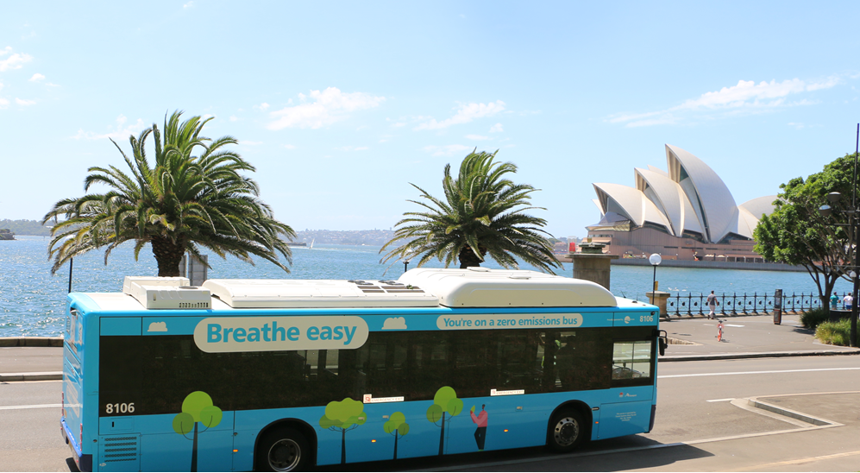
- Key new Transport projects commencing in 2022-23 included in this Budget:
Project | Investment
Digital Systems Tranche 2  Conditional funding to deliver planning and enabling works on the next generation signalling and train control system to replace the conventional signalling assets that are approaching life expiry on the busiest parts of the rail network, covering the North Shore, City Circle, City Area and Sydney Terminal. See Box 2.20. | $660.6 million (over next four years)  $108.2 million (2022-23)
Opal Next Generation Ticketing System  Conditional funding to deliver the next generation of Opal ticketing system that is essential to enable the aging core Opal system and ticketing infrastructure to be replaced. The investment will benefit customers by delivering a connected and personalised 'plan, book and pay' experience across public and private modes of transport throughout Greater Sydney and outer Metro. It is also an enabler for delivering an integrated and consistent ticketing experience for customers in regional New South Wales. | $568.7 million (over next three years)  $159.1 million (2022-23)
Parramatta Light Rail Stage 2  Commencing the detailed planning process and early enabling works for the delivery of a new bridge crossing the Parramatta River between Wentworth Point and Melrose Park as part of the next stage of the Parramatta Light Rail project. This crossing will better connect people on either side of the river, improving access to jobs, educational opportunities, and services. See Box 2.21. | $372.5 million (over next four years)  $26.2 million (2022-23)*  *$602.4 million has been reserved for the first phase of the project
Mona Vale Road, McCarrs Creek Road to Powder Works Road  Upgrading and widening about 3.4 kilometres of Mona Vale Road between McCarrs Creek Road, Terrey Hills, and Powder Works Road, Ingleside, from a two-lane undivided road to a four lane (two lanes in each direction) divided road. | $340.0 million (over next four years)  $25.0 million (2022-23)
Mulgoa Road – Blaikie Road to Union Road Stages 5A and 5B  Widening approximately 2.2 kilometres of Mulgoa Road between Blaikie Road to Union Road from an undivided four lane carriageway to a divided six lane carriageway with medians and active transport facilities. The expected benefits of this NSW and Commonwealth Government funded project are reduced congestion and improved road safety, travel times, efficiency and network reliability. This project is also part of the Western Sydney Growth Roads Program. See box 2.22. | $266.0 million (over next four years)  $1.7 million (2022-23)
Zero Emissions Buses Program  Funding to develop a Final Business Case and commence delivery of enabling works and transitioning to a low-emission bus fleet to allow quiet and environmentally friendly travel services for Sydney commuters, a sustainable and clean economy, and stimulate local manufacturing. See Box 2.19. | $ 218.9 million (over next seven years)  $197.8 million (over next four years)  $114.0 million (2022-23)
Wakehurst Parkway  Funding for safety and capacity improvements to Wakehurst Parkway (NSW and Commonwealth Government funded). | $150.0 million (over next three years)  $40.0 million (2022-23)
Epping Station Bridge Widening  Upgrading the Epping Station Bridge to provide additional road capacity and improve road safety. Accessibility to the Epping Town Centre will be improved by providing a new active transport link and improving general traffic movements within the area. | $123.7 million (over next four years)  $11.5 million (2022-23)
Sydney Metro - Western Sydney Airport Stage 2 (Planning)  Funding for developing a final business case for a south-eastern extension of the Sydney Metro Western Sydney Airport project from the current southern terminus at Aerotropolis to Glenfield (NSW and Commonwealth Government funded). | $60.0 million (over next two years)*  $40.0 million (2022-23)*  *Excludes $95 million reserved for potential Hardship Property Acquisitions on the corridor.
New Line Road over Pyes Creek  Investigating options to upgrade New Line Road over Pyes Creek to ease congestion and allow for better traffic flow, improved safety and travel times for the growing population of Sydney's northwest. | $34.4 million (over next four years)  $2.2 million (2022-23)
Third Flagpole on Sydney Harbour Bridge  Providing a third flagpole at the top of the Sydney Harbour Bridge for the permanent flying of the Aboriginal flag. The permanency of the Aboriginal flag on the Sydney Harbour Bridge is an acknowledgement of the traditional custodians of the land; acknowledges Aboriginal people and their traditions and culture; and stimulates conversations that allow us to highlight Aboriginal people and communities, and be educated about their rich history and continued connection to Country. | $25.0 million (2022-23)
Sutherland to Cronulla Active Transport Link (SCATL) Horizon 3  Delivering the final stage of the SCATL to improve connections and increase road safety for active transport users between Sutherland and Cronulla, as well as links to key attractors along the corridor. The project will provide more direct active transport dedicated paths and safe separation for both riders and walkers between activity hubs, key destinations, schools, employment, and local attractions. | $24.0 million (over next three years)  $2.0 million (2022-23)
Sydney Harbour Bridge Northern Cycle Ramp  Upgrading the Northern Cycle Ramp project which will improve accessibility and safety for bike riders by avoiding the cycleway steps at the northern end of the Sydney Harbour Bridge and improve pedestrian safety by removing conflicts with bike riders at Milsons Point. | $21.2 million (over next two years)  $16.2 million (2022-23)

Digital Systems Tranche 2
The Digital Systems Program is the next generation signalling and train control system for Sydney’s suburban rail network and critical components of the intercity rail network. Conditional funding has been approved to allow for replacing the conventional signalling assets that are approaching end of life, as well as modernising train control operations with the globally recognised European Train Control System. The Tranche 2 would roll out Digital Systems to the busiest and most critical parts of the rail network, which is the North Shore, City Circle, City Area and Sydney Terminal.
Once fully deployed, the Program would improve operational performance of the network through reduction in network incidents accountable to signalling equipment functioning, which would increase reliability on routes where approximately 90 per cent of the suburban services operate. It would provide saving in journey times and improve network reliability to meet customer expectations for predictable on time running.
- What is Digital Systems?
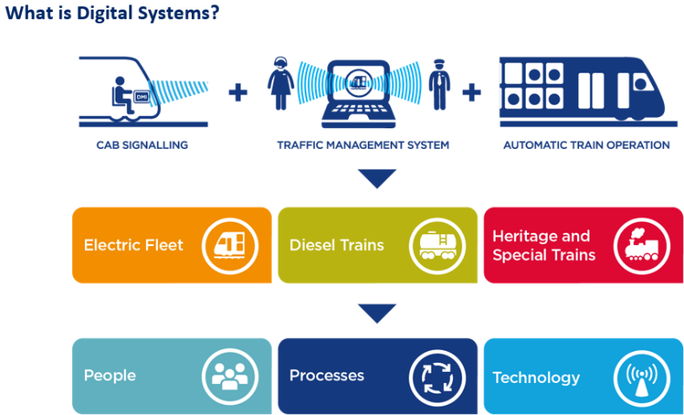
Parramatta Light Rail Stage 2
The NSW Government has committed $602.4 million to proceed with Parramatta Light Rail Stage 2 and commence the detailed planning process to move ahead with the Western Sydney megaproject.
The funding will go towards early works and building the vital bridge connection across the Parramatta River between Wentworth Point to Melrose Park.
Planning and development work is continuing, including utilities and geotechnical investigations across the alignment, as well as progressing the development of the project’s Environmental Impact Statement, which will be released for public comment.
- Parramatta Light Rail Stage 2
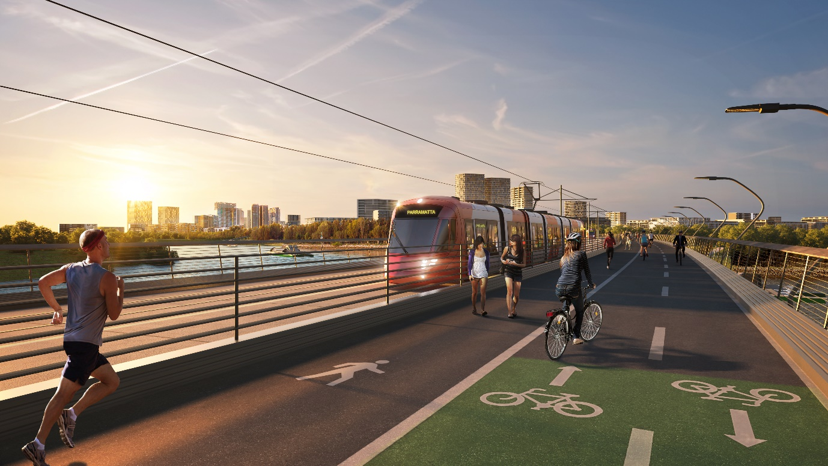
Artist impression of proposed light rail and active transport bridge connecting Wentworth Point and Melrose Park.
- Key State-wide Transport projects continuing in this Budget:
Project | Investment
Road Safety investment  Continuing the Government’s commitment to the Road Safety Action Plan to fund targeted and proven initiatives to improve road safety in New South Wales. The Towards Zero campaign and Commonwealth funded Road Safety works stimulus will build on existing investment in thousands of kilometres of audio-tactile line markings, wide centre lines, crash barriers in regional NSW and other life-saving infrastructure across the State. | $838.4 million (over next four years)  $421.5 million (2022-23)
New Buses to cater for NSW Services  Funding to procure new fleet to cater for bus services across the State and deliver reliable services. | $767.1 million (over next four years)  $127.7 million (2022-23)
Pinch Points  Continuing NSW and Commonwealth Government funded investment in small scale traffic improvements that provide big benefits to residents, including reduced congestion and travel times. It includes programs such as Gateway to the South, Clearways, and Hunter Pinch Points. | $356.9 million (over next four years)  $115.6 million (2022-23)
Commuter Car Parking Program  Continuing the NSW and Commonwealth Government funded program of an integrated and accessible transport system to enable more convenient access to public transport infrastructure and ease congestion on roads. More than 12,000 commuter car spaces have already been delivered across Sydney since 2011, with works continuing. | $351.6 million (over next four years)  $140.2 million (2022-23)
Transport Access Program  Continuing the upgrade of train stations including Redfern, Tuggerah, Waitara, Stanmore, Doonside, Unanderra, Killara, Blackheath, Denistone and Turrella to make them more accessible through the installation of new lifts, ramps and footbridges. | $342.4 million (over next four years)  $240.2 million (2022-23)
Maritime Program  Upgrading ferry wharves at Darling Point, Double Bay and Greenwich Point to improve accessibility in addition to the ongoing maintenance and upgrades to various regional maritime assets, including Eden Wave Attenuator, Coffs Harbour Boat Ramp and replacement of the Crowdy Head Jetty and Narooma Wharf. | $110.8 million (over next four years)  $83.3 million (2022-23)
Active Transport  Delivering projects that expand connected cycleway networks, which increase opportunities for walking in and around connected centres and provide the community with options for moving around neighbourhoods. Active Transport projects encourage more people to choose walking and cycling as a mode of transport. | $60.0 million (over next four years)*  $20.3 million (2022-23)*  *Excludes SCATL Horizon 3 and Sydney Harbour Bridge Northern Cycle Ramp which are separately featured in Table 2.14
- Key Sydney Metropolitan Transport projects continuing in this Budget:
Project | Investment
Sydney Metro West  Delivering a new underground driverless Metro line connecting Greater Parramatta with the Sydney CBD in around 20 minutes. The line will include new metro stations at Westmead, Parramatta, Sydney Olympic Park, North Strathfield, Burwood North, Five Dock, The Bays, Pyrmont and Hunter Street in the Sydney CBD linking communities to rail services. | $12.4 billion (over next four years)  $3.2 billion (2022-23)
Sydney Metro – Western Sydney Airport  Delivering six new Metro stations to service the future Western Sydney International (Nancy-Bird Walton) Airport and the Western Sydney Aerotropolis, interchanging with the T1 Western Line at St Marys (NSW and Commonwealth Government funded). | $8.4 billion (over next four years)  $1.7 billion (2022-23)
Sydney Metro City and Southwest  Delivering an extension of Sydney Metro Northwest from Chatswood, under Sydney Harbour, through new CBD stations and southwest to Bankstown. The line will include new Metro stations at Crows Nest, Victoria Cross (North Sydney), Barangaroo, Pitt Street and Waterloo, new underground Metro platforms at Martin Place and Central stations and 11 upgraded stations between Sydenham and Bankstown. | $5.1 billion (over next four years)  $3.1 billion (2022-23)
Western Harbour Tunnel Upgrade and Beaches Link Planning  Commencing a major construction activity for the Western Harbour Tunnel to deliver the first stage of tunnelling works for a new crossing of the Sydney Harbour. The first package will include construction of around 1.7 kilometres of mainline tunnels from Rozelle to Birchgrove. | $4.1 billion (over next four years)  $558.5 million (2022-23)
M6 Extension Stage 1  Continuing the extension works which will, on completion, remove more than 2,000 trucks a day from surface roads, enable motorists to bypass up to 23 sets of traffic lights on the Princes Highway and enhance pedestrian and cyclist safety through shared pathways. | $2.3 billion (over next four years)  $804.3 million (2022-23)
More Trains, More Services  Continuing the program to simplify and modernise the rail network and integrate Sydney Metro City and Southwest with Sydney’s train network. Customers can expect more frequent train services with less wait times and reduced crowding including additional services on the Illawarra, Airport and South Coast line. | $2.2 billion (over next four years)  $776.3 million (2022-23)
Warringah Freeway Upgrade  Continuing upgrades of the Warringah Freeway for surface roads, bridges and interchanges along about four kilometres of the freeway corridor, which started in early 2022. | $1.7 billion (over next four years)  $445.5 million (2022-23)
Sydney Gateway  Expanding and improving the existing road and freight rail networks to provide a new route for around 10,000 trucks a day. This will divert trucks from local streets in Mascot by providing an alternate route, thereby reducing travel times and congestion, and returning local streets back to the community. | $1.4 billion (over next three years)  $680.5 million (2022-23)
WestConnex  Completing the M4-M5 link tunnels and continuing construction and delivery of Rozelle Interchange. See Box 2.22. | $1.2 billion (over next four years)  $866.1 million (2022-23)
The M12 Motorway  Supporting the Western Sydney International Airport (Nancy-Bird Walton), a part of the Western Sydney Infrastructure Plan. The NSW and Commonwealth Government funded project provides direct access to the airport, running east to west, linking the M7 Motorway and The Northern Road. It will also improve the movement of freight in and through western Sydney. See Box 2.22. | $1.2 billion (over next four years)  $205.6 million (2022-23)
Western Sydney Growth Roads Program  Accommodating population and employment growth in Western Sydney. Key projects include (See Box 2.22.):  - Mulgoa Road Stage 1 – Blaikie Road to M4 Motorway  - Mulgoa Road Stage 2 – Glenmore Parkway to Jeanette Street (NSW and Commonwealth Government funded)  - The Horsley Drive, M7 motorway to Cowpasture Road (NSW and Commonwealth Government funded)  - Appin Road Improvements (Commonwealth funded)  - Spring Farm Parkway Stage 1, and  - Western Sydney Long Term Strategic Transport Corridor Preservation. | $866.0 million (over next four years)  $156.5 million (2022-23)  *Excludes Mulgoa Road Stage 5A and 5B which is separately featured in Table 2.14.
Blackwattle Bay Urban Renewal including the New Sydney Fish Market  Ongoing delivery of the new Sydney Fish Market due for completion in 2024, as well as continuing planning work for the urban renewal of Blackwattle Bay, a rare opportunity for new housing, employment and harbourfront community spaces located less than 1 kilometre from the Sydney CBD. | $652.4 million (over next four years)  $307.9 million (2022-23)
Parramatta Light Rail Stage 1  Continuing construction of the Light Rail, from Westmead to Carlingford via the Parramatta CBD and Camellia with a 12-kilometre two-way track, to support growth in Western Sydney, connecting new communities and places. The Light Rail will open in 2023 servicing 28,000 people every day and an estimated 130,000 people will be living within walking distance of light rail stops. | $308.0 million (over next two years)  $236.0 million (2022-23)
New Hawkesbury River crossing at Richmond  Providing a new bridge over the Hawkesbury River between Richmond and North Richmond through a joint NSW and Commonwealth Government funded initiative. The project will deliver journey time reliability, safer connections along the road corridor and improve flood resilience. | $250.3 million (over next four years)  $10.8 million (2022-23)
Prospect Highway, Reservoir Road to St Martins Crescent  Upgrading a 3.6-kilometre section of the Prospect Highway between Reservoir Road, Prospect and St Martins Crescent, Blacktown to a four-lane divided carriageway with funding provided by the NSW and Commonwealth Government. The section north of Lancelot Street will be upgraded to a six-lane divided road, inclusive of two dedicated bus lanes, and improvements to 11 intersections along the route. The benefits include improved road safety for all road users, reduced congestion leading to improved travel times and increased network efficiency. See Box 2.22. | $243.1 million (over next three years)  $74.0 million (2022-23)
M5 Motorway, Moorebank Avenue and Hume Highway Intersection Upgrade  Delivering the NSW and Commonwealth Government funded M5 Westbound Traffic Upgrade which will provide a new two-lane bridge over Georges River and rail line, and a new underpass at Moorebank Avenue. These upgrades will deliver reduced congestion, improved travel times and accessibility and connectivity of road networks. See Box 2.22. | $223.0 million (over next four years)  $2.6 million (2022-23)
Mamre Road, M4 Motorway to Erskine Park Road  Widening approximately 3.8 kilometres of Mamre Road from a two-lane undivided road to a four-lane divided road, with provision for two additional lanes in the future, between the M4 Motorway and Erskine Park Road, to provide a safer higher capacity link. This project is also part of the Western Sydney Growth Roads Program. See  Box 2.22. | $221.8 million (over next four years)  $24.0 million (2022-23)
Circular Quay Precinct Renewal (Planning)  Refining the pre-concept design options including renewal of aging wharves, and delivery of significant redevelopment of Circular Quay to improve accessibility, revitalise arts and cultural offerings and refresh retail and dining experience. See  Box 2.23. | $216.4 million (over next three years)  $26.7 million (2022-23)
King Georges Road, Stoney Creek Road to Connells Point Road  Widening King Georges Road from two lanes to three lanes in each direction and constructing a dedicated right turning lane for south bound motorists turning into Percival Street will benefit 43,000 motorists by reducing congestion, improving travel times, and boosting safety for all users (NSW and Commonwealth Government funded). | $144.2 million (over next four years)  $30.2 million (2022-23)
Heathcote Road, Infantry Parade Hammondville to the Avenue, Voyager Point  Widening and upgrading a 2.2-kilometre section of Heathcote Road between Infantry Parade and The Avenue to a four-lane divided road, and upgrading intersections at Heathcote Road and The Avenue and Heathcote Road and Macarthur Drive. The NSW and Commonwealth Government funded project also duplicates the existing bridges at Harris Creek, Williams Creek and over the railway line, as well as providing active transport connections along Heathcote Road. | $141.3 million (over next four years)  $45.7 million (2022-23)
Memorial Avenue, Old Windsor Road to Windsor Road  Upgrading Memorial Avenue to a four-lane road to meet the future transport demands of Sydney’s north-west, reducing travel times and congestion for motorists and improving safety as part of the Western Sydney Growth Roads Program. See Box 2.22. | $122.3 million (over next four years)  $37.9 million (2022-23)
Smart Motorways  Utilising complementary technologies to monitor traffic conditions, manage congestion and respond to incidents in real time upgrading the Sydney motorway network from the ANZAC Bridge in Pyrmont to the Warringah Freeway. The NSW and Commonwealth Governments funded project would see reduced congestion and improved road safety, travel times, efficiency and network reliability. | $111.5 million (over next two years)  $66.0 million (2022-23)
Henry Lawson Drive Upgrade  Widening between Tower Road, Georges Hall and Auld Avenue, Milperra (Stage 1) to double capacity and reduce congestion and to continue the development of Stage 2 between Keys Parade and the M5 Motorway. See Box 2.22. | $107.5 million (over next four years)  $17.2 million (2022-23)
Barangaroo Precinct  Continuing the transformation of the Barangaroo precinct including the delivery of a 1.85 hectare public park on Sydney’s Harbour, the fit-out of the Cutaway, a new public Pavilion and other capital projects to enhance local amenity, along with ongoing sustainability, art and culture initiatives. | $97.7 million (over next four years)  $32.8 million (2022-23)
Homebush Bay Drive  Upgrading the intersection of Homebush Bay Drive, Australia Avenue and Underwood Road. The NSW and Commonwealth Government funded project will ease congestion, increase safety, and improve travel times to Homebush and Sydney Olympic Park. | $97.0 million (over next four years)  $2.7 million (2022-23)
Macquarie University Station Transport Interchange  Upgrading a bus interchange, to increase capacity, improve bus customers’ connection to the Macquarie University Metro Station and optimise bus operations which will reduce travel times and delays (NSW and Commonwealth Government funded project). | $91.6 million (over next four years)  $6.8 million (2022-23)
Heathcote Road, Woronora River Bridge  Duplicating Heathcote Road Bridge with a new bridge parallel to the existing bridge. This would separate traffic flows providing safety benefits and allow for safer passing of broken-down vehicles along this section. | $62.1 million (over next four years)  $26.7 million (2022-23)
Kamay Ferry Wharves  Reinstating multi-user wharves at La Perouse and Kurnell to accommodate passenger ferries and other vessels. It will provide better access to the Kurnell Precinct through public transport and active transport allowing for greatly improved physical and cultural links. The project will also improve access and facilities for recreational vessels and fishing. It will create investment opportunities leading to the creation of jobs and wider economic benefits. | $49.3 million (over next three years)  $6.8 million (2022-23)
Heathcote Road – The Avenue to the Princes Highway (Planning)  Continuing planning and development for the duplication of approximately 18 kilometres of Heathcote Road between The Avenue at Voyager Point and Princes Highway at Engadine funded by NSW and Commonwealth Government. The upgrade will increase capacity and create a safer environment. | $39.8 million (over next four years)  $6.5 million (2022-23)

Western Sydney Roads Program
To respond to the planned growth of Western Sydney, the NSW Government is investing in a significant roads program. These investments will:
- meet future demand associated with the forecasted population and employment in the region
- reduce transport costs by improving travel times and reducing congestion
- improve liveability and sustainability for local road users and residents
- support economic growth and productivity by providing road capacity for projected freight and general traffic volumes
- improve road safety in line with the NSW Road Safety Strategy, and
- promote sustainable transport networks by providing facilities for walking and cycling and possible future public transport needs.
One of the key projects connecting Western Sydney both for passengers and freight is WestConnex which is nearing completion with significant ongoing investment in the M4-M5 Link Tunnels and Rozelle Interchange.
Other significant investments on key roads in Western Sydney include the following projects:
- M12 Motorway to provide a motorway connection between the new Western Sydney Airport at Badgerys Creek and the rest of the motorway network
- WestConnex – M4-M5 Link Tunnels and Rozelle Interchange
- Mulgoa Road between Glenmore Parkway and Union Road, Penrith
- Mamre Road between M4 Motorway and Erskine Park Road
- The Horsley Drive, M7 to Cowpasture Road
- Appin Road Improvements
- Spring Farm Parkway Stage 1
- Prospect Highway, Reservoir Road to St Martins Crescent
- Richmond Road Stage 1 – Elara Boulevard to Heritage Road, Marsden Park
- M5 Motorway, Moorebank Avenue and Hume Highway Intersection Upgrade
- Memorial Avenue, Old Windsor Road to Windsor Road
- New Richmond Bridge
- Henry Lawson Drive Upgrade, and
- Western Sydney Long Term Strategic Corridor Preservation.
- Western Sydney Roads Program
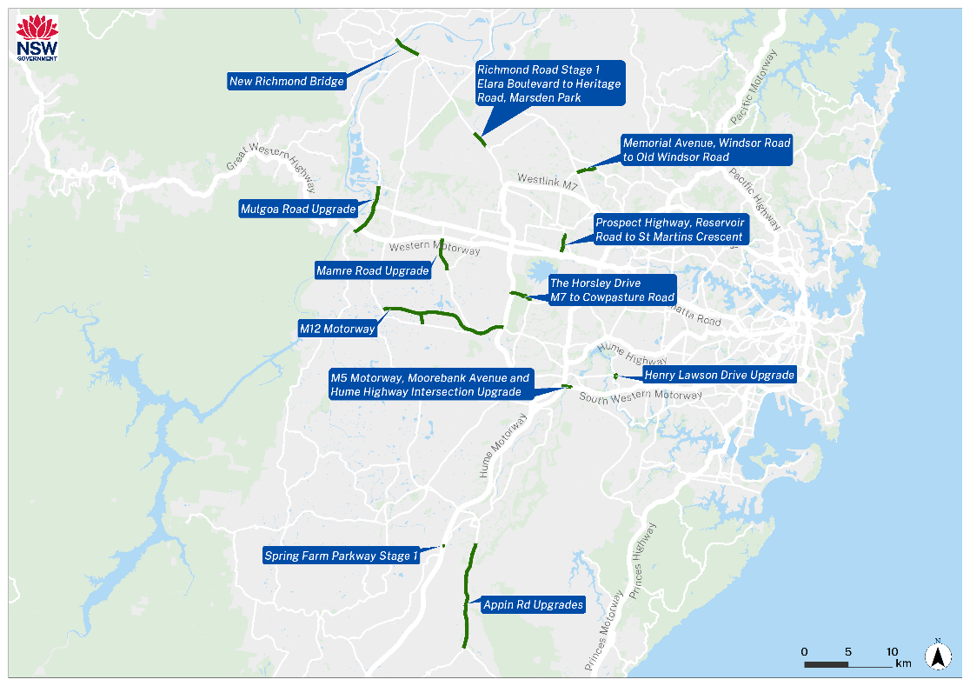

Circular Quay Precinct Renewal
Circular Quay Renewal, currently in planning and development, would bring Australia’s ‘Waterfront to the World’ back to life through the most significant redevelopment of the area since the re-construction of the wharves in the 1940’s. The Budget has committed $216.4 million towards refining the pre-concept design options. One of the project options includes renewing the ageing wharves and train station, ensuring accessibility to everyone, and delivering a world-class customer experience. The renewal aims to revitalise Circular Quay's arts and cultural offerings, by showcasing Australia’s Aboriginal, and non-Aboriginal history. It would provide a refreshed retail and dining experience for one of Australia’s most iconic destinations. The project would be a catalyst for further investment in Sydney, whilst rejuvenating the city landscape to enliven Australia’s global city.
Circular Quay is a critical transport interchange in the heart of Sydney, and the only interchange in Australia where ferry, light rail, heavy rail, bus, taxi and active transport converge. It is home to Sydney’s busiest ferry hub, one of Sydney’s most important train stations and Australia’s main overseas cruise ship terminal.
- Circular Quay Precinct Renewal
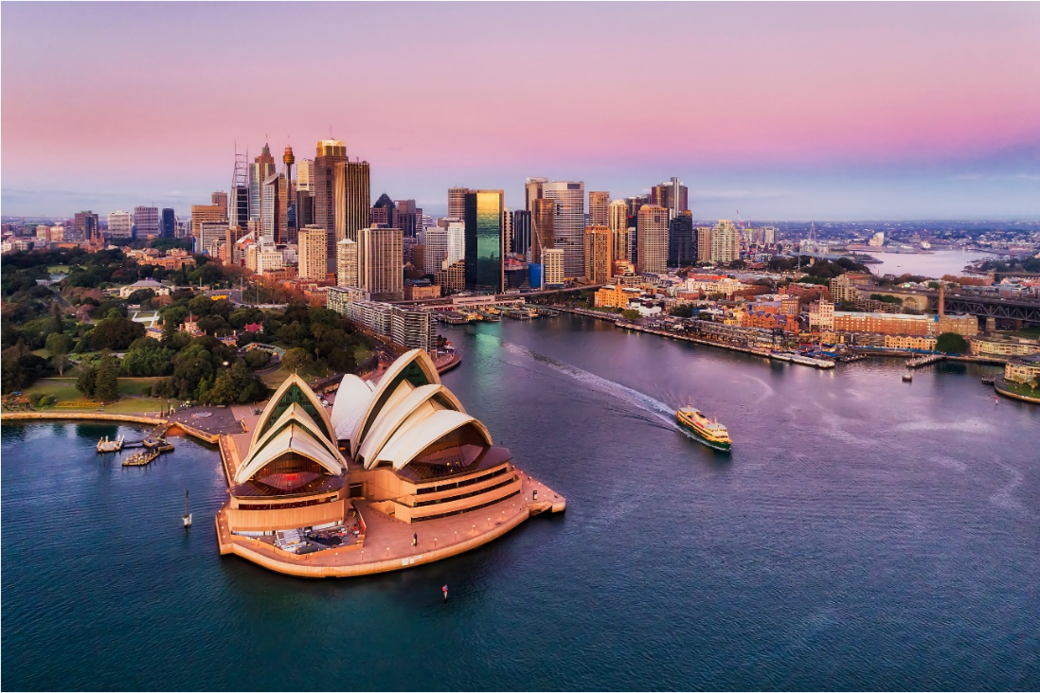

- Key Regional and Outer Metro Transport projects continuing in this Budget:
Project | Investment
Great Western Highway Upgrade  Duplicating the Great Western Highway between Katoomba and Lithgow (Katoomba to Blackheath and Little Hartley to Lithgow), as a joint NSW and Commonwealth Government project.In addition, State funding is being applied for planning to duplicate the Central Section between Blackhealth to Little Hartley. The project will reduce congestion and deliver safer, more efficient and reliable journeys through the Blue Mountains and better connect communities in the Central West. Construction of the $45 million upgrade from Kelso to Raglan will continue. | $3.2 billion (over next four years)  $163.2 million (2022-23)
Princes Highway – Jervis Bay to the Victorian border  Continuing the transformation of the Princes Highway from south of Nowra to the Victorian border with ongoing planning, as well as NSW and Commonwealth Government providing funding for priority projects including:  - Jervis Bay Road Intersection  - Jervis Bay to Sussex Inlet Upgrade  - Milton-Ulladulla Bypass to improve safety, journey times and freight efficiency  - Nowra to Moruya (Planning). | $1.9 billion (over next four years)  $52.5 million (2022-23)
Coffs Harbour Bypass  Continuing the NSW Government and Commonwealth Government funded Pacific Highway upgrade program, to improve connectivity, road transport efficiency and safety for local and interstate motorists. | $1.4 billion (over next four years)  $245.9 million (2022-23)
Pacific Motorway (M1) to Raymond Terrace  Continuing planning of the NSW Government and Commonwealth Government funded upgrade to connect the M1 Pacific Motorway and the Pacific Highway, including commencing early works construction on the widening of Hexham Straight to improve traffic flow and travel time and safety for all road users. | $1.4 billion (over next four years)  $117.9 million (2022-23)
Newell Highway  Continuing the NSW Government and Commonwealth Government funded works for delivery of 40 new overtaking lanes, Parkes bypass, new Dubbo Bridge, heavy duty pavement upgrades, flood mitigation works (State funded) and minor works along the corridor. See Box 2.25. | $885.1 million (over next four years)  $308.3 million (2022-23)
Regional Rail Fleet  Delivering a modern new Regional Rail Fleet to replace the ageing XPT, XPLORER and Endeavour trains and improve travel. Construction of a purpose-built maintenance facility in Dubbo. | $835.6 million (over next three years)  $399.1 million (2022-23)
Mariyung Fleet (New Intercity Fleet)  Delivering a new, state-of-the-art fleet and associated power supply upgrades to provide a new level of comfort and convenience and improve accessibility and safety for customers who travel between Sydney, the Central Coast and Newcastle, the Blue Mountains and the South Coast. | $652.2 million (over next three years)  $296.8 million (2022-23)
New England Highway  Continuing construction on the Belford to Golden Highway duplication, as well as NSW Government and Commonwealth Government funded improvements for early works construction on a bypass for Singleton to improve traffic flow, travel times and safety for motorists. | $457.4 million (over next four years)  $65.0 million (2022-23)
Newcastle Inner City Bypass from Rankin Park to Jesmond  Commencing construction on the NSW and Commonwealth Government funded final stage of the Newcastle Inner City Bypass between the Pacific Highway at Bennetts Green and the final stage of the Pacific Highway at Sandgate. The Bypass provides improved traffic flows across the western suburbs of Newcastle and connectivity to Bennetts Green, Charlestown and Jesmond shopping centres, the John Hunter Hospital precinct at New Lambton Heights and the University of Newcastle at Callaghan with connections to the Pacific Highway. | $318.6 million (over next four years)  $37.8 million (2022-23)
Mt Ousley Interchange  Continuing planning and constructing the interchange to replace the existing intersection of the M1 Princes Motorway and Mount Ousley Road at the base of Mount Ousley (NSW and Commonwealth Government funded). | $286.7 million (over next four years)  $13.9 million (2022-23)
Fast Rail Program  Continuing detailed planning and commence early works of the Fast Rail Network including initial stages on the Northern Corridor to deliver fast, frequent and reliable connections between Sydney, the Central Coast and Newcastle in collaboration with the Australian Government. | $274.5 million (over next four years)  $95.0 million (2022-23)
Muswellbrook Bypass, New England Highway (State and Federal)  Commencing early works construction for the Muswellbrook bypass to improve travel times for long-haul freight movements, and safety for all road users on the New England Highway. | $265.8 million (over next four years)  $14.2 million (2022-23)
Central Coast Roads  Continuing planning and delivery of road projects in the Central Coast area including:  - Pacific Highway, Parsons Road to Ourimbah Street, Lisarow  - Pacific Highway, Wyong Town Centre (NSW and Commonwealth Government funded) See Box 2.24  - Central Coast Highway, Tumbi Road Intersection Upgrade for the construction of the fast-tracked intersection at Tumbi Road (NSW Government and Commonwealth funded). | $238.8 million (over next four years)  $52.0 million (2022-23)
Princes Highway  Continuing upgrades of the Princes Highway, including construction on South Batemans Bay Link Road, and on the NSW Government and Commonwealth Government funded new Nowra Bridge. | $167.0 million (over next four years)  $100.8 million (2022-23)
Nelson Bay Road Upgrade  Upgrading Nelson Bay Road to duplicate the road from Williamtown to Bobs Farm, including commencing work on a one-kilometre section of the existing road from Salt Ash to Bobs Farm. | $156.3 million (over next four years)  $13.9 million (2022-23)
Barton Highway  Continuing improvements on the NSW Government and Commonwealth Government funded Barton Highway duplication. This work will improve road safety while enhancing tourism, driving economic growth and creating vibrant regional spaces. | $124.0 million (over next four years)  $24.2 million (2022-23)
Picton Road Upgrade  Planning the upgrade of Picton Road to improve safety and connectivity as a key link for the Illawarra Region, South Coast, Sydney, Canberra and Melbourne (NSW and Commonwealth funded). | $119.5 million (over next four years)  $39.1 million (2022-23)
Main Western Rail Line Capacity Enhancements  Continuing the project including new passing loops to improve the efficiency and capacity of the Main West Rail Line for passenger and freight services. | $102.4 million (over next four years)  $27.4 million (2022-23)
Fixing Country Rail Program  Providing improved capacity, access, efficiency and reliability of the regional rail network, as well as delivering a highly functional transport network for moving freight in an out of regional areas. | $58.2 million (over next two years)  $42.5 million (2022-23)
Waterfall Way Upgrade (planning)  Upgrading sections of Waterfall Way to improve safety, reliability, travel times, and addressing safety for pedestrians and traffic in the Dorrigo town centre. | $39.3 million (over next three years)  $14.8 million (2022-23)
Hume Highway  Continuing to replace sections of the existing concrete pavement surface on the Hume Highway at Marulan to improve driving conditions with a flexible pavement with a thick asphalt surface which improves road safety and freight productivity. | $27.1 million (over next two years)  $16.6 million (2022-23)
Golden Highway  Continuing the NSW and Commonwealth Government funded Golden Highway safety, to widen flood alleviation works, as well as finalising rest area initiatives to increase heavy vehicle safety and productivity. | $21.4 million (over next three years)  $9.7 million (2022-23)

Pacific Highway Wyong Town Centre
Pacific Highway is the main route through the Wyong Town Centre and is a major urban arterial road connecting the northern suburbs of the Central Coast. The Commonwealth and NSW Governments are investing $420 million to upgrade the Pacific Highway through the Wyong Town Centre.
This upgrade will duplicate the Pacific Highway to two lanes in each direction between Johnson Road and Cutler Drive at Wyong, and replace the Wyong River Road bridge with two new road bridges.
It will also integrate the rail interchange with bus services, taxi services and disabled and short-term parking, provide new signalised intersections at Rose Street, Anzac Avenue, North Road and Cutler Drive, and upgrade the existing intersection at Church Street, and replace the Rose Street rail bridge.
The upgrade will:
- improve safety for all road users, including cyclists and pedestrians
- improve traffic flow to provide reliable road access to and through Wyong town centre
- provide a road environment that maintains as far as practicable the town’s identity while providing opportunities for future revitalisation and growth
- ensure the highway upgrade is compatible with current and future public transport services, and
- provide improved facilities for pedestrians and cyclists.
- Pacific Highway Upgrade through Wyong
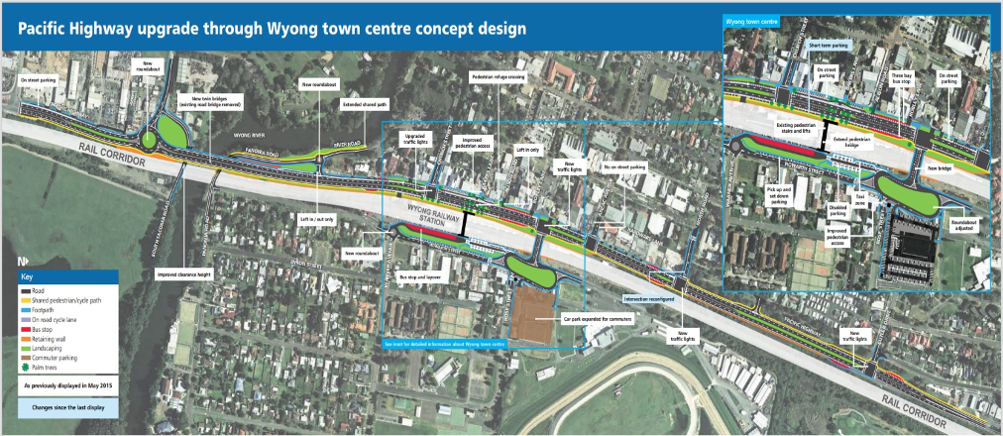
Newell Highway
At over 1,060 kilometres in length, the Newell Highway is the longest highway in New South Wales. It connects the Victorian border at Tocumwal to the Queensland border at Goondiwindi.
The NSW Government is carrying out upgrade works to the Newell Highway. The upgrade program covers a wide range of projects, including infrastructure upgrades and new builds, pavement upgrades, new overtaking lanes and safety upgrades. The $1.7 billion investment, including a $1.0 billion commitment from the Commonwealth Government, will benefit the community through:
- reducing average travel times for freight operators, particularly those running end to end
- increasing usage in the Newell Highway by Performance Based Standards (PBS) 3A heavy vehicles (a national heavy vehicle scheme designed to offer the heavy vehicle industry the potential to achieve higher productivity and safety through innovative and optimised vehicle design)
- increasing the number of end-to-end journeys by freight operators
- reducing the proportion of traffic spending time following other vehicles
- maintaining the Newell Highway safety performance at or above current levels
- reducing the travel time lost to flood events, and
- reducing asset maintenance costs between Narrabri and Boggabilla
Investments on the Newell Highway upgrade include the following projects:
- Trewilga Realignment (completed)
- Intersection upgrade on the Newell and Mitchell Highway at Dubbo (completed)
- Construction of a New Dubbo Bridge over the Macquarie River (due to commence in December 2022)
- Construction of the Parkes Bypass (currently in delivery, to be completed by December 2024)
- Heavy Duty Pavement works at Mungleback (completed), Narrabri to Moree (due to commence September 2022) and North Moree (to commence in late 2023)
- Shoulder widening near Coonabarabran in the Pilliga
- Planning for a Coonabarabran bypass
- Construction of about 40 overtaking lanes along the length of the Newell Highway, and
- Planning to flood proof the Newell Highway between Forbes and West Wyalong.
- Newell Highway
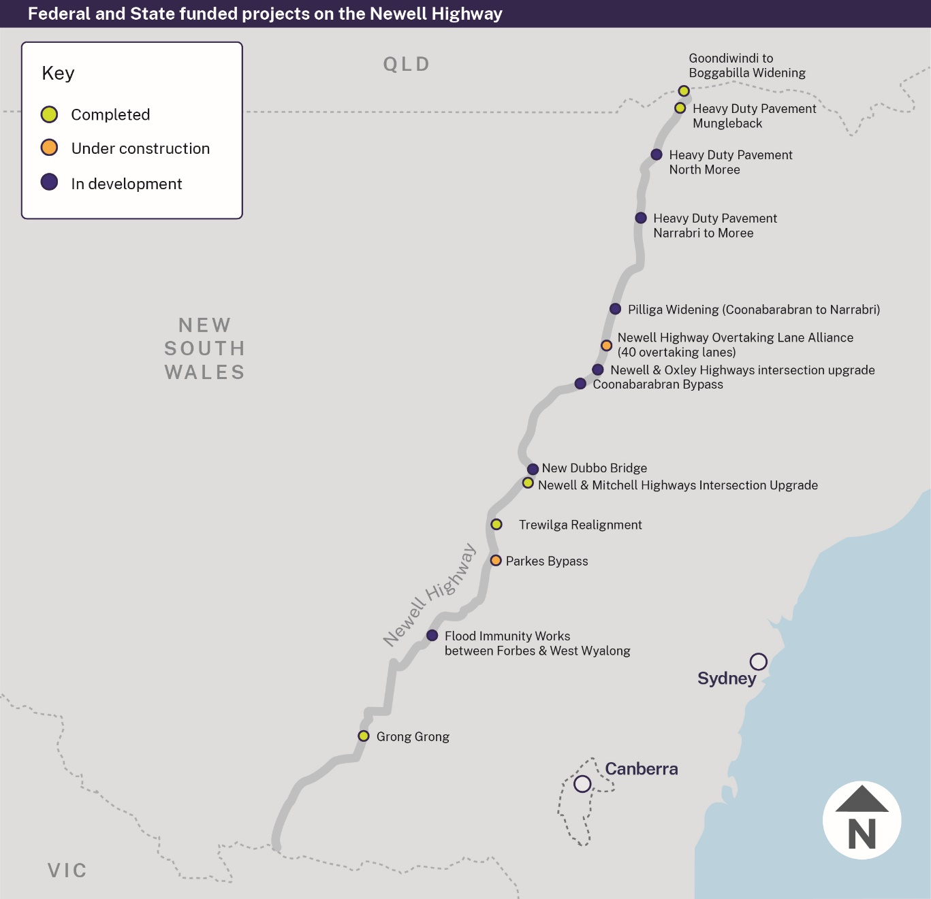

Pages 5-47 to 5-54 of Chapter 5 of this Infrastructure Statement lists the major capital projects and minor works for Transport and Infrastructure cluster, including the ETC, expenditure to 30 June 2022, and 2022-23 allocation. Chapter 6 lists the major capital projects and minor works for the PNFC program for the transport agencies referred to above.

Treasury
$1.9 billion | Capital Expenditure to 2025-26
$384.0 million | Capital  Expenditure  2022-23
The Treasury infrastructure program now predominantly includes the program of the Office of Energy and Climate change (OECC) including the Energy Corporation of NSW.
This program is mainly focussed on delivering on the Electricity Infrastructure Roadmap. The Roadmap will guide the transition of New South Wales to renewable energy over the next decade, principally by supporting Renewable Energy Zones located in regional New South Wales. The program also includes investment to support Treasury’s economic and financial management responsibilities.
- Key new Treasury projects commencing in 2022-23 included in this Budget:
Project | Investment
Transmission Acceleration Facility  The Facility will help to fast-track critical energy infrastructure to deliver lower cost and more reliable energy for all NSW consumers. While the precise projects will be designed and developed over time, the Facility is estimated to accelerate at least $14 billion in private transmission infrastructure investment. Development funding supported by the Facility is intended to be recovered from private investors thereby replenishing the Facility to support further projects until final repayment in 2040. Over the next ten years, a total of $2.6 billion in capital and $425 million in expenses to fund transmission is planned, with a maximum impact on net debt of $1.2 billion after taking account of the progressive repayment of proceeds. | $2.6 billion (ETC)  $1.2 billion net (maximum, after proceeds)

Electricity Infrastructure Roadmap
The NSW Government’s Electricity Infrastructure Roadmap is the largest renewable energy policy in Australia’s history. The Roadmap will support economic growth, lay the foundation for a globally competitive economy and assist the State in meeting its net zero commitment by 2050 and 2030 target.
The Roadmap ensures households and businesses will have access to affordable, reliable and sustainable energy as it delivers new infrastructure. The 2022-23 Budget provides additional funding to support the Roadmap, including the establishment of the Transmission Acceleration Facility. The Facility will fund development activities which are estimated to accelerate billions in private investment in critical energy infrastructure.

- Key Treasury projects continuing in this Budget:
Project | Investment
Climate Change Fund Net Zero Projects  Projects supported by the Climate Change Fund to adapt to climate change. | $13.2 million (ETC)
Electricity Infrastructure Roadmap (capital component)  Part of the Government’s plan to attract up to $32.0 billion in private investment in new generation, storage, firming and network infrastructure by 2030 to modernise the NSW electricity sector and establish transmission in Renewable Energy Zones. | $164.2 million (ETC)
Zero and Low Emission Vehicle Reform Project  Transition of the State vehicle fleet to zero and low emission vehicles. | $264.5 million (ETC)
Pages 5-55 of Chapter 5 of this Infrastructure Statement lists the major capital projects and minor works for Treasury cluster, including the ETC, expenditure to 30 June 2022, and 2022-23 allocation.

Health spending on infrastructure over the next four years includes $623.1 million of capital expensing from the Ministry of Health’s expense budget and $448.3 million for lease acquisitions.
Health spending on infrastructure over the next four years includes $623.1 million of capital expensing from the Ministry of Health’s expense budget and $448.3 million for lease acquisitions. In 2022-23, Health infrastructure spending includes $179.1 million of capital expensing and $89.4 million for lease acquisitions.

