# 5. PREMIER AND CABINET CLUSTER

## Introduction

|  |  |  |
| --- | --- | --- |
| BP3 icons-V02-Expense | $3.0 billion | Recurrent Expenses  2020-21 |
| BP3 icons-V02-Capital Expenditure 03 | $1.5  billion | Capital Expenditure 2020-21 |

The Premier and Cabinet Cluster works for the people of New South Wales by supporting the Premier and the Cabinet to deliver the government’s objectives. It also delivers a diverse range of Outcomes including infrastructure, long-term planning, commercial deals for major developments and precincts, preparedness for disaster and incident recovery, brings the voice of Aboriginal people into policy making, supports arts and culture, protects and preserves the State’s heritage, delivers policy and services, and facilitates stewardship of the public service.

### State Outcomes delivered by Premier and Cabinet Cluster

|  |  |  |
| --- | --- | --- |
| **State Outcomes** What the Cluster is delivering for people and business |  | **Example Programs(a)** underway to support delivery of Outcomes |
|
|  |  |  |
| 1. **Effective and coordinated government**   Supporting the Cluster’s strategic direction, coordination, assurance and project delivery role across government.  *2020-21 investment: $1.9 billion recurrent expenses & $715.9 million capital expenditure* |  | * Infrastructure Development * Project management and delivery * Disaster recovery and building future community resilience * Coordinate, prioritise and undertake long‑term planning of infrastructure |
|  |  |  |
| **2. Excellence in arts, culture and heritage**  Maximising ‘excellence in arts, culture and heritage’ leverages New South Wales’ capabilities, positioning the State as a world-class centre for performances, events, exhibitions and cultural visitation, and developing state cultural assets for future generations. Acknowledging that arts, screen, heritage and culture play a critical role in the State’s economy, from skills development and job creation to attracting tourists.  *2020-21 investment: $739.7 million recurrent expenses & $757.4 million capital expenditure* |  | * Maintain World Heritage and other heritage listed sites * Collect, conserve and maintain cultural assets * Engage and exhibit * Support the arts and culture industry sector * Educate and inspire |
|  |  |  |
| **3. Empowering Aboriginal communities**  Empowering Aboriginal communities leads to a transformed relationship between Aboriginal peoples and government, as well as supporting the delivery of policies and practices that support Aboriginal peoples’ right to self-determination.  *2020-21 investment: $60.0 million recurrent expenses & $0.1 million capital expenditure* |  | * OCHRE (Opportunity, Choice, Healing, Responsibility and Empowerment) * Stolen Generations Reparations Scheme * Aboriginal Economic Prosperity Framework * NSW Jurisdictional plan to Close the Gap * Land and Aboriginal cultural heritage reform |
|  |  |  |

|  |  |  |
| --- | --- | --- |
| **State Outcomes** What the Cluster is delivering for people and business |  | **Example Programs(a)** underway to support delivery of Outcomes |
|
|  |  |  |
| **4. Accountable and responsible government**  Supporting good government decision-making and upholding government integrity.  *2020-21 investment: $343.2 million recurrent expenses & $17.7 million capital expenditure* |  | * Statutory compliance of integrity agencies and independent entities * Oversight and monitoring * Training and prevention * Conduct, regulate and report on elections |

1. Note that Programs are being further refined as the *outcome and performance framework* continues to mature.

## Overview of Cluster expenses by State Outcome

A summary of expenses by State Outcome is provided in the charts below.

1. Recurrent expenses by Outcome 2020-21 (dollars and %)

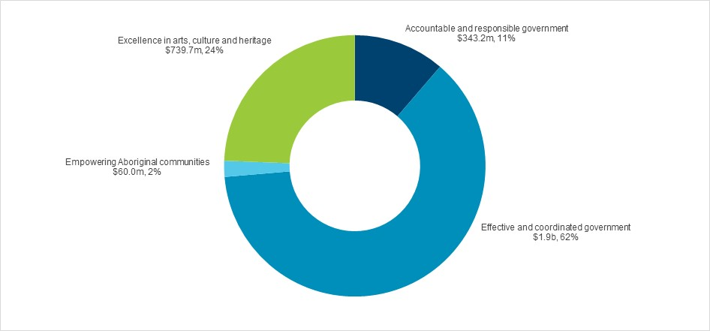

Note: The sum of percentages does not equal one hundred due to rounding.

1. Capital expenditure by Outcome 2020-21 (dollars and %)

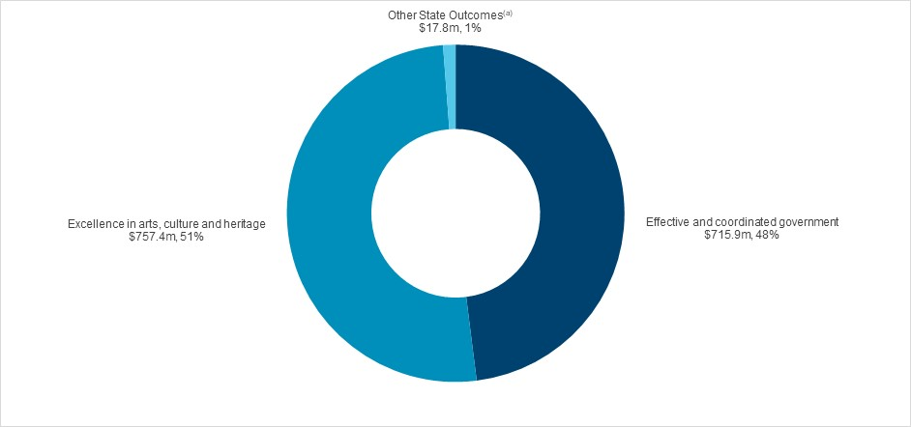

(a) Grouped for presentation purposes, “Other State Outcomes” comprises:

• Empowering Aboriginal communities

• Accountable and responsible government.

## Outcome 1: Effective and coordinated government

|  |  |  |
| --- | --- | --- |
| H:\Documents\Downloads\BP3 icons-V02-Expense.png | $1.9 billion | Recurrent Expenses  2020-21 |
| H:\Documents\Downloads\BP3 icons-V02-Capital Expenditure 03.png | $715.9 million | Capital Expenditure 2020-21 |

### State Outcome overview and 2020-21 investment

This Outcome accounts for the Cluster’s strategic direction, coordination, assurance and project delivery role across government.

### 2020-21 State Outcome Budget highlights

In 2020-21, the Premier and Cabinet Cluster will invest $2.6 billion ($1.9 billion recurrent expenses and $715.9 million capital expenditure) in this Outcome, including:

* $1.2 billion ($1.8 billion expenses and $1.6 billion capital over four years) for Infrastructure NSW (INSW) in continued investment to support major infrastructure. INSW is currently responsible for delivering three major infrastructure projects for New South Wales with total expenditure of $2.5 billion:
* $828.0 million for the Sydney Football Stadium Redevelopment
* $750.0 million for the new Sydney Fish Markets
* $389.6 million total remaining cost in developing the Barangaroo precinct
* $131.6 million ($453.6 million expenses and $102.2 million capital expenditure over four years) for Resilience NSW, created on 1 May 2020, to coordinate and oversee disaster management, disaster recovery and building community resilience to future disasters in the State of New South Wales. Resilience NSW is responsible for funding elements of the State’s recovery from the 2019‑20 bushfires including:
* $865.0 million expenditure in 2020-21 in disaster relief funding as part of the recovery effort associated with the unprecedented 2019-20 bushfire crisis
* $15.6 million expenditure to lead projects that create jobs and drive investment in key precincts, including:
* Atlassian head office development at Tech Central
* new Sydney University campus at the Westmead Health and Innovation District
* Harbourside shopping centre redevelopment at Pyrmont Peninsula
* Entertainment Quarter redevelopment at Moore Park.

### Key performance insights

This section provides analysis and insights on key Outcome Indicators for this State Outcome.

#### Improving governance, design and delivery of project infrastructure to make a significant difference for the people of New South Wales

The Cluster through Infrastructure NSW (INSW) supports Government by overseeing project assurance through the Investor Assurance (Gateway) process, including regular reporting on major projects. It also directly delivers infrastructure projects either for other Clusters or as the responsible agency for project delivery. To maintain independence, NSW Treasury carries out Gateway assurance processes for major projects delivered by INSW. This indicator tracks compliance with Gateway processes and delivery of infrastructure projects and has been recorded as stable as performance has met the established target.

Performance against this indicator has increased and is expected to meet the performance target.

1. Percentage of major projects compliant with Gateway processes

#### Drive the Premier’s Priorities to make a significant difference for the people of New South Wales

The Premier’s Priorities focus on some of the most complex challenges our community faces. The Premier’s Implementation Unit tracks progress of delivery on an annual basis. Meeting these ambitious targets requires cooperation across NSW Government and innovative approaches.

Performance against this indicator remains stable as at the end of its first full year to 30 June 2020.

1. Percentage of the 14 Premier priorities assessed as ‘likely to be delivered’

#### Provide effective leadership in times of a disaster, to coordinate and assure the recovery process and to prepare for future events

Resilience NSW is the newly created lead agency responsible for disaster management, disaster recovery and building community resilience to future disasters.

As Resilience NSW is a newly established agency, performance reporting will commence after the first full year of operation. Performance indicators will focus on measuring preparedness for disasters and timely and appropriate responses to disasters.

### Performance indicators for this Outcome

|  |  |  |  |
| --- | --- | --- | --- |
| **Outcome Indicators** | **Units** | **2019-20** | **2020-21** |
| **Actual** | **Forecast** |
| Delivery of the 14 Premier Priorities as indicated by their "likelihood of delivery" assessment | % | 57.0(a) | 60.0 |
| Effective delivery of infrastructure projects | % | 100.0 | 100.0 |
| Compliance with Gateway processes for major projects | % | 98.0 | 100.0 |

Note

(a) 2019-20 is the baseline as 2020-21 will be the first full year being measured.

## Outcome 2: Excellence in arts, culture and heritage

|  |  |  |
| --- | --- | --- |
| H:\Documents\Downloads\BP3 icons-V02-Expense.png | $739.7 million | Recurrent Expenses  2020-21 |
| H:\Documents\Downloads\BP3 icons-V02-Capital Expenditure 03.png | $757.4 million | Capital Expenditure 2020-21 |

### State Outcome overview and 2020-21 investment

Arts, screen, heritage and culture play a critical role in the State’s economy, from skills development and job creation to attracting cultural tourists. Maximising ‘excellence in arts, culture and heritage’ will leverage New South Wales’ current capabilities, further position the State as a world‑class centre for performances, events, exhibitions and cultural visitation, as well as the development of new state cultural assets for future generations.

### 2020-21 State Outcome Budget highlights

In 2020-21, the Premier and Cabinet Cluster will invest $1.5 billion ($739.7 million recurrent expenses and $757.4 million capital expenditure) in this Outcome, including:

* $840.0 million total government contribution for the creation of a new Powerhouse site at Parramatta along with expanded storage at the Museum Discovery Centre
* $66.0 million ($1.0 million in expenses and $103.5 million in capital expenditure over two years) for an *Arts Maintenance and Upgrade Fund* to both stimulate jobs and the economy through improving accessibility, sustainability and functionality of our cultural assets. The COVID-19 pandemic has led to an ideal opportunity to address critical maintenance and deliver upgrades to maintain the quality and heritage of New South Wales’ cultural infrastructure with limited disruption to building operations
* $50.0 million the *Arts Rescue and Restart package* for NSW arts and cultural organisations to ensure the sector continues to make an important contribution to the NSW economy during and after the COVID-19 pandemic
* $35.0 million ($175.0 million in expenses over five years) expansion for ‘Made in NSW’ Film Industry support
* $21.8 million ($0.8 million in expenses and $23.5 million in capital expenditure remaining over two years) for Australian Museum to complete the Project Discover transformation with the principal elements opening to the public on 28 November 2020
* $3.3 million ($2.1 million in expenses and $12.3 million capital over four years) for upgrades to the State Library of NSW to both stimulate jobs along with improving accessibility and functionality of the State Library of NSW.

### Key performance insights

This section provides analysis and insights on key Outcome Indicators for this State Outcome.

#### Sydney and NSW are world-class centres for performances, events, exhibitions and cultural visitation, telling stories that reflect our diverse histories and contemporary life

New South Wales is the home of the nation’s largest and most diverse arts, cultural and heritage sectors, as well as the engine of Australia’s creative industries. New South Wales’ arts, screen, heritage and culture sectors play a critical role in the State’s economy, supporting skills development and job creation along with actively promoting tourism. This indicator tracks Sydney’s Liveability rating and the increase in the number of annual visits to the Cluster’s arts, cultural and heritage venues.

Maintaining performance levels against this indicator is currently challenging due to COVID-19 restrictions and its impact on the public’s appreciation of the State’s cultural institutions along with the delay of the assessment of the Liveable City Rating (Culture and Environment) due to the COVID-19 pandemic.

1. Liveable city rating(a) - culture and environment

Note: The Liveable city rating is provided by the [Economist’s Global Liveabilitiy Repor](https://culturecounts.cc/blog/the-impact-of-culture-and-environment-on-liveability/)t and represents a “Culture and Environment” rating with scores across nine components as to whether they are available in the city.

#### Collect, research, conserve and exhibit NSW cultural and heritage assets

NSW cultural infrastructure, inclusive of the facility itself and the collections maintained within the facility, create jobs, attracts visitors to New South Wales and preserves cultural assets for future generations.

Performance against this indicator is currently stable with achievement remaining on track to meet the target.

1. Value of cultural and heritage assets being maintained and protected for current and future generations

### Performance indicators for this Outcome

|  |  |  |  |
| --- | --- | --- | --- |
| **Outcome Indicators** | **Units** | **2019-20** | **2020-21** |
| **Actual** | **Forecast** |
| Cultural and heritage assets being maintained and protected for current and future generations | $b | 10.2 | 10.2 |
| Increase annual visits to Premier and Cabinet arts, cultural and heritage venues | million | 6.2 | 5.4 |
| Increase in the number of customers who have their Heritage Act applications determined statutory timeframes | % | 37.0 | 40.0 |
| Liveable city rating - culture and environment | no. | 94.4 | 94.4 |

## Outcome 3: Empowering Aboriginal communities

|  |  |  |
| --- | --- | --- |
| H:\Documents\Downloads\BP3 icons-V02-Expense.png | $60.0  million | Recurrent Expenses  2020-21 |
| H:\Documents\Downloads\BP3 icons-V02-Capital Expenditure 03.png | $0.1  million | Capital Expenditure 2020-21 |

### State Outcome overview and 2020-21 investment

Empowering Aboriginal communities leads to a transformed relationship between Aboriginal peoples and government, as well as supporting the delivery of policies and practices that support Aboriginal peoples’ right to self-determination.

### 2020-21 State Outcome Budget highlights

In 2020-21, the Premier and Cabinet Cluster will invest $60.1 million ($60.0 million recurrent expenses and $0.1 million capital expenditure) in this Outcome, including:

* $20.0 million expenses over four years for *Closing the Gap* in accordance with the National Agreement, and support for the equal participation of Aboriginal communities in priority reforms
* $4.0 million ($8.0 million expenses over two years) for the Australian Indigenous Education Foundation to support the boarding school and tertiary scholarship programs for Aboriginal and Torres Strait Islander students
* $1.3 million expenses for the *COVID-19* *Aboriginal Community Organisations Grants Program* to provide small grant funding to Aboriginal community-controlled organisations (ACCOs) that have been impacted by COVID-19. The funding will allow ACCOs to continue providing culturally appropriate, locally based supports for Aboriginal communities, particularly in regional and remote areas
* $0.7 million expenses for the *Aboriginal Food Security Program* to support Aboriginal Affairs, in partnership with the New South Wales Aboriginal Land Council, provide essential supplies to vulnerable Aboriginal communities impacted by the COVID-19 pandemic.

### Key performance insights

This section provides analysis and insights on key Outcome Indicators for this State Outcome.

#### Drive transformation in Aboriginal communities – government relationships

*Unfinished Business*, the NSW Parliament General Purpose Standing Committee’s report on its inquiry into Stolen Generations reparations, was tabled in Parliament on 23 June 2016. The report made 35 recommendations relating to reparations. This indicator remains a key area of focus as it tracks Government’s compliance with the Stolen Generations Reparations Scheme guidelines.

Performance against this indicator is currently stable with achievement remaining in line with the target at 100 per cent compliance with the Stolen Generations Reparations Scheme guidelines.

1. Level of compliance with the Stolen Generations Reparations Scheme guidelines

**Drive sustainable economic prosperity**

The Aboriginal procurement policy guides the NSW Government procurement activity with the objective to support the opportunity to increase Aboriginal skills, economic participation and grow the Indigenous business sector. The Government’s procurement capacity will be leveraged to support Aboriginal employment opportunities and participation along with growth of Aboriginal-owned businesses in order to drive prosperity across Aboriginal communities.

This indicator tracks the increase in government contracts awarded to Aboriginal businesses in line with the Aboriginal Procurement Policy target of seven per cent in 2022-23.

The policy will be strengthened from 1 January 2021 by combining the *Aboriginal Procurement Policy* and the *Aboriginal Participation in Construction Policy.*  This will concentrate Government’s procurement activities through a single policy framework in order to improve outcomes.

1. Percentage of government contracts awarded to Aboriginal business in line with theAboriginalprocurementtarget

### Performance indicators for this Outcome

|  |  |  |  |
| --- | --- | --- | --- |
| **Outcome Indicators** | **Units** | **2019-20** | **2020-21** |
| **Actual** | **Forecast** |
| Aboriginal Language Trust board commences by 30 March 2020 | % | 100 | N/A(a) |
| Compliance with the Stolen Generations Reparations Scheme guidelines | % | 100 | 100 |
| Increase in government contracts awarded to Aboriginal business in line with the Aboriginal procurement target | % | 0.5 | 4.0 |
| Percentage of Aboriginal Language Boards having developed and implemented local language programs within their community | % | n.a.(b) | 50.0 |

Notes

1. 2020-21 forecast is not applicable as the indicator was completed in 2019-20
2. Data is currently not available.

## Outcome 4: Accountable and responsible government

|  |  |  |
| --- | --- | --- |
| H:\Documents\Downloads\BP3 icons-V02-Expense.png | $343.2  million | Recurrent Expenses  2020-21 |
| H:\Documents\Downloads\BP3 icons-V02-Capital Expenditure 03.png | $17.7  million | Capital Expenditure 2020-21 |

### State Outcome overview and 2020-21 investment

This Outcome accounts for the Cluster’s role in supporting good government decision-making and upholding government integrity.

### 2020-21 State Outcome Budget highlights

In 2020-21, the Premier and Cabinet Cluster will invest $360.9 million ($343.2 million recurrent expenses and $17.7 million capital expenditure) in this Outcome, including:

* $168.2 million ($480.7 million expenses and $16.4 million capital over four years) for the New South Wales Electoral Commission to simplify, modernise and improve the conduct of elections and to increase regulation of Local Government election participants’ campaign finance, making it consistent with oversight of the State elections including:
* Up to $48.9 million reserved over two years to ensure COVID-19 safe local government elections can be held in September 2021
* $11.7 million ($5.2 million expenses and $6.5 million capital over four years) for funding of the Online Electoral Funding and Disclosure System (FDC Online)
* $41.9 million ($137.4 million expenses and $1.1 million capital over four years) for the Public Service Commission
* $32.2 million ($112.0 million expenses and $2.8 million capital over four years) for the Independent Commission Against Corruption (ICAC) to enhance the Commission’s ability to fulfil its statutory obligations
* $29.0 million ($100.2 million expenses and $2.7 million capital over four years) for the New South Wales Ombudsman
* $24.8 million ($94.9 million expenses and $4.8 million capital over four years) to the Law Enforcement Conduct Commission to oversee law enforcement agencies, ensuring that policing in New South Wales is carried out in a responsible and appropriate manner.

### Key performance insights

This section provides analysis and insights on key Outcome Indicators for this State Outcome.

#### Upholding government integrity through responsive, risk-based and efficient oversight

Individual integrity agencies are integral to instilling public trust and confidence in government. This indicator tracks whether integrity agencies and independent entities are meeting their statutory requirements.

Performance against this indicator continues to be stable at the 2022-23 target level, with full compliance recorded by integrity agencies and independent agencies.

1. Percentage of statutory requirements met by integrity agencies and independent entities

#### Attracting and developing the best people to deliver a world-class public service

Both employee engagement and a diversified workforce are key indicators of workforce innovation, productivity and performance. Improvement in these indicators will underpin the achievement of Premier’s Priority 14 – *World Class Public Service*. This indicator tracks public sector engagement as well as key metrics including: the number of female leaders, Aboriginal leaders and roles held by people with a disability.

Data collection for this indicator in 2019-20 has been delayed due to COVID-19, however performance is forecasted as on track to meet the 2022-23 target.

1. NSW attracts the best employees ensuring delivery of a World Class Public Service for the people of NSW

Note: 2019-20 actual data is not yet available, and an estimate for 2019-20 has been provided.

### Performance indicators for this Outcome

|  |  |  |  |
| --- | --- | --- | --- |
| **Outcome Indicators** | **Units** | **2019-20** | **2020-21** |
| **Actual** | **Forecast** |
| Increase engagement of public sector employees | % | n.a.(a) | 67.0 |
| Increase in roles held by people with a disability by 2025 | % | 2.4 | 3.5 |
| 114 Aboriginal leaders by 2025 | no. | 105.0 | 105 |
| Increase percentage of female leaders by 2025 | % | 41.1 | 43.5 |
| Increase workforce satisfaction in relation to effective utilisations of technology in order to improve outcomes | % | n.a.(b) | n.a.(c) |
| NSW attracts the best employees ensuring delivery of a World Class Public Service for the people of NSW | % | 72.0(d) | 74.0 |
| Percentage of SGE staff trained | % |  |  |
| % of SGE staff satisfied with training |  | n.a.(b) | n.a.(b) |
| % of SGE Staff trained |  | n.a.(b) | n.a.(b) |
| Website user satisfaction rates |  | n.a.(b) | n.a.(b) |
| Meeting statutory requirements for integrity agencies and independent entities | % | 100 | 100 |
| No successful challenges to elections | % | 0.0 | 0.0 |
| Overall core voter satisfaction rates | % | n.a.(b) | 85.0 |
| Participation rates state/local elections | % |  |  |
| Participation rates for NSW - local elections |  | n.a.(b) | 85.0 |
| Participation rates for NSW - State elections |  | n.a.(b) | n.a.(b) |
| Voter enrolment rate | % | 97.7 | 98.2 |

Notes

1. Data is currently not available
2. These items have not been rated due to local elections being delayed as a result of COVID-19
3. First year will determine baseline for 2020-21 forecast
4. A forecast for 2019-20 has been provided.