2. Delivering OUR JOB CREATING infrastructure PIPELINE
- Since the 2019-20 Half-Year Review, the Government has increased infrastructure spending from $97.3 billion to $107.1 billion over the four years to 2023-24, an increase of more than 10 per cent. This additional expenditure is supporting the Government’s COVID-19 response and recovery measures.
- COVID-19 stimulus measures included in this budget are supporting jobs and revitalising the economy by providing new and improved infrastructure that underpins more efficient and effective service delivery.
- This program includes investment of $72.2 billion for public transport and roads,
$10.7 billion for health infrastructure, $7.7 billion for schools and skills infrastructure and $2.8 billion to deliver on our commitment to build stronger communities. It also includes $1.6 billion for digital transformation projects over the next three years.
- This Budget includes funding for existing transport projects, including the Sydney Metro City and Southwest and new projects such as the Sydney Metro – Western Sydney Airport.
- Significant projects delivered since the 2019-20 budget include the CBD and South East Light Rail, NorthConnex, the new WestConnex M8 tunnel from Kingsgrove to St Peters, the Arthur Phillip High School and the Westmead Hospital Redevelopment.
- Four-year capital program from 2019-20 Half-Yearly Review to 2020-21 Budget
$97.3 bn
Total capital program at
2019-20 Half-Yearly Review
Major highways including New England, Newell, Pacific and Princes Highways ($3.9 billion)
Sydney Metro West ($10.4 billion)

Regional Digital Connectivity ($400.0 million)
Royal Prince Alfred Hospital ($750.0 million)
Sydney Metro – Western Sydney Airport ($9.2 billion)

$107.1 bn
Total capital program at 2020-21 Budget,
including:

Key infrastructure projects delivered since the 2019-20 Budget

- Delivering on our infrastructure commitments
The Government’s record infrastructure program has been made possible by its successful Asset Recycling Strategy and strong fiscal discipline. Projects in delivery include Sydney Metro City and Southwest, the WestConnex Motorway (M4-M5 link tunnels and Rozelle Interchange) and Parramatta Light Rail Stage 1.
Since 2011, the Government has invested $153.9 billion in new and upgraded infrastructure to deliver projects including improved accessibility and reliability of transport infrastructure, new and upgraded schools and critical health services.
Key infrastructure projects delivered since the 2019-20 budget include WestConnex M8, WestConnex M4 East tunnel, NorthConnex, 61 new and upgraded schools and more than 29 health capital projects.
The construction industry plays a vital role in supporting economic stimulus and the Government is working closely with industry to ensure the infrastructure pipeline delivers on priorities. For further information see Box 1.4 in Chapter 1.

The Government’s infrastructure program has now delivered significant projects as follows:
Recently completed Transport projects include:
- the new M4 East tunnel and new M5 tunnel (now the M8) were completed in July 2019 and July 2020, respectively, as part of the $16.8 billion WestConnex program
- the $3.0 billion NorthConnex project, completed in October 2020 (see Box 2.2)
- the $682.6 million Northern Beaches Hospital road upgrades, completed in May 2020
- the $615.7 million Easing Sydney’s Congestion, M4 Smart Motorway, main works completed in June 2020 (undergoing commissioning)
- the $240.0 million new Grafton Bridge, opened to traffic in December 2019
- the $116.0 million Pacific Motorway (M1) widening, Kariong Interchange to Somersby Interchange, completed in June 2020.

- NorthConnex
The recently opened NorthConnex is the missing link in the National Highway route, connecting the M1 Motorway in Wahroonga to the Hills M2 Motorway at West Pennant Hills via twin nine kilometre tunnels. NorthConnex delivers faster, safer, more reliable and efficient journeys for road users, saving motorists up to 15 minutes, avoiding 21 sets of traffic lights along Pennant Hills Road and providing motorists with a traffic light-free trip from Newcastle to Melbourne.
As part of an alternative route to the Sydney CBD, NorthConnex avoids 40 sets of traffic lights on the Pacific Highway. By removing up to 5,000 trucks a day from Pennant Hills Road, NorthConnex reduces congestion and noise, improves safety and returns local streets to local communities.
NorthConnex will create 8,700 jobs for New South Wales over its lifetime and is predicted to inject around $4.0 billion into the NSW and national economies.
Figure 2.2: NorthConnex
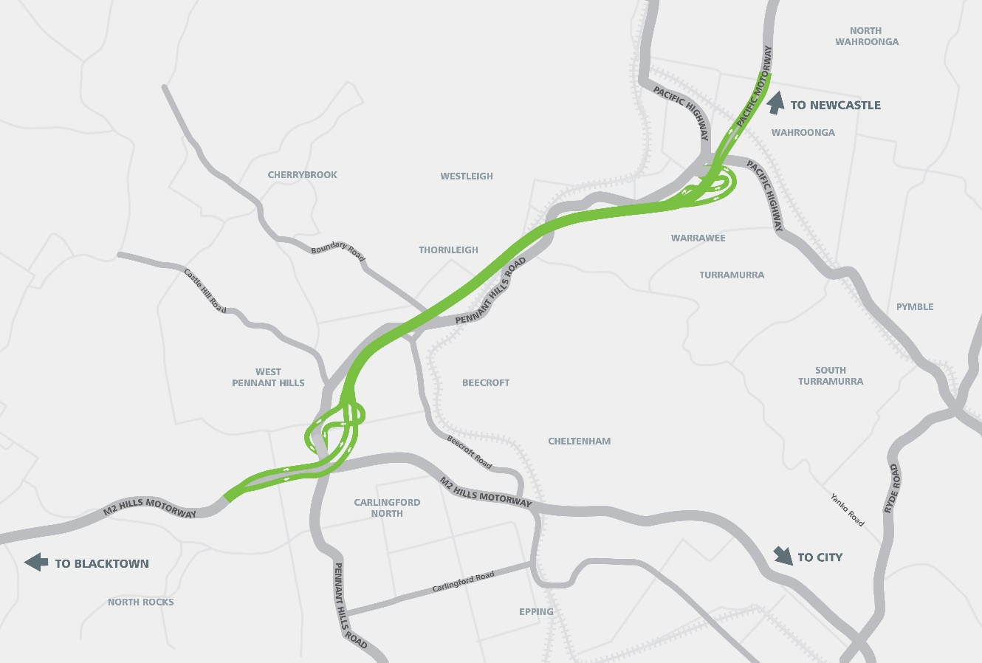

Significant transport projects to be completed soon include:
- the Pacific Highway upgrade, Woolgoolga to Ballina, scheduled to be completed by the end of 2020 for $5.3 billion (see Box 2.3)
- Sydney Airport North, O'Riordan Street Widening, scheduled to be completed by 2021 for $152.0 million
- Windsor Bridge Replacement over Hawkesbury River, opened to traffic in May 2020 but scheduled to be fully completed by 2021 for $130.0 million
- Princes Highway, Albion Park Rail Bypass, scheduled to be completed by 2022 for $630.0 million
- Princes Highway, Berry to Bomaderry upgrade, scheduled to be completed by 2022 for $450.0 million
- Mona Vale Road, Manor Road to Foley Street, scheduled to be completed by 2022 for $250.0 million.

- Pacific Highway Upgrade - Woolgoolga to Ballina
The 155 kilometre Woolgoolga to Ballina upgrade is the final link in the 657 kilometre Pacific Highway upgrade, an Australian and NSW Government commitment to upgrade the highway to a four-lane divided road between Hexham and the Queensland border. The final 17 kilometre section is scheduled to be completed in late 2020.
This upgrade is providing local, inter-regional and interstate travelers with vastly improved road safety, contributing to approximately 75 per cent reduction in fatal and injury crashes.
In addition to a reduced travel time of approximately 25 minutes, bypassed townships are also benefiting from the removal of heavy highway traffic from local roads, which has reduced noise levels and improved pedestrian and commuter safety.
The project includes nine interchanges, 170 bridges and more than 350 connectivity structures over the highway’s 155 kilometre length.
Figure 2.3: Pacific Highway Upgrade – Woolgoolga to Ballina
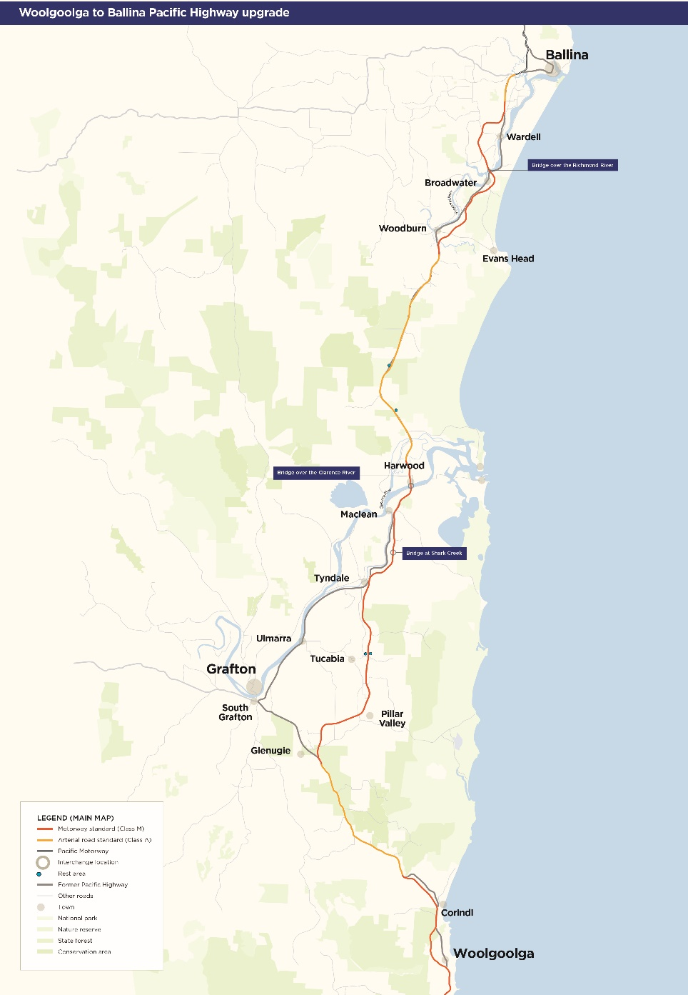
Health projects completed include:
- the $832.3 million Westmead Hospital Redevelopment Stage 1 and the $95.0 million Sydney Children’s Hospital Network Westmead Redevelopment Stage 1, including two new emergency departments, one for adults and one for children, more than 300 new patient rooms and 1.5 floors for the University of Sydney to enable greater integration of education, research and health services delivery
- Blacktown and Mount Druitt Hospitals Redevelopment and carparks, costing more than $700.0 million, including a new Acute Services Building at Blacktown which opened in stages from August 2019
- eight new ambulance stations, completed as part of the $122.1 million Rural Ambulance Infrastructure Reconfiguration Program, located at Birmingham Gardens, Cowra, Goulburn, Grenfell, Bungendore, Rutherford, Yass and Pottsville
- the $73.0 million Macksville Hospital, opened in May 2020, six months ahead of schedule. The new hospital is located on a greenfield site, three kilometres north of the Macksville town centre and includes an emergency department, inpatient units, an operating theatre, maternity and Tresillian (early parenting) services, community and allied health facilities
- the new $70.7 million Mudgee Hospital, opened in May 2020, incorporating an emergency department, an inpatient unit, operating theatres, a maternity unit and outpatient services
- the new Bulli Hospital and Aged Care Centre, opened to patients in August 2020, featuring rehabilitation spaces, residential aged care and a new urgent primary health care centre (ETC $53.7 million, includes $16.6 million contribution from the Illawarra Retirement Trust)
- Muswellbrook Hospital, opened in August 2019, including enhanced chemotherapy and renal dialysis services and a new medical imaging facility (ETC $20.1 million)
- a new Ambulatory Care Centre, opened at the Grafton Base Hospital in August 2020 includes renal dialysis, oncology, obstetrics and gynaecology clinics and fracture clinics (ETC $17.5 million).
The completion dates identified in Chapter 4 are the financial completion dates, which involve the finalisation of all commercial payments and confirmation that all contractual obligations have been met. This may occur 12-18 months after the building becoming ready for commissioning and occupation by patients and staff.

Projects delivered for education and skills include:
Since 2011, the Government has delivered 140 new and upgraded schools that have provided more than 1,960 new classrooms and more than 36,800 additional student places (as at July 2020), with thousands of additional classrooms and tens of thousands of additional student places on the way.
- Arthur Phillip High School and Parramatta Public School
- the high school accommodates 2,000 students and showcases the delivery of a multi-storey education facility in response to metropolitan Sydney’s increasing student community
- the public school provides a new multi-storey public school for 1,000 students on the original school site with 40 permanent, flexible learning spaces, support areas and modern indoor and outdoor landscaped spaces
- Ashbury Public School – four new permanent innovative learning spaces to meet forecast population growth in the local area
- Byron Bay Public School – 10 new permanent teaching spaces in a two-storey building and a total of 28 teaching spaces for 650 students
- Carlingford Public School – 20 new permanent teaching spaces, a new hall and upgrades to some existing core facilities such as staff areas, administration and library
- Epping Public School – 22 new permanent teaching spaces, a new library, an upgrade of existing core facilities, such as special programs rooms and an upgrade of existing administration and staff areas
- Gledswood Hills Public School – catering for up to 600 students, includes 24 flexible learning spaces, a new and upgraded hall, a library, special programs rooms, as well as before and after school facilities
- Gwynneville Public School – a new building with 11 flexible learning spaces, new staff and administration facilities, toilets, library and shaded outdoor space
- Newcastle East Public School – four new flexible, permanent learning spaces, a new Covered Outdoor Learning Area (COLA) and communal gathering space, refurbishment of the staff administration area and replacement of the roof on the heritage building
- Oran Park High School – includes 90 innovative learning spaces, a hall to accommodate two basketball courts and core facilities such as fitness and performance studios, a hospitality café, maker spaces and senior learning centre
- Riverbank Public School – an additional 15 new flexible learning spaces, the expansion of administrative and staff areas, a COLA, additional student amenities and shade structures
- Smalls Road Public School – accommodates up to 1,000 students. The benefits are 43 learning spaces (including three special education classrooms), a hall, a two-storey library, COLA, out of school hours care facilities, a canteen, administration facilities and multi-purpose sports courts
- Wamberal Public School – includes a new building with 15 flexible learning spaces, a refurbished administration building, as well as an updated school hall and staff car park
- Willoughby Girls High School – accommodates up to 1,000 students in permanent, flexible teaching spaces. It includes 14 new permanent teaching spaces, a music learning centre, new student and staff amenities, a multi-purpose sports court and increased open outdoor play space
- Yagoona Public School – 16 new permanent, flexible teaching spaces, new toilet facilities, a new administration building and landscaping
- development or refurbishment of TAFE facilities at St George Campus, Meadowbank Relocation Phase 1, Gunnedah Trades Refurbishment, Randwick Partnership Development and Miller Carpentry Construction and Electrical Consolidation
- Connected Learning Centres (CLC) at Murwillumbah, Scone, Singleton, Yamba, Corowa, Deniliquin and Narrandera.

Projects delivered for planning, industry and environment include:
- relocation of the Department of Planning, Industry and Environment and the Environment Protection Authority to Parramatta as part of the Government’s commitment to jobs in Western Sydney ($66.4 million)
- upgrade of Sydney Olympic Park Tennis Centre ($50.5 million)
- new housing supply for Aboriginal communities ($36.6 million)
- development of Eastern Creek Business Hub creating opportunities for small and large retailers ($14.9 million)
- Minnamurra Rainforest Centre – Infrastructure and experience invigoration ($4.7 million)
- upgrade on Great Southern Nature Walk – Wattamolla Visitor Precinct ($3.9 million)
- Saving Our Species On-Park – investment in threatened species and ecological communities ($2.6 million).
Projects delivered for stronger communities include:
- Clarence Correctional Centre, delivering a state-of-the-art facility commissioned to house 1,700 inmates, operational since 1 July 2020 ($798.8 million)
- Prison Bed Capacity Program:
- a new 500 bed maximum-security extension for Parklea Correctional Centre opened in April 2020 ($176.5 million)
- completion of the security upgrade of 320 beds at the Geoffrey Pearce Correctional Centre in October 2020 ($84.7 million)
- a new 480 bed expansion of the Junee Correctional Centre opened in December 2019 ($275.4 million)
- a new 440 bed expansion of the Mid North Coast Correctional Centre opened in November 2019 ($183.9 million)
- new police stations open and operational at Mount Druitt, Taree and Wentworthville
($45.0 million)
- renovation of the City of Sydney and Kariong Fire Stations and new stations at Parkes and South Tamworth ($15.8 million)
- a new training facility at Goulburn Police Academy to provide specialist training to police officers in responding to active armed offender incidents and other high-risk events
($8.0 million).

Key infrastructure projects in delivery
Health
This Budget includes $10.7 billion of capital investment over the four years to 2023-24 on health infrastructure including hospitals and health facilities.
This unprecedented investment includes funding from the NSW Government’s $3.0 billion Jobs and Infrastructure Acceleration Fund to bring forward several major projects to 2020-21, increase the scope of existing projects and to fund additional new works.
Key projects commencing in 2020-21 included in this budget:
- Bankstown‐Lidcombe Hospital and Community Health Services Redevelopment
(ETC $1.3 billion) – a new hospital on a greenfield site to deliver comprehensive healthcare including emergency medicine, surgical services and critical care
- Royal Prince Alfred Hospital Redevelopment (ETC $750.0 million) – refer to Box 2.4
- Shellharbour Hospital Redevelopment (ETC $698.6 million) – a new hospital on a greenfield site, with expanded scope to include enhanced medical and surgical services, contemporary mental health facilities and expanded outpatient services
- Tweed Hospital and Integrated Ambulatory Services Redevelopment (ETC $673.3 million) – main works for the new hospital on a greenfield site to include additional inpatient capacity, expanded emergency department and enhanced surgical and ambulatory services
- Sydney Children’s Hospital Network, Randwick Stage 1 and Comprehensive Children’s Cancer Centre (ETC $608.0 million) – a new and expanded emergency department, a short stay unit and expansion and relocation of clinical spaces, including Australia’s first Comprehensive Children’s Cancer Centre (CCCC)
- Nepean Hospital Redevelopment and Associated Community Based Services Stage 2 (ETC $450.0 million) – a new intensive care unit, in-centre renal dialysis unit, medical imaging and nuclear medicine services, more beds, staff education and training facilities, community health services and a new front of house for the hospital
- Shoalhaven Hospital Redevelopment (ETC $438.0 million) – a significant expansion of the ambulatory care precinct, surgical beds and operating suites, medical wards including aged care, emergency department, enhanced medical imaging, pathology and support facilities
- St George Hospital – Ambulatory Care, Day Surgery, Subacute Inpatient Building (ETC $385.0 million) – increased subacute and day only inpatient bed capacity to enable the expansion of ambulatory care and outpatient services and a centre for community-based services
- Eurobodalla Health Service Redevelopment (ETC $200.0 million) – refer to Box 2.5.

Other projects commencing in 2020-21 included in this budget:
- Rural Ambulance Infrastructure Reconfiguration Stage 2 (ETC $100.0 million)
- Manning Hospital Redevelopment Stage 2 (ETC $100.0 million)
- Sutherland Hospital operating theatre complex (ETC $81.5 million)
- Cowra Hospital Redevelopment (ETC $70.2 million)
- Tweed Hospital car park (ETC $50.0 million)
- Dubbo Base Hospital car park (ETC $30.0 million)
- Maitland Hospital car park (ETC $30.0 million)
- St Vincent's Darlinghurst Integrated Campus Redevelopment – service upgrade
(ETC $25.0 million)
- Glen Innes Hospital upgrade (ETC $20.0 million)
- Manly Adolescent and Young Adult Hospice (ETC $19.5 million)
- Sutherland Hospital Magnetic Resonance Imaging (MRI) (ETC $7.0 million)
- Bathurst Hospital MRI (ETC $4.0 million)
- NSW Pathology Single Statewide Laboratory Information Management System
- Real Time Prescription Monitoring
- Planning for future new works, including hospital and health facilities in Forster-Tuncurry, Grafton, Gunnedah, Moree and Ryde and a new helipad at Port Macquarie Hospital and the John Hunter Hospital car park.

- Royal Prince Alfred Hospital
Program: This Budget includes funding for the Royal Prince Alfred Hospital (RPAH) Redevelopment. This project will provide future proofed health facilities to serve Sydney’s growing community and enhance the opportunities for teaching, training and research. The project will complement new and innovative models of care including an expansion of rpavirtual.
Service delivery objective: This project will deliver a new hospital building, more adult inpatient beds and integrated ambulatory care services. Existing spaces will also be expanded and refurbished, including the emergency department, medical imaging, operating theatres, intensive care unit and maternity, birthing and neonatal services.
Implementation: Planning is continuing, with the early works proposed to commence in 2021 and the new hospital building expected to open to patients in 2026-27.
Funding allocation: The estimated total cost of the project is $750.0 million.

- Eurobodalla Hospital
Program: This Budget includes funding for the site identification, acquisition, planning and delivery of a new Eurobodalla Hospital. The new hospital on a greenfield site will provide capacity for integrated and enhanced hospital services for the communities in the Eurobodalla region.
Service delivery objective: This project will provide access to a range of health services available at one main campus. Enhanced coordination and functional integration of acute inpatient, subacute and ambulatory care clinical streams will deliver better health outcomes and improve the patient experience.
Implementation: The scope includes the site identification and acquisition along with planning and development of the new health facility. Site selection is anticipated by the end of 2020.
Funding allocation: The estimated total cost of the project is $200.0 million.

Page 4-17 to 4-22 of Chapter 4 of this Infrastructure Statement lists the major capital projects and minor works for the Health cluster, including the ETC, expenditure to 30 June 2020 and the 2020-21 allocation.

Education
In this budget, communities across New South Wales are benefiting from $7.7 billion capital investment in education and skills infrastructure over the four years to 2023-24. This includes an historic $7.0 billion investment over four years to deliver more than 200 new and upgraded government schools.
In addition to this, non-government schools will continue to be supported via recurrent grant funding of $500.0 million over four years to build, extend, or upgrade their facilities to provide more student places in growing communities.
Key projects in this budget are:
Over $1.5 billion (over three years) in new school and skills infrastructure, including:
- new primary schools at Googong, Murrumbateman and Edmondson Park
- the new Murwillumbah Education Campus
- upgrades to Carlingford West Public School, North Sydney Public School and Picnic Point High School
- the Regional Schools Roof Upgrade program
- the pilot Schools Renewable Energy Infrastructure project
- $365.8 million (over two years) for the Rural Access Gap Direct Intervention program, to deliver improved access to digital teaching, learning aids and collaboration tools to rural and remote schools
- $240.0 million (over two years) government co-contribution for capital improvement projects in public schools, including covered outdoor learning areas, science facilities, toilet blocks, administration buildings and canteens
- $157.8 million (over two years) to upgrade schools across the State with LED lighting
- $100.0 million for the TAFE NSW Asset Renewal Program to continue to deliver quality training services.
Key ongoing projects in this budget are:
- $300.0 million for the relocation of Meadowbank Public School and Marsden High School to the Meadowbank Education and Employment Precinct
- $125.9 million (over four years) to co-deliver the Meadowbank Education and Employment Precinct by transforming TAFE NSW Meadowbank into the first campus focused on digital technology in partnership with higher education providers and industry
- $121.2 million for the new Armidale Secondary College, which will combine Armidale High School and Duval High School and accommodate approximately 1,500 students
- $79.6 million (over four years) for the Western Sydney Construction Hub at Kingswood, a specialist facility that will help train the State’s much-needed pipeline of construction workers
- $55.1 million for the new Galungara Public School to accommodate up to 500 students and cater for 1,000 students in the future.
For further information about the Government’s record education program, see Box 2.6 which sets out the NSW schools investment program in detail.

- An unprecedented school infrastructure program
The Government’s $7.0 billion school infrastructure program is delivering over 200 upgraded and new schools.
For more information see https://www.schoolinfrastructure.nsw.gov.au
New Works 2020-21
Jobs and Infrastructure Acceleration Fund 2020-21
Regional  - Co Funded Regional School Renewal Program  - Googong (new primary school)  - Murrumbateman (new primary school)  - Regional Roof Upgrade Program | Metropolitan  - Carlingford West Public School Upgrade  - Edmondson Park (new primary school)  - North Sydney Public School Upgrade  - Picnic Point High School Upgrade
New Works 2020-21
- Canterbury Boys High School Upgrade  - Co Funded Metropolitan School Renewal Program  - Gledswood Hills Public School - Stage 2  - LED Lighting Upgrade Program | - Lindfield Learning Village -  Stage 2  - Moruya High School Upgrade  - Murwillumbah Education Campus  - Passfield Park School Upgrade  - Rural Access Gap Direct Intervention Package | - Schools Renewable Energy Infrastructure Project – Pilot Program  - Vocational Schools Pilot Program  - Wilkins Public School (new pre-school)  - Wilton Public School Upgrade
Ongoing projects
New schools
- Alexandria Park Community School (new school)  - Armidale Secondary College Upgrade (Armidale and Duval High Schools)  - Bungendore High School (new school)  - Catherine Field (new primary school)  - Epping (new primary school)  - Galungara Public School (Alex Avenue new primary school)  - Inner Sydney High School (new school) – enrolment is being staged, with the first Year 7 students starting classes at Inner Sydney High School from Day 1 Term 1 2020 | - Jerrabomberra (new high school)  - Jordan Springs (new primary school)  - Leppington (new primary school)  - Mainsbridge School (relocation)  - Marsden Park (new primary school)  - Meadowbank Education and Employment Precinct Schools  - Mulgoa Rise Glenmore Park (new primary school)  - New Environmental Education Centre in Penrith Lakes | - New primary school in Wagga Wagga electorate  - New Primary School in Liverpool electorate  - Porters Creek Public School (Warnervale new primary school)  - Queanbeyan School  - Sydney Olympic Park (new high school)  - Tallawong (new primary school)

Box 2.6: An unprecedented school infrastructure program (cont.)

Upgraded schools
- Ajuga School, Campbell House School and Glenfield Park School  - Ashtonfield Public School  - Bangalow Public School  - Bankstown North Public School  - Bexhill Public School  - Bletchington Public School  - Braidwood Central School  - Brooke Avenue Public School  - Brookvale Public School  - Budawang School (relocation)  - Callaghan College, Jesmond Campus  - Canley Vale High School  - Canterbury South Public School  - Chatswood Public School and High School  - Cranebrook High School (New Learning Centre)  - Croydon Public School  - Curl Curl North Public School  - Dapto Public School  - Darlington Public School  - Eastwood Public School  - Engadine High School  - Epping West Public School  - Fairvale High School  - Fort Street Public School | - Glenmore Park High School  - Glenwood High School  - Greystanes Public School  - Harrington Park Public School  - Hastings Secondary College  - Hurlstone Agricultural High School - Stage 2 and Upgrades for Agricultural Education in NSW  - James Fallon High School  - Jamison High School  - Jannali East Public School  - Jindabyne Central School  - Jindabyne High School - Stage 2  - John Palmer Public School  - Kent Road Public School  - Killarney Heights Public School  - Kingscliff High School  - Kingscliff Public School  - Kingswood High School  - Ku-ring-gai High School  - Kyeemagh Infants School  - Lake Cathie Public School  - Lennox Head Public School  - Liverpool West Public School  - Millthorpe Public School  - Milperra Public School  - Mona Vale Public School  - Monaro High School | - Mosman High School  - Murrumbidgee Regional High School  - Muswellbrook South Public School  - Nepean Creative and Performing Arts High School  - Parramatta West Public School  - Pendle Hill High School  - Penshurst Public School  - Picton High School  - Queanbeyan West Public School  - Samuel Gilbert Public School  - Schofields Public School  - Speers Point Public School  - St Ives High School  - St Ives North Public School  - Stanwell Park Public School  - Tamworth Public School  - Teven-Tintenbar Public School  - Tweed Heads South Public School  - Tweed River High School  - Wentworthville Public School  - West Ryde Public School  - Westfields Sports High School  - Wollongong Public School  - Yass High School Multi-Purpose Hall  - Young High School
Advanced Planning
- Cecil Hills High School  - Cumberland High School  - Darcy Road Public School | - Girraween Public School  - Green Square (new primary school)  - Gregory Hills (new primary school) | - Narrabeen Education Precinct  - Neutral Bay Public School  - Punchbowl Public School
Assurance Review
- Birrong Boys and Girls High School  - Castle Hill Public School  - Cronulla High School  - Edmondson Park (new high school)  - Hunter River High School  - Irrawang High School  - Liverpool Boys and Girls High School | - Macquarie Park Education Precinct  - Matthew Pearce Public School  - Marsden Park (new high school)  - Middle Head Environmental Education Centre  - Newcastle Education Precinct  - Orange Grove Public School  - Randwick Girls and Boys High Schools | - Rhodes East (new primary school)  - Rydalmere Education Precinct  - South Nowra/Worrigee (new primary school)  - St Leonards Education Precinct  - Wilton Junction (new primary school)  - Westmead (new primary school)  - Yanco Agricultural High School

Page 4-8 to 4-16 of Chapter 4 of this Infrastructure Statement lists the major capital projects and minor works for the Education cluster, including the ETC, expenditure to 30 June 2020, and 2020-21 allocation.
Transport
The transport capital program includes a record $72.2 billion investment over the four years to 2023-24. This represents a $16.5 billion, or 29.7 per cent, increase on the four years to
2022-23 included in the 2019-20 Budget.
Key new and accelerated 2020-21 infrastructure projects include:
- $10.4 billion over the next four years, including $2.1 billion in 2020-21, for Sydney Metro West (see Box 2.7)
- $9.2 billion over the next four years, including $810.0 million in 2020-21, for Sydney Metro – Western Sydney Airport
- $2.2 billion over the next four years, including $382.0 million in 2020-21, for Sydney Gateway
- $902.7 million over the next four years, including $243.1 million in 2020-21 to continue the upgrade of train stations under the Transport Access Program to make them more accessible including new lifts, ramps and footbridges (see Box 2.9)
- $781.2 million over the next four years, including $341.4 million in 2020-21, for Road Safety investment, including Towards Zero
- $656.3 million over the next four years, including $194.8 million in 2020-21, for new buses to cater for NSW services
- $608.2 million over the next four years, including $230.0 million in 2020-21, to provide additional car spaces for public transport users through the Commuter Car Parking Program (State and Federal funded)
- $603.8 million over the next four years, including $169.1 million in 2020-21, for Pinch Points and Clearways, including programs such as Gateway to the South, Hunter Pinch Points and other metropolitan pinch points co-funded through the recently announced Federal Budget
- $197.4 million over the next four years, including $13.9 million in 2020-21, for the Prospect Highway upgrade (State and Federal funded)
- $164.8 million over the next four years, including $6.7 million in 2020-21, for the upgrade to Heathcote Road, between Infantry Parade, Hammondville and The Avenue, Voyager Point (State and Federal funded)
- $148.7 million over the next four years, including $36.8 million in 2020-21, for the Memorial Avenue, Kellyville upgrade
- $123.1 million over the next four years, including $6.4 million in 2020-21, for Mamre Road Stage 1, M4 to Erskine Park Road
- $104.7 million over the next three years, including $20.1 million in 2020-21, for Spring Farm Parkway, Menangle Park

- $98.4 million over the next four years, including $12.8 million in 2020-21, for Regional NSW Bridge upgrades including Monkerai Bridge, Clarence Town Bridge, Barrington Bridge, Briner Bridge rehabilitation and design for the Warroo Bridge at Warroo, through the Bridges for the Bush Program
- $61.6 million over the next two years, including $50.0 million in 2020-21, to complete the Silver City and Cobb Highway Seal Extension.

- Sydney Metro West
The Sydney Metro West project will double rail capacity between the Parramatta and Sydney CBDs, linking new communities to rail services and supporting employment growth and housing supply. Sydney Metro West will have a travel time target of around 20 minutes between Parramatta and the Sydney CBD and is expected to create about 10,000 direct and 70,000 indirect jobs during construction.
The locations of seven metro stations have been confirmed at Westmead, Parramatta, Sydney Olympic Park, North Strathfield, Burwood North, Five Dock and The Bays.
Sydney Metro West features include:
- faster, more frequent access to major employment and education centres like Parramatta, Sydney Olympic Park and The Bays
- a new metro station at Westmead servicing one of Australia’s largest health and education precincts
- delivering new rail services for the first time at Burwood North, Five Dock and The Bays
- a new metro station at Sydney Olympic Park servicing Sydney’s sporting and entertainment super-precinct
- integration with the rest of Sydney’s public transport system
- fully accessible with lifts and level access between trains and platforms
- next generation fully air-conditioned metro trains.

Figure 2.4: Sydney Metro West

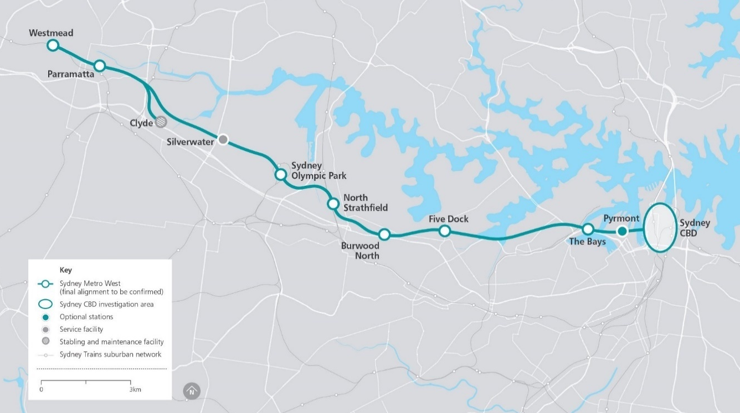

Significant infrastructure projects underway and funded in the 2020-21 Budget include:
For Sydney Metropolitan:
- $9.9 billion over the next four years, including $900.9 million in 2020-21, for planning and preconstruction activities for motorway links in Sydney including the M6 extension Stage 1, Sydney Gateway, Western Harbour Tunnel and Warringah Freeway upgrade
- $8.3 billion over the next four years, including $2.7 billion in 2020-21, to continue delivery of the Sydney Metro City and Southwest linking Chatswood and Bankstown
- $3.1 billion over the next four years, including $1.3 billion in 2020-21, for staged delivery of the WestConnex Motorway including the M4-M5 link tunnels and Rozelle Interchange
- $2.8 billion over the next four years, including $824.4 million in 2020-21, for More Trains, More Services for delivery of frequent, and reliable rail services to customers on the Illawarra, Airport, and South Coast lines
- $1.4 billion over the next four years, including $656.5 million in 2020-21, for the Parramatta Light Rail Stage 1 (see Box 2.8)
- $1.2 billion over next four years, including $300.0 million in 2020-21, for the M12 Motorway (State and Federal funded)
- $891.5 million over the next four years, including $244.9 million in 2020-21, for the Western Sydney Growth Roads program to accommodate population and employment growth in Western Sydney. Projects include:
- Mulgoa Road upgrades (State and Federal funded)
- The Horsley Drive, M7 motorway to Cowpasture Road
- Memorial Avenue, Old Windsor Road to Windsor Road
- Appin Road Improvements (Federal funded)
- Spring Farm Parkway Stage 1
- Mamre Road, M4 Motorway to Erskine Park Road
- Western Sydney Long Term Strategic Transport Corridor Preservation
- $79.0 million ($73.5 million over the next four years), including $2.0 million in 2020-21, to commence planning for upgrades to complete the duplication of Heathcote Road and planning for future upgrades of Picton Road.
- Paramatta Light Rail Stage 1
The Parramatta Light Rail Stage 1 will connect Westmead to Carlingford via the Parramatta CBD and Camellia with a two-way track spanning 12 kilometres. It is on target to be opened in late 2023. By 2026, around 28,000 people are forecast to use the Parramatta Light Rail daily, benefiting an estimated 130,000 people living within walking distance of a light rail stop.
Key features of the Parramatta Light Rail Stage 1 will include:
- 16 highly accessible stops
- regular services from early morning to late at night, including services every 7.5 minutes during peak periods, and
- modern and comfortable air-conditioned vehicles, each with a minimum capacity of 250 passengers.

Figure 2.5: Parramatta Light Rail

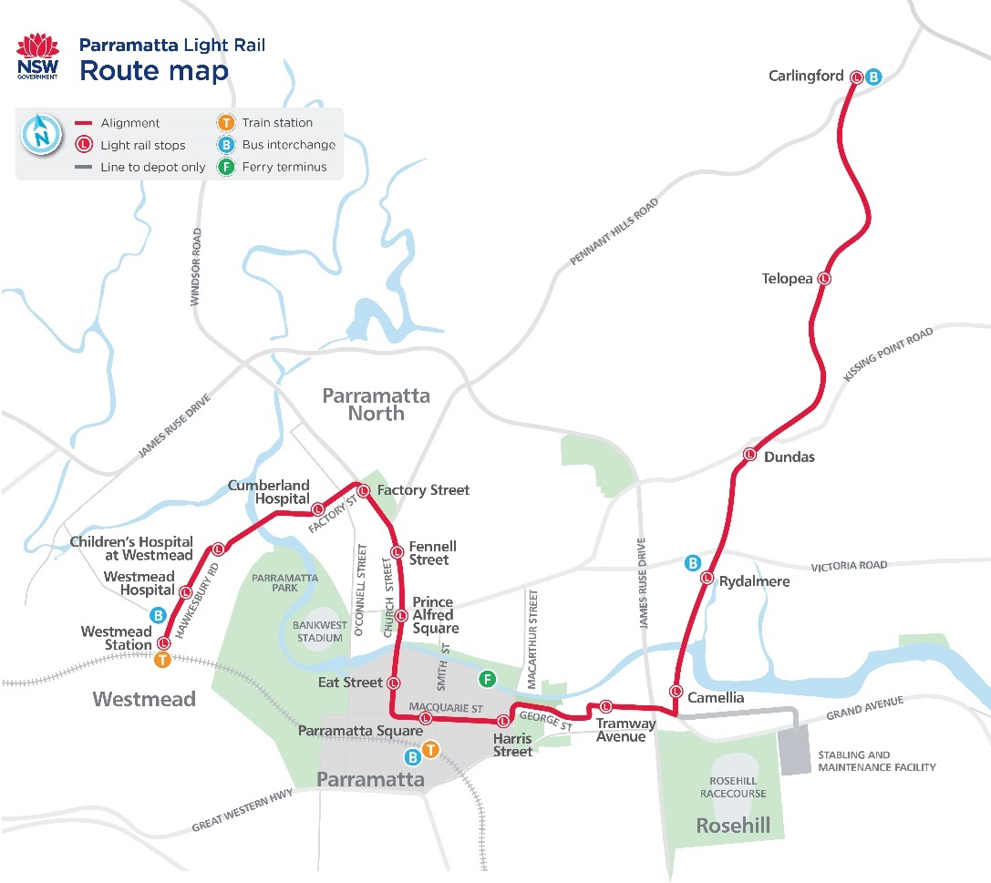

For Regional and Outer Metropolitan areas:
- $1.6 billion over the next four years, including $335.0 million in 2020-21, to deliver the New Intercity Fleet
- $1.0 billion over the next four years, including $135.0 million in 2020-21, towards the planning and preconstruction of the Coffs Harbour Bypass (State and Federal funded)
- $852.6 million over the next four years, including $41.7 million in 2020-21, towards the Newcastle Inner City bypass from Rankin Park to Jesmond and the Pacific Motorway extension to Raymond Terrace (both State and Federal funded)
- $671.1 million over the next four years, including $20.1 million in 2020-21, to continue planning and development of further upgrades to the Princes Highway between Nowra and the Victorian border to improve safety, journey times and freight efficiency, including the Milton-Ulladulla Bypass (State and Federal funded)
- $436.3 million over the next four years, including $15.3 million in 2020-21, to continue planning and development as part of the $2.5 billion commitment towards the duplication of the full 31 kilometres of the Great Western Highway, between Katoomba and Lithgow
- $204.6 million over the next two years, including $148.2 million in 2020-21, to complete construction of the Albion Park Rail Bypass
- $134.4 million over the next four years, including $87.6 million in 2020-21, for the Fixing Country Rail Program to provide improved capacity, access, efficiency and reliability on the regional rail network
- $122.6 million over the next four years, including $51.0 million in 2020-21, to continue planning and delivery of road projects in the Central Coast area including:
- Pacific Highway, Parsons Road to Ourimbah Street
- Pacific Highway and Manns Road, Narara Creek Road to Parsons Road (planning)
- Pacific Highway, Wyong Town Centre (planning)
- Manns Road, Central Coast Highway to Narara Creek Road (planning)
- Central Coast Highway, Tumbi Road to Bateau Bay Road (planning)
- $6.0 million in 2020-21, towards Nelson Bay Road Improvements.

- Transport Access Program (TAP)
Program: The TAP is an initiative to improve access to public transport.
Service delivery objective: While around 90 per cent of all public transport journeys are accessible, the TAP aims to further improve accessibility by delivering more convenient, accessible, modern, secure and integrated transport infrastructure. It also improves commuter access with dedicated commuter parking close to public transport hubs throughout New South Wales.
Key benefits of the program include providing:
- improved station accessibility for people with a disability, limited mobility and parents with prams
- modern buildings and facilities for all modes of transport, to help meet the needs of a growing population
- modern interchanges to support an integrated network and provide better connections between all modes of transport, for all customers.

Box 2.9: Transport Access Program (TAP) (cont.)

Implementation: Since 2011 the following stations have been upgraded:
- Aberdeen  - Albion Park  - Arncliffe  - Artarmon  - Bankstown  - Bathurst  - Berala  - Blacktown  - Broadmeadow  - Cardiff  - Casula  - Cheltenham  - Concord West  - Croydon  - Dungog  - East Richmond  - Edmondson Park  - Edgecliff  - Fairy Meadow  - Flemington  - Gerringong  - Glenbrook  - Glenfield | - Hazelbrook  - Harris Park  - Heathcote  - Homebush  - Ingleburn  - Jannali  - Kingswood  - Leppington  - Leura  - Lochinvar  - Marrickville  - Martin Place  - Minto  - Mittagong  - Millthorpe  - Museum  - Narwee  - Newtown  - North Strathfield  - Oatley  - Panania  - Pendle Hill  - Penrith | - Picton  - Quakers Hill  - Rooty Hill  - Scone  - Sefton  - Shellharbour Junction  - Singleton  - St James  - Sydenham  - Sutherland  - Tahmoor  - Toongabbie  - Victoria Street  - Wallarobba  - Warwick Farm  - Warrawee  - Waterfall  - Wentworth Falls  - Wentworthville  - Windsor  - Wyee  - Waratah

This Budget includes funding for further works at these stations:
- Armidale  - Banksia  - Beecroft  - Bellambi  - Bexley North  - Birrong  - Blackheath  - Blayney  - Canley Vale  - Canterbury (Sydney Metro)**  - Casino  - Clarendon  - Como  - Cootamundra  - Dapto  - Denistone  - Doonside  - Dubbo  - Dulwich (Sydney Metro)**  - East Hills  - Erskineville | - Grafton  - Gunnedah  - Faulconbridge  - Goulburn  - Griffith  - Hawkesbury River  - Hurlstone Park (Sydney Metro)**  - Junee  - Killara  - Lapstone  - Lisarow  - Moree  - Moss Vale  - Narara  - Narrabri  - Niagara Park  - Normanhurst  - Ourimbah  - Parkes  - Petersham  - Point Clare | - Punchbowl (Sydney Metro)**  - Pymble  - Queanbeyan  - Redfern  - Roseville  - St Peters  - Stanmore  - Taree  - Towradgi  - Thornleigh  - Tuggerah  - Turella  - Unanderra  - Wahroonga  - Waitara  - Warrawee  - Wauchope  - Wiley Park (Sydney Metro)**  - Wollstonecraft  - Yagoona
* Station lists exclude council assets and maritime wharves
** Relates to Sydney Metro Stations not included in this TAP project funding. Funding is consistent with the relevant Sydney Metro project.
Funding allocation: This Budget allocates $902.7 million over the next four years, including $243.1 million in 2020-21 to continue the program.

Pages 4-46 to 4-51 of Chapter 4 of this Infrastructure Statement lists the major capital projects and minor works for Transport cluster, including the ETC, expenditure to 30 June 2020, and 2020-21 allocation. Chapter 5 provides full details for the PNFC program for the transport agencies referred to above.

Planning, Industry and Environment
This Budget includes more than $2.0 billion in spending for planning, industry and environment initiatives and projects over the four years to 2023-24. This investment will drive economic activity, protect our native flora and fauna, facilitate a lower carbon emissions future and create better public and open spaces. Other key areas of focus include improving and securing the state’s water supply, increasing housing affordability, supply and diversity and improving outcomes for Aboriginal people across the State.
Additional funding for key new projects in this budget include:
- $113.9 million over two years for new social and community housing for Aboriginal communities and upgrades to existing properties, driving economic activity, delivering new jobs and improving social and economic outcomes for Aboriginal people
- $93.5 million over two years to create better public and open spaces and improve government infrastructure to support service delivery. Key initiatives include:
- $36.1 million to enhance parklands and gardens, protect major heritage assets and support participation in sport and cultural activities in the Royal Botanic Gardens, Domain, Centennial Park and Moore Park
- $15.7 million to increase participation in sport and cultural activities and to improve visitor experiences at Sydney Olympic Park facilities
- $5.0 million to improve access to high quality nature-based experiences by upgrading national parks’ infrastructure, access roads and carparks and reducing pests and weeds
- $81.4 million over three years for critical maintenance works at Stadium Australia to ensure the Stadium remains fit-for-purpose to host major events, including the 2023 FIFA Women’s World Cup
- $53.2 million over four years to deliver the NSW Planning Reform Action Plan to improve the speed, effectiveness and efficiency of the NSW planning system (including
$45.8 million over three years from the Digital Restart Fund)
- $40.0 million over three years for the Cumberland Plain Conservation Plan to acquire the first stage of the Georges River Koala Reserve and installation of koala exclusion fencing to protect koalas from urban interfaces
- $20.0 million over two years for the Coffs Harbour Jetty Foreshore precinct
- $9.6 million over four years to reinvigorate the Wombeyan Caves experience and deliver new nature-based tourism opportunities
- $5.7 million in 2020-21 for bushfire hazard reduction initiatives
- $1.1 million for the Royal Botanic Gardens to replace bushfire damaged trees and for the collections rehabilitation program.

- Enjoying our natural and outdoor spaces
$831.5 million will be invested over four years to support the quality and enjoyment of our natural and outdoor assets, including $508.5 million for national parks and natural habitats throughout New South Wales, $179.5 million for Sydney’s parks and gardens, and $143.5 million for the Strategic Open Spaces Program to upgrade our local parks.
Our vibrant natural assets are crucial to the enjoyment and wellbeing of our communities, and following the closure of international borders, these cornerstones of local tourism are more important than ever.
This investment ensures the state’s national parks and open spaces can be rebuilt and restored after a devastating bushfire season, ensuring these important assets continue to be available for the enjoyment of the community.
In addition, the Government is investing $46.3 million over the next two years in our world-class zoos for:
- expanded Wildlife Hospital facilities at Taronga Sydney and Western Plains Dubbo (part-funded from private contributions) to increase capability to support emergency responses to wildlife crises, koala rescue and rehabilitation, wildlife conservation efforts and education facilities
- a Platypus Visitor and Education Centre at Western Plains Dubbo as a world-class facility as a refuge for critical platypus populations.
Projects continuing in this budget include:
- $175.6 million over five years to improve access to national parks and support local tourism by upgrading and extending walking trails, improving visitor infrastructure and facilities and introducing online and digital tools for virtual tours
- $144.4 million over four years to continue delivering new social and community housing and upgrades for Aboriginal communities through the Aboriginal Housing Office
- $143.5 million over three years to continue the Strategic Open Spaces Program across Greater Sydney including new and upgraded parks at Penrith, Ermington, Appin, Leppington, Frenchs Forest, Carramar, Beaumont Hills, Hurstville and Callan Park
- $66.6 million over three years to upgrade fire trails as part of the National Parks and Wildlife Service Strategic Fire Trails Network Program
- $53.1 million over three years for a purpose-built, state-of-the art facility protecting the Royal Botanic Garden’s collection of more than 1.4 million plant specimens at Mount Annan
- $50.1 million over eight years for Western Sydney Parkland Trust conservation works, pathways, track and park facility improvements
- $28.6 million over two years to continue upgrades of short stay accommodation in national parks and to the Light to Light Great Walk, the Murramarang South Coast Walk, the Snowies Iconic Great Walk, the Thredbo Valley Track and the Royal Coast Track
- $22.4 million over two years to upgrade venues at the Eastern Creek Motor Sports Precinct improving safety, lighting and attendance facilities as part of the Government’s Motor Sports Strategy
- $16.8 million over two years to construct new visitor facilities, new ferry wharves and conserve and adapt important heritage to commemorate the meeting of two cultures at Kamay Botany Bay National Park
- $13.4 million over two years for the Bringelly Road and Fifth Avenue business hubs
- $7.6 million in 2020-21 to complete the consolidation of regional offices in Orange.

- Water security
The NSW Government, together with the Commonwealth, will deliver a $1.0 billion water infrastructure package for rural and regional communities impacted by the devastating drought in New South Wales.
This funding builds on the $3.0 billion in drought support and water security announced since 2017, including funding for 60 bores across 23 communities and 14 pipelines, such as that from Wentworth to Broken Hill.
$245.0 million has been allocated from this package to commence Stage 1 of the delivery of the Wyangala Dam and Dungowan Dam projects in New South Wales and investigations into a third dam on the Mole River. These projects will secure water for regional communities as well as provide economic and social benefits to residents and business.
In 2020-21 the Government will invest $728.3 million ($713.6 million recurrent expenses and $14.7 million capital expenditure) for water security, including:
- $188.5 million ($754.5 million over four years) for water rebates to low income households to assist with cost of living
- $122.0 million ($139.6 million over four years) to continue commitments for drought relief including:
- $58.4 million for critical drought infrastructure
- $38.0 million for accelerated ground water assessments and rebates for licence holders
- $18.5 million for emergency water carting and infrastructure to ensure critical regional town water supply
- $7.1 million for business and household water saving and resourcing
- $44.9 million ($61.6 million over two years) for the regional water stimulus program delivering urgent water infrastructure to improve water supply management, water security and supplementary supply via stormwater harvesting
- $35.3 million ($231.2 million over four years), under the Safe and Secure Water Program for critical local water infrastructure to maintain town water supply
- $30.3 million ($80.1 million over four years) to deliver investigation and enforcement of suspicious activities and alleged breaches to water regulation in New South Wales and manage dam safety.

Pages 4-23 to 4-29 of Chapter 4 of this Infrastructure Statement lists the major capital projects and minor works for the Planning, Industry and Environment cluster, including the ETC, expenditure to 30 June 2020 and 2020-21 allocation. Chapter 5 provides full details for the PNFC program for the water agencies referred to above.

Regional NSW
This Budget includes $587.4 million in capital spending for the Regional NSW cluster over the four years to 2023-24. This investment will enable New South Wales to strengthen primary industries and provide for stronger and more cohesive regional communities and economies.
In addition, Regional NSW manages significant grants programs to local government and community-based organisations.
This budget includes new projects to support regional development and primary industries, including:
- an additional $300.0 million for the Regional Growth Fund plus $50.0 million for the Resources for Regions – Round 7
- $185.4 million for the Parkes Special Activation Precinct. This precinct covers around 4,800 hectares of development, which will promote Parkes as a major inland freight and logistics hub in Australia
- $100.0 million from the Snowy Hydro Legacy Fund for the Gig State project, under the Regional Digital Connectivity program. This program will upgrade digital network infrastructure to:
- provide faster, more affordable digital connectivity to target locations in regional NSW
- address a key barrier to productivity by challenging the market to provide regional communities with the same service standards as metropolitan customers
- $50.8 million from the Bushfire Restart Reservation to fund a further nine projects at Food and Fibre research stations. These projects will:
- commence quickly, providing critical stimulus and jobs for local trades and suppliers in regional areas
- leverage significant co-investment from industry and from research and development partners
- provide a substantial number of ongoing skilled employment opportunities for regional NSW communities
- implement a key pillar of the Department of Primary Industries World Class Food and Fibre (Stage 2) proposal – ensuring the state remains at the forefront of agricultural research, development and education.
Projects continuing in this budget:
The Government is continuing major investments to strengthen NSW’s primary industries, which includes:
- $27.8 million in 2020-21 to boost agricultural productivity and support world class food and fibre production through enhancements to research stations including glasshouses, exotic disease diagnostic instruments and on-farm sensors and data technology
- $4.0 million in 2020-21 to enhance productivity of plant and livestock systems in partnership with the Grain Research and Development Corporation

- $2.1 million in 2020-21 to progress with the delivery of three new Doppler radar stations in western New South Wales. The new stations will provide real time rainfall data and wind observations to 34 local government areas in western New South Wales, covering almost 30 per cent of the state by 2023-24.
Assisting councils, the community and other agencies with capital spending:
The Regional NSW Public Works Advisory and Regional Development Unit plays an instrumental role in assisting in the delivery of regional infrastructure projects which are not necessarily reported as part of the Government’s own capital expenditure. The Unit’s key activities include:
- leading on the delivery of projects under the Regional Growth Fund and Economic Recovery packages
- assisting communities with regional building and infrastructure project and program management
- strategic construction procurement
- water, environmental, asset management, heritage and technical advisory
- emergency management
- working with industry and communities to support jobs, skills and training
- providing leadership among government agencies, local government, industry and community on regional outcomes, aboriginal issues and regional youth issues.
Key highlights in this budget include:
- $140.0 million for the Bushfire Industry Recovery Package
- $106.1 million for the fast-tracked regional economic activation, sports, culture and tourism package
- $100.0 million for the Regional Job Creation Fund to incentivise the attraction and expansion of businesses and jobs in the regions
- $61.6 million for critical water security planning and infrastructure in response to drought
- $25.0 million to Orange City Council to fast track Orange Sports Complex, a regional sporting hub for various sports, with a capacity of 8,500 visitors
- $11.1 million to Lismore City Council to deliver the Lismore Employment Lands project
- $10.2 million to Lachlan Shire Council to deliver freight logistics projects at Condobolin
- $9.5 million to the NSW Wheat Research Foundation, for the International Crop and Digital Agricultural Research Centre.

- Supporting the regions through the Snowy Hydro Legacy Fund
The Snowy Hydro Legacy Fund was established in June 2018 to facilitate the investment in infrastructure across regional New South Wales of $4.2 billion in proceeds from the State’s share of the sale of Snowy Hydro.
The Snowy Hydro Legacy Fund is investing in productive infrastructure to support economic development in the regions. The projects and programs consist of major state-building infrastructure and are for the primary benefit of regional New South Wales.
This Budget includes new allocations to progress priority areas including:
- $185.4 million for the Parkes Special Activation Precinct to deliver vital infrastructure including roads, sewer and water connections in the precinct
- $100.0 million for the Gig State Project to deliver a metro-level internet service to regional communities and businesses with improved price, quality of service and speed
- $20.6 million to progress early works and land acquisition for the Wagga Wagga Special Activation Precinct.
This is in addition to the continued planning for Special Activation Precincts across the State including in Moree, Williamtown and the Snowy Mountains.

- Regional Growth Fund and Bushfire Industry Recovery Package
Regional NSW’s Public Works Advisory and Regional Delivery unit plays an important role in managing the Regional Growth Fund and the Bushfire Industry Recovery Package.
The Government has committed $1.7 billion to the Regional Growth Fund, with more than 2,100 projects approved to date. An additional $300.0 million is allocated in this Budget to the Regional Growth Fund bringing total commitments to $2.0 billion.
In the aftermath of the 2019-20 bushfires, the Government has committed $140.0 million as part of the Bushfire Industry Recovery Package and $540.0 million towards the Bushfire Local Economic Recovery Fund under the joint Australian-State Disaster Recovery Funding Arrangements.

Pages 4-35 to 4-36 of Chapter 4 of this Infrastructure Statement lists the major capital projects and minor works for the Regional NSW cluster, including the ETC, expenditure to 30 June 2020, and 2020-21 allocation.
Stronger Communities
The Stronger Communities cluster contributes to the delivery of well-connected communities that support a safe and just New South Wales through: the protection of children and families; building resilience to natural disasters and emergencies; promoting public safety; reducing reoffending; and promoting physical activity and participation in organised sport, active recreation and sporting events. Capital investment is $3.4 billion over the four years to
2023-24.
Key commitments in this budget include:
- Sustaining Critical Infrastructure Program, delivering infrastructure upgrades across the Department of Communities and Justice critical asset base, including investment in Audio Visual Link (AVL) facilities and other upgrades for courthouses, correctional facilities and youth justice facilities (ETC $100.0 million)
- Goulburn Police Academy upgrades to training facilities, student rooms and parade grounds (ETC $60.0 million)
- a range of capital works at police stations across metropolitan and regional New South Wales (ETC $37.7 million)
- Digital Courts Reform Program, enhancing efficiency, building data capability and improving customer experience and business continuity across the court network (ETC $33.1 million as part of a $54.5 million overall investment)
- protecting highly sensitive data and improving productivity through technology upgrades, deploying modern digital technology that will provide stronger security protection and enabling more efficient and seamless service delivery (ETC $30.0 million)
- $18.6 million over five years for the Government’s Reponses to the NSW Bushfire Inquiry (including $4.0 million to the Planning, Industry and Environment cluster)
- X-ray and Millimetre-wave Body Scanners for Maximum-Security Correctional Centres, improving the safety of inmates and staff (ETC $15.2 million)
- building and renovating fire stations at Busby, Kingscliff and Wentworth Falls (combined ETC of $13.2 million)
- Youth Justice System Reform Program and enhancements of critical infrastructure and information technology (ETC $6.1 million)
- Albury Courthouse upgrades, providing essential capacity upgrades to enhance service delivery including additional custodial courtrooms, judge’s chambers, amenities, jury assembly space and refurbishment of the registry (ETC $5.0 million).
Continuing investment programs include:
- the redevelopment of Sydney Football Stadium (delivered by Infrastructure NSW) (ETC $828.0 million)
- $274.2 million in 2020-21 towards the Prison Bed Capacity Program, to deliver fit for purpose capacity across the custodial system (ETC $2.4 billion)
- the Multipurpose Police Station Program to redevelop police stations at Cessnock, Broken Hill, Inverell, Parramatta, and Hurstville and for land acquisition and planning for Port Macquarie Police Station (ETC $107.9 million)
- the Future Light Helicopter Program for three new replacement helicopters (for PolAir 1, 3, and 4), as part of the NSW Police Force aircraft fleet (ETC $47.8 million)
- the Marine Vessel Replacement Program to supply the NSW Police Force with seven offshore patrol vessels and four tactical response vessels (ETC $29.0 million)
- the Regional Small Police Station Program to redevelop police stations in regional locations across New South Wales including Adelong, Bonalbo, Collarenebri, Karuah, Laurieton, Tathra, Tea Gardens, Tullamore, and South West Rocks (ETC $15.9 million)
- Queanbeyan Courthouse Upgrade, providing a full refurbishment of the Queanbeyan courthouse and facilitating integration into the broader precinct (ETC $10.0 million)
- building and upgrading police stations in Bega, Goulburn, Jindabyne area (including Jindabyne, Perisher and Thredbo), Bourke and Bathurst, and a new police education and training facility at Dubbo (ETC $100.0 million)
- $68.7 million ($51.5 million capital and $17.2 million recurrent) in 2020-21 for the Stay Safe and Keep Operational program which will support the expansion of the Government Radio Network across the State
- $16.5 million in 2020-21 to continue the SES Fleet Replacement Program. This program is a Government commitment to provide a high quality, fit for purpose and safe fleet of vehicles, vessels and trailers (ETC $116.0 million)
- the development of a Regional Sports Hub at Jindabyne ($4.6 million).
Pages 4-37 to 4-45 of Chapter 4 of this Infrastructure Statement lists the major capital projects and minor works for the Stronger Communities cluster, including the ETC, expenditure to
30 June 2020, and 2020-21 allocation.

Premier and Cabinet
This budget includes more than $3.3 billion in capital spending for Premier and Cabinet initiatives and projects over the four years to 2023-24. This investment recognises the importance of enhancing the State’s magnificent cultural institutions together with modernising significant infrastructure projects across the State.
Key Projects commencing in 2020-21 included in this budget:
- $103.8 million over two years for an Arts Maintenance and Upgrades Fund to improve accessibility, sustainability and functionality of cultural infrastructure
- $12.3 million (ETC) for State Library of NSW capital upgrades to improve accessibility and functionality. The upgrades involve constructing an accessible entrance for the Mitchell Building with a new link between Mitchell and Macquarie Street Buildings, restoring the historic Mitchell Reading Room and upgrades to the fire systems. The project is due for completion in 2022-23.
Projects continuing in this budget include:
- $840.0 million government contribution towards the new Powerhouse Museum at Parramatta and the expansion of the Museum Discovery Centre in Castle Hill. These facilities incorporate exhibition spaces of extraordinary scale to enable the delivery of an ambitious, dynamic and constantly changing program of exhibitions showcasing Powerhouse collections. This program is due for completion in 2024
- $750.0 million (ETC) for the new Sydney Fish Markets at Blackwattle Bay. The project will revitalise Blackwattle Bay with the site to include a variety of fishmongers, restaurants, cafes, bars and specialty food stores in a four-storey market stall. The project is due for completion in 2024
- $371.3 million (ETC) to revitalise the Walsh Bay Arts Precinct in order to house an expanded group of prestigious arts companies and showcase diverse cultural events. Construction of Wharf 4/5 will be completed by the end of 2020 with Pier 2/3 to follow in late 2021
- $344.3 million (ETC) towards construction of the Sydney Modern project, transforming the Art Gallery of New South Wales into one of the world’s great art museums. Completion is due in 2022
- $338.8 million (ETC) for the Barangaroo Precinct over the next four years to transform a disused container terminal into a globally renowned urban renewal project encompassing a continuous Sydney Harbour promenade, expansive parklands, plazas and coves, office space and homes for 3,500 residents. The project is due for completion in 2028
- $213.3 million (ETC) for the Sydney Opera House Stage 1 Renewal program, with focus on delivery of the last two projects: transforming office space into a new Creative Learning Centre and a major upgrade to the largest internal venue, the Concert Hall. Completion of the two projects is due 2021 and 2022 respectively

- $50.5 million government contribution towards Stage 1 of the Australian Museum’s redevelopment, Project Discover. This will transform the museum by providing new public galleries, an exhibition hall, along with expanded educational and engagement capabilities. The principal elements of Project Discover are complete with the Museum re-opening to the public on 28 November 2020. The final elements of Project Discover will be completed across 2021 and 2022.

- Bushfire Infrastructure Package
Program: The $1.0 billion Bushfire Infrastructure Package is providing vital assistance to rebuild communities following the disastrous 2019-20 bushfires.
Service delivery objective: The Bushfire Infrastructure package has been established to support the restoration of damaged critical infrastructure assets and future proof against natural disasters while also providing important stimulus and resilience to communities impacted by the 2019-20 bushfires.
Implementation: Initiatives funded through the Bushfire Infrastructure Package include:
- clean-up and repair of roads, bridges, schools and other state assets
- $217.0 million for the Critical Communications Enhancement Program
- $209.0 million for the Crown Land Fencing program
- over $190.0 million for local infrastructure projects and additional agricultural research stations to stimulate local economies and improve the resilience of regional communities and industries
- $100 million to fund replacement or repair of essential state government owned assets including assets that could be made more resilient to bushfires
- $46.0 million to support for the Forestry Industry.
Funding allocation: The Bushfire Infrastructure Package is providing $1.0 billion to rebuild communities affected by the 2019-20 bushfires.

Pages 4-30 to 4-34 of Chapter 4 of this Infrastructure Statement lists the major capital projects and minor works for the Premier and Cabinet cluster (with cultural venues), including the ETC, expenditure to 30 June 2020, and 2020-21 allocation.

Customer Service
The Customer Service cluster is committed to improving key services and providing the people of New South Wales a great customer experience when they interact with the NSW Government. This includes delivering world-class human and digital service channels guaranteeing both speed and accuracy of service.
This Budget includes more than $1.0 billion in capital spending for the Customer Service initiatives and projects over the four years to 2023-24.
Key commitments in this budget include:
- a $217.0 million boost (over two years) through the Critical Communications Enhancement Program to expand the Public Safety Network (also known as the Government Radio Network). By consolidating about 70 separate agency radio networks into one and allowing vital information to be shared more efficiently, the investment will strengthen community safety and better protect first responders. This funding is in addition to the more than $401.0 million allocated to the upgrade of the Public Safety Network since 2016
- $5.0 million for the Cyber Security Upgrade program to ensure that measures used to protect Government systems – and the information processed, stored or communicated on these systems – is protected in terms of confidentiality, integrity and availability
- $3.8 million for a Digital Renewal Notice program to provide an option for customers to receive vehicle registration renewal notices and reminders via email or text. This will save customers time and money and allow customers immediate access to their documentation.
Projects continuing in this budget include including:
- $14.3 million for the Easy to do Business program, an online, one-stop-shop for business customers, streamlining the way businesses transact with all levels of government to obtain information, approvals and licences needed to support business activity
- $4.7 million to continue the expansion of the Service NSW footprint with the opening of an additional 10 service centres over four years.
Pages 4-5 to 4-7 of Chapter 4 of this Infrastructure Statement lists the major capital projects and minor works for the Customer Service cluster, including the ETC, estimated expenditure to 30 June 2020, and 2020-21 allocation.

Digital delivery
The Customer Service cluster continues to focus on augmenting and improving the digital offering particularly around small business, with a number of initiatives such as:
- creating the Service for Business offering
- transitioning the Commerce Regulation to e-Regulation
- implementing temporary regulatory changes during COVID-19
- administering various grants, tax, debt deferral and fines online
- running multiple online campaigns to deliver accurate, targeted and coordinated Government information through nsw.gov.au.
Service NSW is the Government’s digital services provider to the citizens of New South Wales, providing a one stop shop for access to government services and MyServiceNSW.
Service NSW established a dedicated business support program for the bushfire crisis and to manage the continuing response to COVID-19, by providing business concierges and on-line assistance to NSW businesses transacting with the government. Over $860.0 million has been provided to 120,000 businesses. The related digital platform has been visited over 1.2 million times and provides a strong impetus to further increase the reach of digital services across government, leveraging off the Service NSW current customer base.
A $1.6 billion Digital Restart Fund (DRF) was established in June 2020 to invest in digital transformation projects in NSW over the next three years. This investment is stimulating the NSW economy, delivering service improvements for customers regardless of location and driving productivity and efficiency across the sector. A key part of the Fund’s approach is the incremental release of funding to approved projects to enable testing of concepts and tools and to ensure that projects achieve their intended outcomes (see Box 2.15).
Initial investments through the Fund include:
- $365.8 million over two years to close the digital gap between regional and metropolitan schools through better integration of digital into the curriculum and infrastructure. Providing the necessary infrastructure and teacher training to digitise manual tasks will generate modern digital platforms and support improved learning outcomes. The DRF will fund an immediate release of $85.0 million for the first cohort of 97 schools. The overall program is expected to enhance digital access to 1,002 rural and remote schools (approximately 210,000 students)
- $54.5 million over three years to enhance courts and tribunal efficiency, improve customer service and reduce technology risk through new digital technologies. This program includes development of a single point of access for all court tribunal services by November 2021 and a pilot program to centralise digital case file management
- $45.8 million over three years to implement the next phase of an end-to-end digital planning service for NSW through the ePlanning program, with an immediate funding release of $10.0 million. The program will improve customer experience by streamlining services within the NSW planning system to reduce assessment times and increase transparency
- $17.5 million over two years, with an initial funding release of $3.5 million, to improve the online customer experience for key Revenue NSW online services, delivering seamless integration with Service NSW for all taxes and fines.
The Fund also reserves up to $240.0 million for the State’s cyber security, including
$60.0 million over the next 3 years for CyberSecurity NSW to provide a centralised government response to incidents and proactive management of cyber security threats.

- Digital Restart Fund
Program: $1.6 billion is available from the Digital Restart Fund (DRF), created under the Digital Restart Fund Act 2020, to promote a progressive, whole of sector approach to the planning of and investment in digital initiatives, whilst also stimulating the NSW economy and enabling clusters to drive productivity and efficiency.
The DRF will fund digital initiatives in the following categories:
- Life journeys, Life events: initiatives that deliver changes which improve citizen experience across End to End journeys, with faster time to market
- State digital assets: initiatives that create cost savings and consistent user experience, through increasing agencies’ use of ‘Core and Common’ ICT components
- Legacy modernisation: initiatives that support agency digital innovation, ICT modernisation, and reusable components
- Enabling capabilities: initiatives that uplift the capability of NSW Government, including but not limited to, portfolio management, digital capability uplift and cyber security coordination.
Service delivery objective: Accelerate projects that modernise legacy systems, focus on customer-driven business transformation and collaboration across government to drive improved outcomes.
Implementation: The Fund will be administered by the Department of Customer Service.
Funding allocation: $500.0 million in 2020-21, $550.0 million in 2021-22 and
$550.0 million in 2022-23.

Health spending on infrastructure includes $462.5 million for lease acquisitions and $522.7 million of capital expensing from the Ministry of Health’s expense budget over the next four years.
The Digital Restart Fund includes $400.0 million in recurrent expenditure. Further information on the Digital Restart Fund is provided in Box 2.15
Where a health facility has been opened, further works (such as refurbishment) may continue. Further information can be found on pages 4-17 to 4-21 of Chapter 4 of this Infrastructure Statement.
Health spending on infrastructure includes $462.5 million for lease acquisitions and $522.7 million of capital expending from the Ministry of Health’s expense budget over the next four years.

