1. Customer Service Cluster

Introduction
 | $3.4 billion | Recurrent  Expenses  2020-21
 | $485.2 million | Capital  Expenditure  2020-21
The Government, through the Customer Service Cluster, builds upon work already undertaken to deliver and exceed customer expectations of NSW Government services. By implementing the Government’s priorities the Cluster strives to be the world’s most customer-centric government with the fundamental purpose of providing trustworthy, effective and easy to use services to customers and communities, no matter who or where they are, or what they need. The Cluster works to ensure customer insights are embedded in policy design and service. The accelerated use of digital data and behavioural insights ensures that service delivery meets customer expectations.

State Outcomes to be delivered by the Customer Service Cluster
State Outcomes  What the Cluster is delivering for people and business |  | Example Programs^{(a)}  underway to support delivery of Outcomes
- Excellence in Customer Service  This Outcome focuses the Cluster’s efforts towards a customer-centred approach in everything it does, resulting in better customer experiences and easier transactions. This Outcome measures the availability of digital transactions, customer satisfaction with government services, and the number of services where customers only need to “Tell us Once”.  2020-21 investment: $1.2 billion recurrent expenses & $175.0 million capital expenditure |  | - Service excellence for people  - Efficient and effective revenue collection  - Service transformation and customer engagement across government
- Digital leadership and innovation in government services  The Cluster aims to invest in innovation and technology to increase and improve digital availability, reliability and security of NSW Government platforms, information and services. This Outcome measures digital readiness and the public safety coverage and operation of the Critical Communications Enhancement Program.  2020-21 investment: $690.3 million recurrent expenses & $243.5 million capital expenditure |  | - Telecommunication connectivity  - Digital service for customers across government  - Trust in ICT and digital government services  - Value from digital investments
- Fair, secure and efficient markets  The Cluster has a fundamental objective of delivering a regulatory framework that promotes safety, efficiency and regulatory requirements with the evolving expectations of businesses and customers. This Outcome measures the regulatory compliance rates of selected industries, the rate of work-related traumatic injury fatalities and the affordability of the Compulsory Third Party Insurance scheme.  2020-21 investment: $1.5 billion recurrent expenses & $66.7 million capital expenditure |  | - Safety and harm protection  - Affordable and effective insurance schemes  - Fair and compliant business

- Note that Programs are being further refined as the outcome and performance framework continues to mature.

1.1 Overview of Cluster expenses by State Outcome
A summary of expenses by State Outcome is provided in the charts below.
- Recurrent expenses by Outcome 2020-21 (dollars and %)
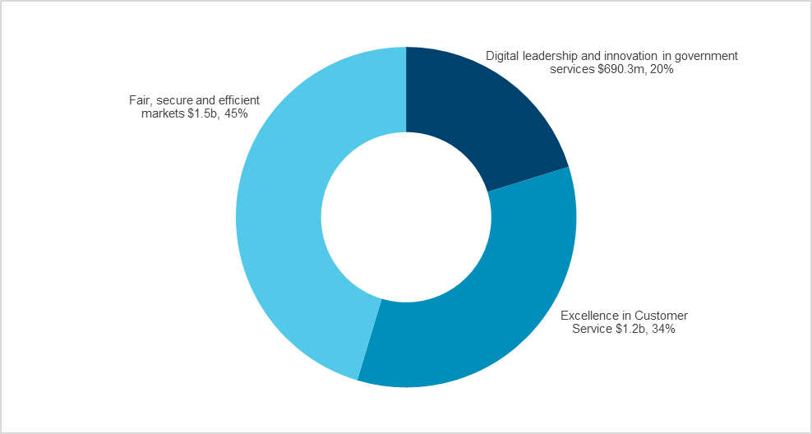
Note: The sum of percentages does not equal one hundred due to rounding.

- Capital expenditure by Outcome 2020-21 (dollars and %)

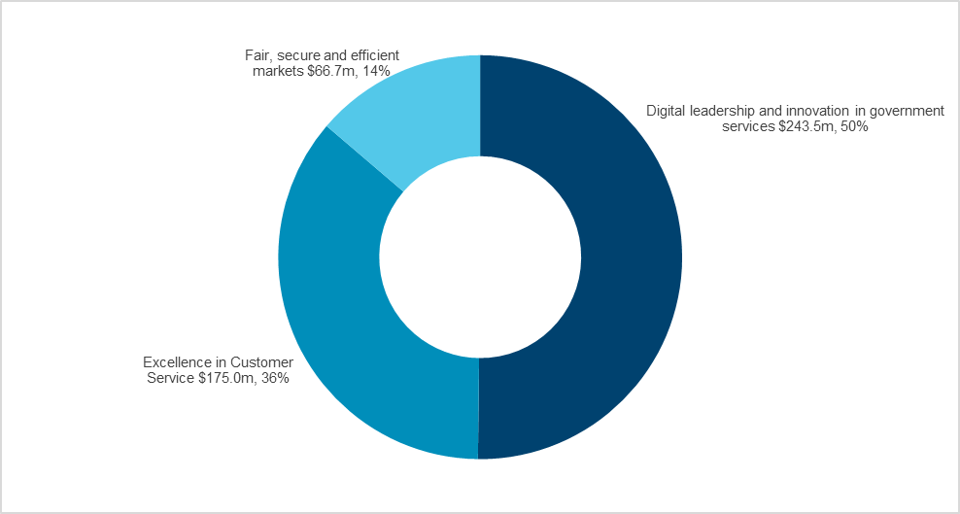

Outcome 1: Excellence in Customer Service

State Outcome overview and 2020-21 investment
 | $1.2 billion | Recurrent  Expenses  2020-21
 | $175.0 million | Capital  Expenditure  2020-21
This Outcome focuses the Cluster’s efforts and investment towards delivering a customer-centred approach in everything it does, resulting in better experiences and easier transactions for its customers and the communities, irrespective of who or where they are, or what services they want. This Outcome is measured by the availability of digital transactions, customer satisfaction with government services, and the number of services where customers only need to “Tell us Once’.

2020-21 State Outcome Budget highlights
In 2020-21, the Customer Service Cluster will invest $1.4 billion ($1.2 billion recurrent expenses and $175.0 million capital expenditure) in this Outcome, including:
- $102.9 million to add 1,000 staff in Service NSW to support projects and expand the capacity of Service NSW frontline services to respond to increased customer demand and changing customer needs during COVID-19
- $50.0 million ($200.0 million over four years) to further support Service NSW as it increases the number of services offered through its one-stop shop model across the state, matching increased customer demand particularly in the digital channel with Service NSW the lead agency in delivery of Covid-19 support measures for both individuals and business
- $26.0 million ($51.0 million over two years) for the Business Concierge service as part of the Easy To Do Business Program to support businesses with specialist advice and provide a one-stop-shop for meeting regulatory requirements
- $13.6 million ($17.5 million expenses over two years) for the Assured Revenue Program which will deliver transformational improvements in customer experience, with seamless integration with Service NSW for taxes and fines, making it easier for our customers to comply with their obligations
- $8.6 million ($14.9 million capital and $55.3 million expenses over four years) for the opening of four new Service centres in 2020-21 as part of the 10 New Services Centres election commitment, which will provide greater access for customers to government services and enhance service delivery and service offering to meet future needs
- $3.8 million ($7.8 million expenses over two years) to continue the operation of Mobile Service Centres in regional NSW to provide increased presence to rural & regional communities across New South Wales who are unable to access many government services
- improving customer interactions through the Government Made Easy Premier’s Priority, allowing customers to opt in to sharing their information across government so they only need to tell us once about them, when things change, and when they need help.

Key performance insights
This section provides analysis and insights on key Outcome Indicators for this State Outcome.

Increase the number of government services where customers only have to "Tell government once"
Government Made Easy means customers can choose to reuse their personal details to reduce customer time and effort in accessing services and to improve customer outcomes:
- for everyday transactional services, customer details can be pre-filled in forms, for example applying for Active Kids and Creative Kids vouchers using a MyServiceNSW account
- when things change in customers’ lives, multiple agencies can be notified in one step, for example a single notification on the death of a loved one through the Australian Death Notification Service
- in more complex situations, sensitive information can be shared with customer consent between agencies, for example the bushfire customer care model.
Performance against this indicator is well on track to significantly exceed the target of 60 services by June 2023, with 25 services delivered as at 30 June 2020.
- Number of government services where customers only have to "Tell government once"

Percentage of transactions available digitally through Service NSW
Service NSW is committed to excellence in customer service and continues to improve access to government services by making more services available online. Performance against this indicator is increasing and is expected to achieve the ambitious target of making 80 per cent of services available digitally by 2023-24. The data underpinning this Outcome Indicator currently relates to Roads and Maritime Services transactions only.

Customers without access to digital services by phone or from home, or who would like support accessing digital services can visit one of 109 Service Centres around the State, or our four Mobile Service Centres that bring services to communities across the State. All Service Centres have digital kiosks and specially trained team members who can help customers to understand and access digital services.

- Percentage of transactions available digitally through Service NSW

Performance indicators for this Outcome
Outcome Indicators | Units | 2019-20 | 2020-21
 |  | Actual | Forecast
Increase the number of government services where customers only have to  "Tell government once" | no. | 25.0 | 50.0
Percentage of transactions available digitally through Service NSW | % | 75.4 | 75.4

Outcome 2: Digital leadership and innovation in government services
 | $690.3 million | Recurrent  Expenses  2020-21
 | $243.5 million | Capital  Expenditure  2020-21

State Outcome overview and 2020-21 investment
The Cluster aims to invest in innovation and technology to increase and improve digital availability, reliability and security of NSW Government platforms, information and services. This Outcome measures digital readiness, and the public safety coverage and operation of the Critical Communications Enhancement Program – a critical enabling asset for many government service providers, including emergency services.

2020-21 State Outcome Budget highlights
In 2020-21, the Customer Service Cluster will invest $933.8 million ($690.3 million recurrent expenses and $243.5 million capital expenditure) in this Outcome, including:
- $500.0 million ($1.6 billion for projects over three years) for the Digital Restart Fund. The purpose of the Fund is to support digital and information and communications technology initiatives across the government sector
- $240.0 million under the Digital Restart Fund over three years has been allocated to Cyber Security Investments across the sector. The first initiative to be approved under this fund is a $20.0 million ($60.0 million expenses over three years) investment in Cyber Security Maturity, a program under the control of the NSW Chief Cyber Security officer in the Department of Customer Service
- $63.1 million ($217.0 million capital over four years) for the Critical Communications Enhancement Project, which will deliver greater access to public safety standard radio communications for the State’s first responders and essential service agencies
- $10.0 million ($30.6 million expenses over four years) to deliver a one front door corporate shared services model that is secure, innovative, efficient and scalable to support a seamless customer experience for our consumers and better value for money for the citizens of New South Wales.

Key performance insights
This section provides analysis and insights on key Outcome Indicators for this State Outcome.

Public safety coverage and operations of the CCEP
The Public Safety Network (PSN), also referred to as the Government Radio Network, is one of the world's largest trunked radio networks, shared by more than 50 agencies and serving approximately 42,000 registered terminals.
This indicator measures the coverage of the PSN. Performance against this indictor has been improving and continues to track to the network availability target of 99.95 per cent.

Under the Critical Communications Enhancement Program (CCEP) geographic coverage of the PSN has increased to 40 per cent providing population coverage of 93 per cent. In 2019-20, 31 new sites were added to the network bringing the total number of sites delivered under the CCEP to 66. During the 2019-20 bushfires, more than 10 million calls were made on the PSN, 24 sites were fast-tracked and 36 mobile units deployed in support of the emergency response in New South Wales.
- Public safety coverage and operations of the CCEP

Note: Performance targets are in development.

NSW digital government readiness
New South Wales remains the leading Australian jurisdiction for digital transformation, with a score of 9.7 out of 10 on the latest Digital Government Readiness report. The score measures what a government has done to ensure agencies are supported and enabled in digital transformation, and reflects the significant change realised through the establishment of the right strategy, policy and governance for customer service delivery channels.
Performance against this indicator continues to be strong, and meaningful progress has been made in all areas of digital readiness. Key initiatives underpinning this progress include strong participation in the Australian Data and Digital Council, the establishment of the Digital Restart Fund, the launch of the Beyond Digital strategy, the roll out of GovDC cloud services, the buy.nsw purchasing platform, the Trusted Digital Identity Framework, the Australian Digital Twin, and digital marketplaces.

- NSW digital government readiness score

Note: A forecast is not available as the values are sourced from the Digital Government Readiness Report prepared by Intermedium. The next results are expected to be released in early 2021.
Note: Performance targets are in development.

Performance indicators for this Outcome
Outcome Indicators | Units | 2019-20 | 2020-21
 |  | Actual | Forecast
NSW digital government readiness | no.
New South Wales |  | 9.7 | n.a.^{(a)}
Australian Government |  | 9.2 | n.a.^{(a)}
Victoria |  | 8.8 | n.a.^{(a)}
Queensland |  | 8.7 | n.a.^{(a)}
South Australia |  | 8.5 | n.a.^{(a)}
Northern Territory |  | 8.0 | n.a.^{(a)}
Australian Capital Territory |  | 7.9 | n.a.^{(a)}
Western Australia |  | 7.4 | n.a.^{(a)}
Tasmania |  | 7.0 | n.a.^{(a)}
Public safety coverage and operations of the CCEP | %
Geographic |  | 40 | 40
Operational |  | 99.95 | 99.95
Population |  | 93 | 93

Note
- A 2020-21 forecast is not available as the values are sourced from the Digital Government Readiness Report prepared by Intermedium. The next results are expected to be released in early 2021.

Outcome 3: Fair, secure and efficient markets
 | $1.5 billion | Recurrent  Expenses  2020-21
 | $66.7 million | Capital  Expenditure  2020-21

State Outcome overview and 2020-21 investment
The Cluster has a fundamental objective of delivering a regulatory framework that promotes safety, efficiency and regulatory requirements with the evolving expectations of businesses and customers. This Outcome is measured by the regulatory compliance rates of selected industries, the rate of work-related traumatic injury fatalities and the affordability of the Compulsory Third Party Insurance scheme.

2020-21 State Outcome Budget highlights
In 2020-21, the Customer Service Cluster will invest $1.6 billion ($1.5 billion recurrent expenses and $66.7 million capital expenditure) in this Outcome, including:
- $41.2 million ($152.0 million expenses over four years) for Responsible Gambling to support responsible gambling and reduce gambling harm in the community
- $23 million ($139 million over 3 years) for an assurance program to project manage the remediation process for removal of high-risk cladding in residential apartment buildings across the State
- $15.9 million ($22.9 million expenses over two years) for the Office of Racing to assist Greyhound Racing NSW and its clubs to improve animal welfare, including track upgrades to reduce injury rates for racing dogs
- $6.7 million ($27.3 million expenses over four years) for the Construct NSW Transformation program to support the Building Commissioner to implement a comprehensive strategy that will restore public confidence in the NSW building and construction industry, particularly for multi-storey residential apartments.

Key performance insights
This section provides analysis and insights on key Outcome Indicators for this State Outcome.

Reduced rate of work-related traumatic injury fatalities (worker fatalities per 100,000 employees)
The Work Health and Safety Roadmap for NSW 2022 outlines a strategic approach to reducing workplace fatalities and injuries by focusing on priority high risk sectors, workplaces and workers.
SafeWork NSW works proactively and responsively to support worker safety. When a fatality or serious injury occurs, SafeWork NSW responds quickly with significant resources to ensure the workplace is made safe and the investigation commences immediately. In 2016, SafeWork NSW adopted the national target of a 20 per cent reduction in workplace fatalities and a 30 per cent reduction in workplace injuries and illnesses by 2022.
Performance against this indicator continues to improve and is on track to meet the national target of 1.34 by 2022.

- Worker fatalities per 100,000 employees

Compliance rate of selected regulatory activities
Better Regulation Division protects the New South Wales community through innovative regulatory services to ensure fair, secure and efficient markets. Our compliance efforts include a commitment to working with businesses and educating industry groups and other government agencies to promote compliance and secure standards.
Significant compliance and enforcement outcomes have been achieved by educating and enabling businesses to comply and taking proportional enforcement actions against those who do not meet their regulatory obligations. Enforcement actions are intelligence-based and evidence-led, including legal proceedings where appropriate.
Performance against this indicator is currently exceeding the target of 90 per cent. In 2020, 91 per cent of selected regulated entities were found compliant with the laws and regulations which govern their operations.
- Compliance rate of selected regulatory activities

Note: The target for this indicator exists in both 2021-22 and 2022-23, however, has only been included in 2022-23 for presentational purposes.

Performance indicators for this Outcome
Outcome Indicators | Units | 2019-20 | 2020-21
 |  | Actual | Forecast
Affordability of the Compulsory Third Party insurance scheme (Motor vehicles) | % | 24.4 | 24.4
Compliance rate of selected regulatory activities | % | 91.0 | 91.0
Reduced rate of work-related traumatic injury fatalities (worker fatalities per 100,000 employees) | no. | 1.42 | 1.37

